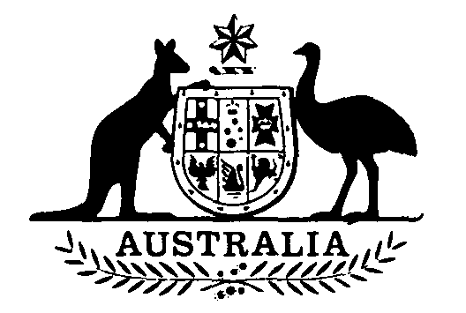
Meat Chicken Levy Amendment Act 1991
No. 44 of 1991

An Act to amend the Meat Chicken Levy Act 1969
[Assented to 27 March 1991]
The Parliament of Australia enacts:
Short title etc.
1. (1) This Act may be cited as the Meat Chicken Levy Amendment Act 1991.
(2) In this Act, “Principal Act” means the Meat Chicken Levy Act 1969¹.
Commencement
2. This Act commences on 1 July 1991.
Rate of levy
3. Section 7 of the Principal Act is amended by omitting from paragraph (1) (b) “0.005 cent” and substituting “0.05 cent”.
NOTE
1. No. 36, 1969 as amended. For previous amendments, see No. 103, 1985; No. 24, 1986; No. 133, 1989; and No. 17, 1990.

[Minister’s second reading speech made in—
House of Representatives on 13 February 1991
Senate on 14 March 1991]

