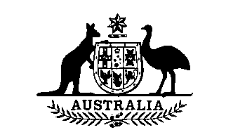
Wool Tax (No. 2) Amendment Act 1990
No. 64 of 1990

An Act to amend the Wool Tax Act (No. 2) 1964, and for related purposes
[Assented to 16 June 1990]
BE IT ENACTED by the Queen, and the Senate and the House of Representatives of the Commonwealth of Australia, as follows:
Short title etc.
1. (1) This Act may be cited as the Wool Tax (No. 2) Amendment Act 1990.
(2) In this Act, “Principal Act” means the Wool Tax Act (No. 2) 1964¹.
Commencement
2. This Act commences on the day on which it receives the Royal Assent.
Rate of Tax
3. Section 5 of the Principal Act is amended by omitting from paragraph (a) “10” and substituting “20”.

Application
4. Regulations made for the purposes of section 5 of the Principal Act as amended by this Act may be expressed to apply to all shorn wool on which a tax is imposed under section 4 of the Principal Act as so amended, being shorn wool purchased by a registered wool-dealer from a person other than a wool-broker after 30 June 1990 or such later day as is from time to time specified in the regulations.
——————————————————————————————————————————
NOTE
1. No. 26, 1964, as amended. For previous amendments, see No. 65, 1973; No. 67, 1974; No. 87, 1975; Nos. 37 and 73, 1976; No. 45, 1977; No. 73, 1978; No. 33, 1979; No. 52, 1980; No. 86, 1985; and No. 47, 1987.
[Minister’s second reading speech made in—
House of Representatives on 17 May 1990
Senate on 1 June 1990]

