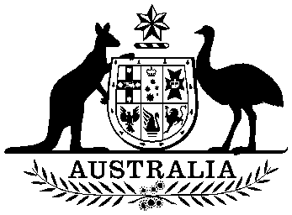

International Financial Institutions (Share Increase) Act 1986

No. 143 of 1986

An Act relating to the purchase of additional shares of the capital stock of the International Bank for Reconstruction and Development and of the International Finance Corporation

[Assented to 9 December 1986]

BE IT ENACTED by the Queen, and the Senate and the House of Representatives of the Commonwealth of Australia, as follows:

Short title
- This Act may be cited as the International Financial Institutions (Share Increase) Act /986.

Commencement
- This Act shall come into operation on the day on which it receives the Royal Assent.

Interpretation
- In this Act, unless the contrary intention appears—
“Bank” means the International Bank for Reconstruction and Development established under the Articles of Agreement set out in Schedule 2 to the International Monetary Agreements Act 1947;

International Financial Institutions (Share Increase) No. 143, 1986

“Corporation” means the International Finance Corporation established under the Articles of Agreement set out in the First Schedule to the International Finance Corporation Act 1955.

Agreements for purchase of additional shares of capital stock of the Bank
- The Treasurer may, on behalf of Australia, make an agreement or agreements with the Bank for the purchase by Australia of 815 additional shares of the capital stock of the Bank at a price per share that is the equivalent of 100,000 United States dollars, being dollars in the currency of the United States of America of the weight and fineness that was in effect on 1 July 1944.

Agreements for purchase of additional shares of capital stock of the Corporation
- The Treasurer may, on behalf of Australia, make an agreement or agreements with the Corporation for the purchase by Australia of 14,560 additional shares of the capital stock of the Corporation at a price per share of 1,000 United States dollars or their equivalent in any other freely convertible currency or currencies.

Agreements subject to terms and conditions
- Subject to this Act, an agreement referred to in section 4 or 5 may contain such terms and conditions as the Treasurer determines.

Appropriation and issue of securities
- (1) There may be paid out of the Consolidated Revenue Fund, which is appropriated accordingly, the moneys necessary for the purpose of making any payment to be made by Australia in pursuance of an agreement made under section 4 or 5.

(2) Section 7 of the International Monetary Agreements Act 1947 applies to any payment to be made by Australia in pursuance of an agreement made under section 4 as it applies to payments under that Act.

[Minister's second reading speech made in-
House of Representatives on 15 October 1986
Senate on 12 November 1986]

