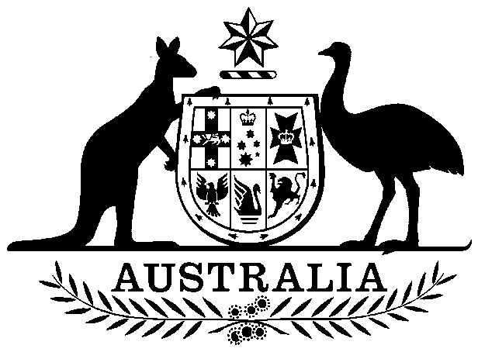

Petermann Aboriginal Land Trust (Boundaries) Act 1985

No. 109 of 1985

An Act relating to the boundaries of the land held by the Petermann Aboriginal Land Trust established under the *Aboriginal Land Rights (Northern Territory) Act 1976*, and for related purposes

Contents

1 Short title 1

2 Commencement 2

3 Boundaries of the Petermann Aboriginal Land Trust 2

4 Validation of Proclamation 2

5 No compensation payable 2

Schedule 3



Petermann Aboriginal Land Trust (Boundaries) Act 1985

No. 109 of 1985

An Act relating to the boundaries of the land held by the Petermann Aboriginal Land Trust established under the *Aboriginal Land Rights (Northern Territory) Act 1976*, and for related purposes

[*Assented to 16 October 1985*]

The Parliament of Australia enacts:

##### 1 Short title

This Act may be cited as the *Petermann Aboriginal Land Trust (Boundaries) Act 1985*.

##### 2 Commencement

This Act shall come into operation on the day on which it receives the Royal Assent.

##### 3 Boundaries of the Petermann Aboriginal Land Trust

The boundaries of the land held by the Petermann Aboriginal Land Trust, being the trust of that name that was established by the Minister under subsection 4(1) of the *Aboriginal Land Rights (Northern Territory) Act 1976*, shall, in lieu of the boundaries that were specified in the notice published in the *Gazette* on 21 July 1978 under that sub-section and in the relevant deed or deeds of grant executed under section 12 of that Act, be, and be deemed to have at all times been, the boundaries set out in the description of land in the Schedule to this Act.

##### 4 Validation of Proclamation

The Proclamation in relation to the Uluru (Ayers Rock—Mount Olga) National Park that was made and published in the *Gazette* on 24 May 1977 under subsection 7(2) of the *National Parks and Wildlife Conservation Act 1975* shall be deemed to have been validly made notwithstanding that the description of the area of the Park contained in the Schedule to the Proclamation contained an area that was included in the description of land in Schedule 1 to the *Aboriginal Land Rights (Northern Territory) Act 1976* under the heading ‘Petermann’.

##### 5 No compensation payable

Notwithstanding any law of the Commonwealth or of the Northern Territory, the Commonwealth is not liable to pay compensation to any person by reason of the enactment of this Act.

# Schedule

Section 3

All that piece of land in the Northern Territory of Australia containing an area of 44970 square kilometres more or less: Commencing at the northwestern corner of Northern Territory Portion 2214; thence southerly by the western boundary of the said Northern Territory Portion, the western boundary of Northern Territory Portion 1097 and the southerly prolongation of the western boundary of Northern Territory Portion 1097 to the parallel of south latitude 24 degrees 50 minutes; thence west by the said parallel to the meridian of east longitude 130 degrees 45 minutes; thence south by the said meridian to the parallel of south latitude 25 degrees 7 minutes 24 seconds; thence northwesterly to a point of south latitude 25 degrees 4 minutes 54 seconds and east longitude 130 degrees 40 minutes; thence south by the said meridian to parallel of south latitude 25 degrees 25 minutes; thence east by the said parallel to a western boundary of Northern Territory Portion 1818; thence southerly by the said western boundary of Northern Territory Portion 1818 and the western boundary of Northern Territory Portion 325 (Mulga Park) to the southern boundary of the Northern Territory; thence west along the southern boundary of the Northern Territory to the southwestern corner of the Northern Territory; thence north along the western boundary of the Northern Territory to a point west of the point of commencement; thence east to the point of commencement.