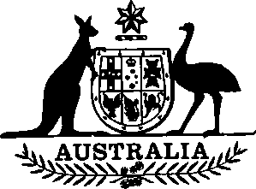

International Development Association (Special Contribution) Act 1985

No. 11 of 1985

An Act relating to the making by Australia of a special contribution to the International Development Association
[Assented to 5 April 1985]
BE IT ENACTED by the Queen, and the Senate and the House of Representatives of the Commonwealth of Australia, as follows:
Short title
1. This Act may be cited as the International Development Association (Special Contribution) Act 1985.
Commencement
2. This Act shall come into operation on the day on which it receives the Royal Assent.
Interpretation
3. In this Act, “the Association” means the International Development Association established by the Articles of Agreement of the International Development Association, a copy of which is set out in the Schedule to the International Development Association Act 1960.

Approval of making of special contribution
4. The making by Australia of a special contribution to the Association of an amount not exceeding $60,000,000 is approved.
Issue of promissory notes
5. (1) For the purpose of the payment of the special contribution referred to in section 4, the Treasurer may, on behalf of Australia, make promissory notes and issue them to the Association.
(2) A promissory note made under sub-section (1) shall be—
(a) payable to the Association;
(b) non-negotiable and non-interest bearing; and
(c) made payable at its par value on demand.
(3) Section 6 of the International Development Association Act 1960 does not apply in relation to the payment of the special contribution referred to in section 4.
Appropriation
6. The moneys necessary for the payment of the special contribution referred to in section 4, including the making of any payment that is to be made under a promissory note made under sub-section 5 (1), shall be paid out of the Consolidated Revenue Fund, which is appropriated accordingly.

[Minister’s second reading speech made in—
House of Representatives on 20 March 1985
Senate on 27 March 1985]

