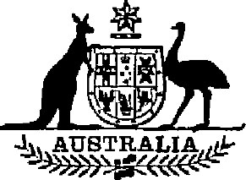

**Public Accounts Committee Amendment Act 1983**

**No. 111 of 1983**

**An Act to amend the *Public Accounts Committee Act 1951***

[*Assented to 8 December 1983*]

BE IT ENACTED by the Queen, and the Senate and the House of Representatives of the Commonwealth of Australia, as follows:

**Short title, &c.**

**1. (1)** This Act may be cited as the *Public Accounts Committee Amendment Act 1983.*

**(2)** The *Public Accounts Committee Act 1951*1is in this Act referred to as the Principal Act.

**Commencement**

**2.** This Act shall come into operation on the day on which it receives the Royal Assent.

**Joint Committee of Public Accounts**

**3.** Section 5 of the Principal Act is amended—

(a) by omitting from sub-section (1) “ten” and substituting “15”;

(b) by omitting from sub-section (2) “Three” and substituting “Five”; and

(c) by omitting from sub-section (2) “seven” and substituting “10”.

**Quorum and voting**

**4.** Section 7 of the Principal Act is amended by omitting from sub-section (1) “4” and substituting “6”.

**[**

**NOTE**

1.No. 60, 1951, as amended. For previous amendments, see No. 79, 1965; No. 93, 1966; No. 216, 1973 (as amended by No. 20, 1974); No. 70, 1976; No. 36, 1978; No. 187, 1979; and No. 80, 1982.