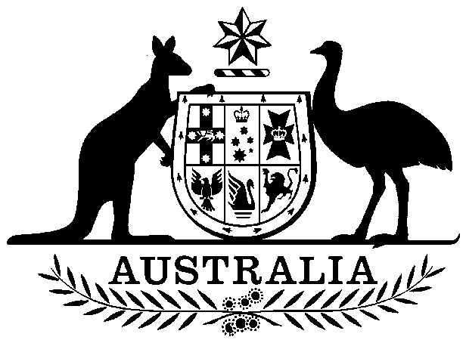

Papua New Guinea Loans Guarantee Act 1975

No. 99 of 1975

An Act to provide for a Statutory Guarantee by Australia in respect of the repayment, on and after the date on which Papua New Guinea attains Independence, of certain Public Loans raised before that date by the Government of Papua New Guinea

Contents

1 Short title 2

2 Commencement 2

3 Guarantee 2

4 Appropriation 2



Papua New Guinea Loans Guarantee Act 1975

No. 99 of 1975

An Act to provide for a Statutory Guarantee by Australia in respect of the repayment, on and after the date on which Papua New Guinea attains Independence, of certain Public Loans raised before that date by the Government of Papua New Guinea

[*Assented to 9 September 1975*]

The Parliament of Australia enacts:

##### 1 Short title

This Act may be cited as the *Papua New Guinea Loans Guarantee Act* 1975.

##### 2 Commencement

This Act shall come into operation on 16 September 1975.

##### 3 Guarantee

(1) Notwithstanding the repeal of section 75a of the *Papua New Guinea Act* 1949‑1975 by the *Papua New Guinea Independence Act* 1975, the guarantee deemed to have been given by Australia under that section in respect of the repayment of moneys borrowed in Australian currency before the date of commencement of this Act and the payment of interest in respect of those moneys shall, by force of this section, continue in force.

(2) For the purposes of the guarantee so continued in force, the liabilities of the Government of Papua New Guinea immediately before the date of commencement of this Act shall be deemed, on and after that date, to be liabilities of the Government of the Independent State of Papua New Guinea.

##### 4 Appropriation

Any amount payable by Australia in pursuance of this Act is payable out of the Consolidated Revenue Fund, which is appropriated accordingly.