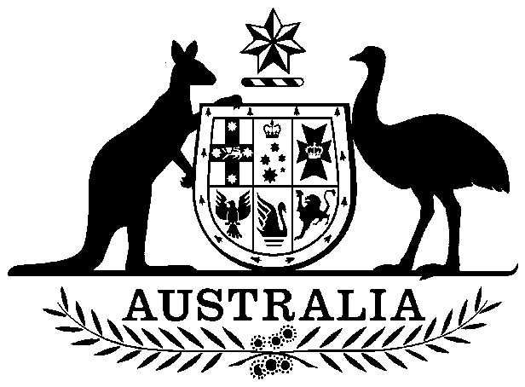

Private Health Insurance (Collapsed Organization Levy) Act 2003

No. 71, 2003

An Act to impose a levy to be known as the collapsed organization levy on registered health benefits organizations, and for related purposes

Contents

1 Short title 1

2 Commencement 2

3 Crown to be bound 2

4 Extension of Act to external Territories 2

5 Definitions 2

6 Purpose of imposing collapsed organization levy 3

7 Imposition of collapsed organization levy 3

8 Exempt organizations 4

9 Rate of collapsed organization levy 4

10 Minister to obtain advice from Council 5

11 Validation of collapsed organization levy 6

12 Regulations 6



Private Health Insurance (Collapsed Organization Levy) Act 2003

No. 71, 2003

An Act to impose a levy to be known as the collapsed organization levy on registered health benefits organizations, and for related purposes

[*Assented to 15 July 2003*]

The Parliament of Australia enacts:

##### 1 Short title

This Act may be cited as the *Private Health Insurance (Collapsed Organization Levy) Act 2003*.

##### 2 Commencement

This Act commences on 1 July 2004.

##### 3 Crown to be bound

This Act binds the Crown in each of its capacities.

##### 4 Extension of Act to external Territories

This Act extends to the Territory of Cocos (Keeling) Islands and to the Territory of Christmas Island.

##### 5 Definitions

In this Act, unless the contrary intention appears:

***capital adequacy requirements*** means:

(a) the capital adequacy standard that a registered health benefits organization is required to comply with under section 73BCI of the National Health Act; and

(b) any capital adequacy directions given to the organization under section 73BCJ of that Act.

***capital adequacy standard*** means a capital adequacy standard established by the Council under section 73BCG for the purposes of Division 3B of Part VI of the National Health Act.

***collapsed organization*** meansa registered health benefits organization in relation to which:

(a) a person is appointed as an administrator under section 82XD of the National Health Act; or

(b) a winding up application is made under section 82YT of that Act;

whether before or after the commencement of this Act.

***collapsed organization levy*** means a collapsed organization levy imposed under section 7.

***collapsed organization levy day*** means a collapsed organization levy day specified in a determination by the Minister under section 7.

***Council*** has the same meaning as in the National Health Act.

***levy determination*** means a determination by the Minister under paragraph 7(1)(b).

***National Health Act*** means the *National Health Act 1953*.

***registered health benefits organization*** has the same meaning as in the National Health Act.

***solvency requirements*** means:

(a) the solvency standard that a registered health benefits organization is required to comply with under section 73BCD of the National Health Act; and

(b) any solvency directions given to the organization under section 73BCE of that Act.

***solvency standard*** means a solvency standard established by the Council under section 73BCB for the purposes of Division 3A of Part VI of the National Health Act.

##### 6 Purpose of imposing collapsed organization levy

The purpose of imposing a collapsed organization levy is to help meet a collapsed organization’s liabilities to its contributors that it is unable to meet itself.

##### 7 Imposition of collapsed organization levy

(1) If:

(a) a registered health benefits organization is a collapsed organization; and

(b) the Minister determines in writing that this section applies to the organization;

collapsed organization levy is imposed on each registered health benefits organization (other than an exempt organization) on each collapsed organization levy day for a levy determination.

Note: Section 8 sets out the circumstances in which a registered health benefits organization will be an exempt organization.

(2) The Minister may determine in writing the day that is to be, or the days that are to be, the collapsed organization levy day or days for a levy determination.

(3) A determination under paragraph (1)(b) or subsection (2) is a disallowable instrument for the purposes of section 46A of the *Acts Interpretation Act 1901*.

##### 8 Exempt organizations

(1) A registered health benefits organization is an exempt organization in relation to a levy determination if:

(a) it is the collapsed organization; or

(b) the Minister determines in writing that the organization is an exempt organization.

(2) The Minister may determine that an organization is an exempt organization in relation to a levy determination if he or she is satisfied that imposing the collapsed organization levy on the organization would have a significantly adverse affect on the organization’s ability to comply with:

(a) the solvency requirements; or

(b) the capital adequacy requirements.

(3) A determination under paragraph (1)(b) is a disallowable instrument for the purposes of section 46A of the *Acts Interpretation Act 1901*.

##### 9 Rate of collapsed organization levy

(1) The rate of collapsed organization levy imposed on a collapsed organization levy day is the rate that:

(a) is determined in writing by the Minister; and

(b) applies on that day.

(2) In determining the rate of levy, the Minister must have regard to the total value of the collapsed organization’s liabilities to its contributors.

(3) The rate of levy:

(a) must be based on the number of contributors who contribute to the health benefits fund conducted by the registered health benefits organization on the day determined in writing by the Minister as the census day for the levy day; and

(b) may be different for:

(i) contributors who contribute in respect of one person to the health benefits fund conducted by the organization; and

(ii) contributors who contribute in respect of more than one person to the health benefits fund conducted by the organization; and

(c) may be set at zero.

(4) A determination under subsection (1) or paragraph (3)(a) is a disallowable instrument for the purposes of section 46A of the *Acts Interpretation Act 1901*.

##### 10 Minister to obtain advice from Council

(1) Before making a determination under section 7, 8 or 9, the Minister must obtain, and take into account, advice from the Council in relation to the following matters:

(a) whether to make a levy determination;

(b) whether to make a determination under paragraph 8(1)(b);

(c) the day that is to be, or the days that are to be, specified as the collapsed organization levy day or days;

(d) the rate that is to be specified as the rate of the collapsed organization levy imposed on the collapsed organization levy day or days;

(e) the day that is to be, or the days that are to be, specified as the census day or days for the collapsed organization levy day or days;

(f) the total value of the collapsed organization’s liabilities to its contributors.

(2) An advice given to the Minister by the Council under subsection (1) must be laid before each House of the Parliament with the determination to which the advice relates.

##### 11 Validation of collapsed organization levy

(1) This section applies to each amount that the Council purported before 1 July 2004 to impose as levy on a registered organization on a particular date under paragraph 82G(1)(j) of the National Health Act.

(2) By force of this section, collapsed organization validation levy of an equal amount is taken to have been imposed on the organization on that date.

(3) The amount of collapsed organization validation levy for which the organization is liable is:

(a) reduced by the sum of the amounts the organization paid on account of the levy the Council purported to impose under paragraph 82G(1)(j) of the National Health Act; and

(b) increased by so much of the sum of those amounts as the organization recovers from the Council.

(4) Amounts paid by an organization on account of levies that the Council purported to impose under paragraph 82G(1)(j) of the National Health Act are taken to be applied to the collapsed organization validation levies in the order in which the Council purported to impose the levies.

##### 12 Regulations

(1) The Governor‑General may make regulations prescribing matters:

(a) required or permitted by this Act to be prescribed; or

(b) necessary or convenient to be prescribed for carrying out or giving effect to this Act.

(2) Before the Governor‑General makes regulations under subsection (1), the Minister must take into consideration any relevant recommendation made to the Minister by the Council.

[*Minister’s second reading speech made in—*

*House of Representatives on 26 March 2003*

(36/03)

*Senate on 23 June 2003*]