

Appropriation Act (No. 1) 2000-2001

No. 81, 2000

Appropriation Act (No. 1) 2000-2001

No. 81, 2000

An Act to appropriate money out of the Consolidated Revenue Fund for the ordinary annual services of the Government, and for related purposes

Contents
Part 1—Preliminary 1
1 Short title 1
2 Commencement 2
3 Definitions 2
4 Portfolio Budget Statements 3
5 Notional payments, receipts etc. 3
Part 2—Basic appropriations 4
6 Summary of basic appropriations 4
7 Departmental items—basic appropriation 4
8 Administered items—basic appropriation 5
Part 3—Additions to basic appropriations 6
9 Net appropriations 6
10 Departmental items—adjustments 6
11 Advance to the Finance Minister—unforeseen expenditure etc. 7
12 Comcover receipts 7
Part 4—Miscellaneous 9
13 Crediting amounts to Special Accounts 9
14 Appropriation of the Consolidated Revenue Fund 9
Schedule—Services for which money is appropriated 11

Appropriation Act (No. 1) 2000-2001
No. 81, 2000

An Act to appropriate money out of the Consolidated Revenue Fund for the ordinary annual services of the Government, and for related purposes
[Assented to 30 June 2000]

The Parliament of Australia enacts:

Part 1—Preliminary

1 Short title
This Act may be cited as the Appropriation Act (No. 1) 2000-2001.

2 Commencement
This Act commences on the day on which it receives the Royal Assent.

3 Definitions
In this Act, unless the contrary intention appears:
administered item means an amount set out in the Schedule opposite an outcome of an entity under the heading “Administered Expenses”.
Agency has the same meaning as in the Financial Management and Accountability Act 1997.
Agency Minister, in relation to an Agency, means the Minister responsible for the Agency.
Chief Executive has the same meaning as in the Financial Management and Accountability Act 1997.
Commonwealth authority has the same meaning as in the Commonwealth Authorities and Companies Act 1997.
Commonwealth company has the same meaning as in the Commonwealth Authorities and Companies Act 1997.
current year means the financial year ending on 30 June 2001.
departmental item means the total amount set out in the Schedule in relation to an entity under the heading “Departmental Outputs”.
Note: The amounts set out opposite outcomes, under the heading “Departmental Outputs”, are “notional”. They are not part of the item, and do not in any way restrict the scope of the expenditure authorised by the item.
entity means any of the following:
(a) an Agency;
(b) a Commonwealth authority;
(c) a Commonwealth company.
expenditure means payments for expenses, acquiring assets, making loans or paying liabilities.
Finance Minister means the Minister administering this Act.
item means an administered item or a departmental item.
Portfolio Budget Statements means the Portfolio Budget Statements that were tabled in the House of Representatives in relation to the Bill for this Act.
section 31 agreement means an agreement under section 31 of the Financial Management and Accountability Act 1997.
Special Account has the same meaning as in the Financial Management and Accountability Act 1997.

4 Portfolio Budget Statements
(1) The Portfolio Budget Statements are hereby declared to be a relevant document for the purposes of section 15AB of the Acts Interpretation Act 1901.
Note: See paragraph 15AB(2)(g) of the Acts Interpretation Act 1901.
(2) If the Portfolio Budget Statements indicate that activities of a particular kind were intended to be treated as activities in respect of a particular outcome, then expenditure for the purpose of carrying out those activities is taken to be expenditure for the purpose of contributing to achieving the outcome.

5 Notional payments, receipts etc.
For the purposes of this Act, notional transactions between Agencies are to be treated as if they were real transactions.
Note: This section applies, for example, to a “payment” between Agencies that are both part of the Commonwealth. One of the effects of this section is that the payment will be debited from an appropriation for the paying Agency, even though no payment is actually made from the Consolidated Revenue Fund.

Part 2—Basic appropriations

6 Summary of basic appropriations
The total of the items specified in the Schedule is $38,530,846,000.
Note 1: Items in the Schedule can be increased under Part 3 of this Act.
Note 2: See also section 30A of the Financial Management and Accountability Act 1997, which provides for adjustment of appropriations to take account of GST.

7 Departmental items—basic appropriation
(1) For a departmental item for an entity, the Finance Minister may issue out of the Consolidated Revenue Fund amounts that do not exceed, in total, the amount specified in the item.
Note: Generally, the Finance Minister is permitted, but not obliged, to issue the amounts out of the Consolidated Revenue Fund. However, subsections (3) and (4) impose an obligation on the Finance Minister to issue the amounts in certain circumstances.
(2) An amount issued out of the Consolidated Revenue Fund for a departmental item for an entity may only be applied for the departmental expenditure of the entity.
Note: The acquisition of new departmental assets will usually be funded from a departmental capital item (in another Appropriation Act).
(3) If:
(a) an Act provides that an entity must be paid amounts that are appropriated by the Parliament for the purposes of the entity; and
(b) the Schedule contains a departmental item for that entity;
then the Finance Minister, under subsection (1), must issue out of the Consolidated Revenue Fund the full amount specified in the item.
(4) If a departmental item for an Agency includes provision for payment of remuneration and allowances to the holder of:
(a) a public office (within the meaning of the Remuneration Tribunal Act 1973); or
(b) an office specified in a Schedule to the Remuneration and Allowances Act 1990;
then the Finance Minister, under subsection (1), must issue out of the Consolidated Revenue Fund, under that item, amounts that are sufficient to pay the remuneration and allowances and must apply the amounts for that purpose.

8 Administered items—basic appropriation
(1) For an administered item for an outcome of an entity, the Finance Minister may issue out of the Consolidated Revenue Fund amounts that do not exceed, in total, the lesser of:
(a) the amount specified in the item; and
(b) the amount determined by the Finance Minister in relation to the item, having regard to the expenses incurred by the entity in the current year in relation to the item.
(2) An amount issued out of the Consolidated Revenue Fund for an administered item for an outcome of an entity may only be applied for expenditure for the purpose of carrying out activities for the purpose of contributing to achieving that outcome.
Note: The acquisition of new administered assets will usually be funded from an administered capital item (in another Appropriation Act).

Part 3—Additions to basic appropriations

9 Net appropriations
Departmental items
(1) If a section 31 agreement applies to a departmental item, then the amount specified in the item is taken to be increased in accordance with the agreement, and on the conditions set out in the agreement. The increase cannot be more than the relevant receipts covered by the agreement.
(2) For the purposes of section 31 of the Financial Management and Accountability Act 1997, each departmental item is taken to be marked “net appropriation”.
Administered items
(3) If a section 31 agreement applies to an administered item, then the amount specified in the item is taken to be increased in accordance with the agreement, and on the conditions set out in the agreement. The increase cannot be more than the relevant receipts covered by the agreement.
(4) For the purposes of section 31 of the Financial Management and Accountability Act 1997, the following administered items are taken to be marked “net appropriation”:
(a) the administered items for outcomes 2 and 3 of the Department of Finance and Administration; and
(b) the administered item for outcome 2 of the Department of Industry, Science and Resources.

10 Departmental items—adjustments
(1) The Finance Minister may determine that the amount specified in a departmental item is to be increased by an amount specified in the determination.
(2) The total of the amounts determined by the Finance Minister under this section for all departmental items cannot be more than $20 million.
(3) The Finance Minister must give the Parliament details of increases made under this section.

11 Advance to the Finance Minister—unforeseen expenditure etc.
(1) This section applies if the Finance Minister is satisfied that:
(a) there is an urgent need for expenditure that is not provided for, or is insufficiently provided for, in the Schedule; and
(b) the additional expenditure is not provided for, or is insufficiently provided for, in the Schedule:
(i) because of an erroneous omission or understatement; or
(ii) because the additional expenditure was unforeseen until after the last day on which it was practicable to provide for it in the Bill for this Act before that Bill was introduced into the House of Representatives.
(2) This Act has effect as if the Schedule were amended, in accordance with a determination of the Finance Minister, to make provision for so much (if any) of the additional expenditure as the Finance Minister determines.
(3) The total of the amounts determined under this section cannot be more than $175 million.
(4) The Finance Minister must give the Parliament details of amounts determined under this section.

12 Comcover receipts
(1) This section applies whenever an amount (the Comcover payment) is debited from The Comcover Account in respect of a payment to an Agency.
Note: The Comcover Account is a Special Account for the purposes of the Financial Management and Accountability Act 1997.
(2) Amounts totalling the full amount of the Comcover payment must be added to an available item or items for the Agency. For this purpose, available item means an item in the Schedule to this Act or in a Schedule to the Appropriation Act (No. 2) 2000-2001.
(3) The items and respective amounts are to be determined by the Agency Minister. In making a determination, the Agency Minister must comply with any written directions given by the Finance Minister.
(4) The Agency Minister may delegate his or her powers under this section to the Chief Executive of the Agency.

Part 4—Miscellaneous

13 Crediting amounts to Special Accounts
If any of the purposes of a Special Account is a purpose that is covered by an item (whether or not the item expressly refers to the Special Account), then amounts may be debited against the appropriation for that item and credited to that Special Account.

14 Appropriation of the Consolidated Revenue Fund
The Consolidated Revenue Fund is appropriated as necessary for the purposes of this Act.

Schedule – Services for which money is appropriated
Note: See Sections 6 and 14
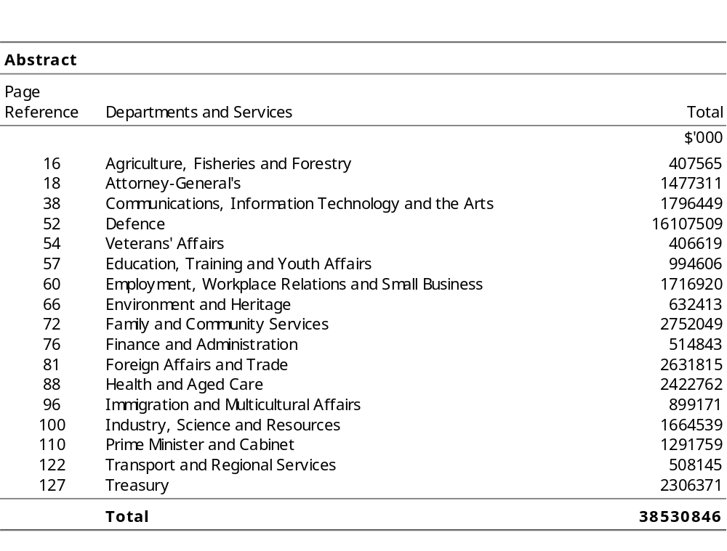

Departments and Services

summary
Appropriation (light figures) – 2000-2001
Estimate (italic figures) – 1999-2000
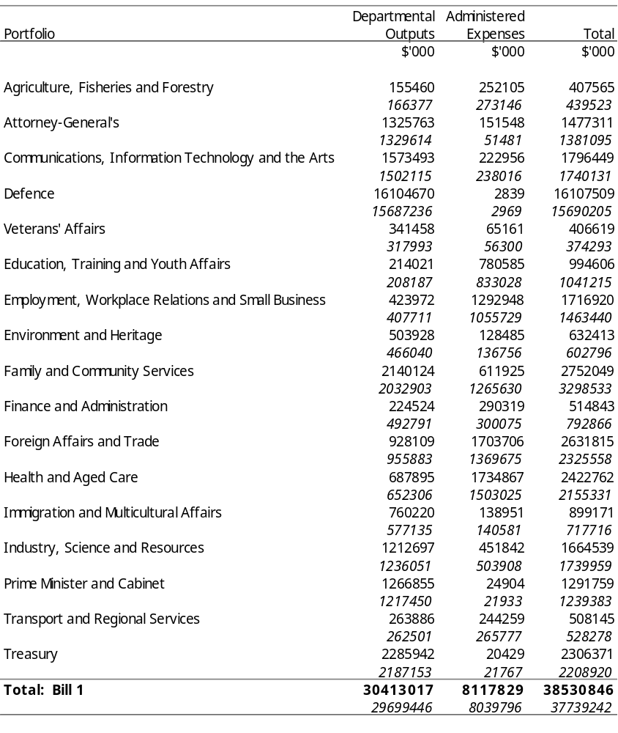
Appropriation Bill (1) 2000-2001
Summary
Appropriation (light figures) – 2000-2001
Estimate (italic figures) – 1999-2000
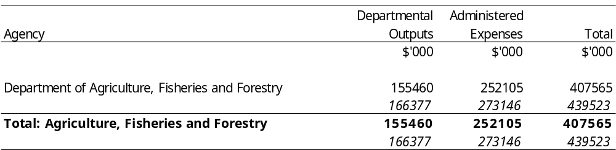
Appropriation Bill (1) 2000-2001
Appropriation (light figures) – 2000-2001
Estimate (italic figures) – 1999-2000
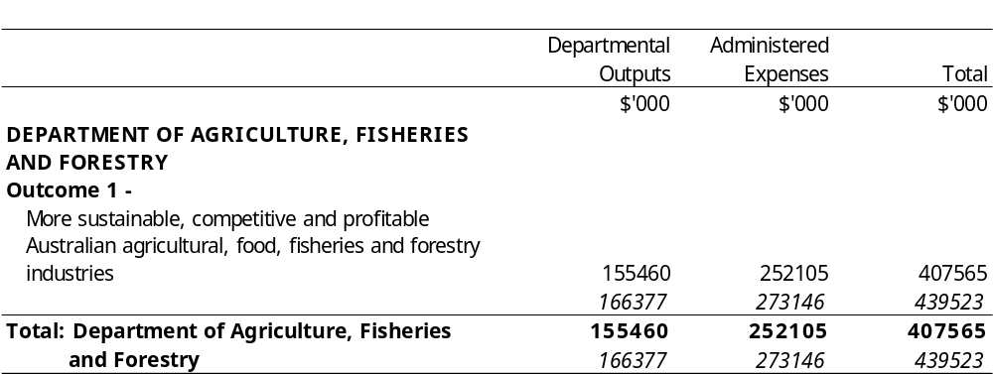
Appropriation Bill (1) 2000-2001
Summary
Appropriation (light figures) – 2000-2001
Estimate (italic figures) – 1999-2000
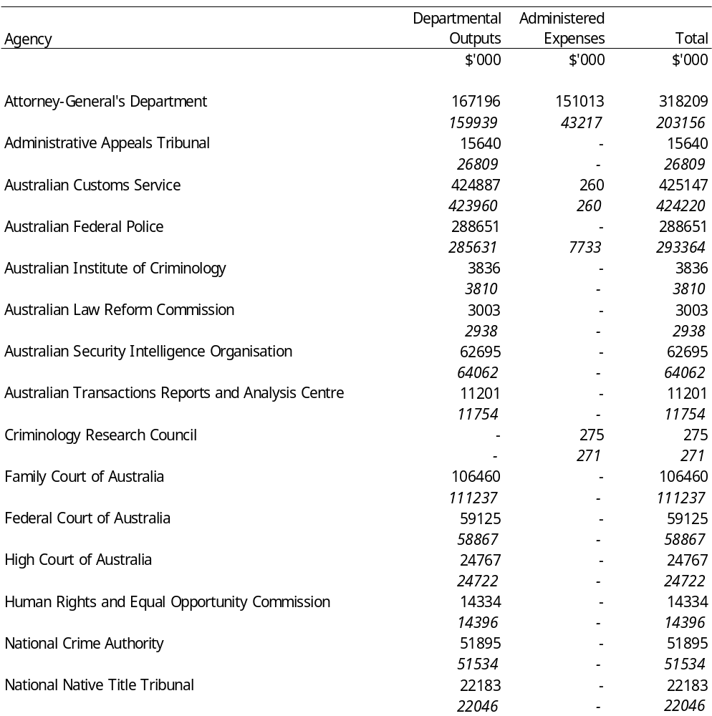
Continued
Appropriation Bill (1) 2000-2001
Summary
Appropriation (light figures) – 2000-2001
Estimate (italic figures) – 1999-2000
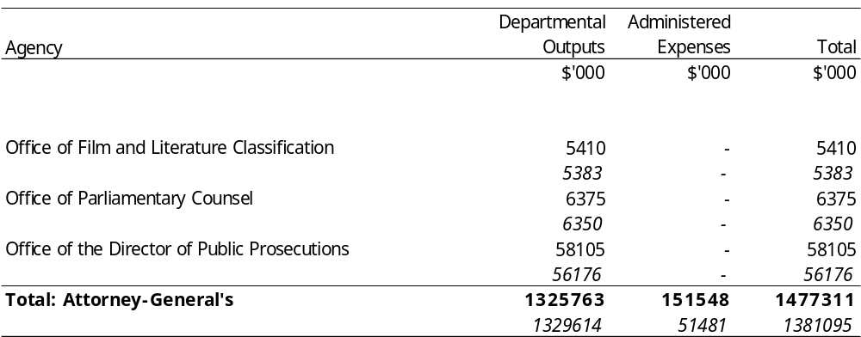
Appropriation Bill (1) 2000-2001
Appropriation (light figures) – 2000-2001
Estimate (italic figures) – 1999-2000
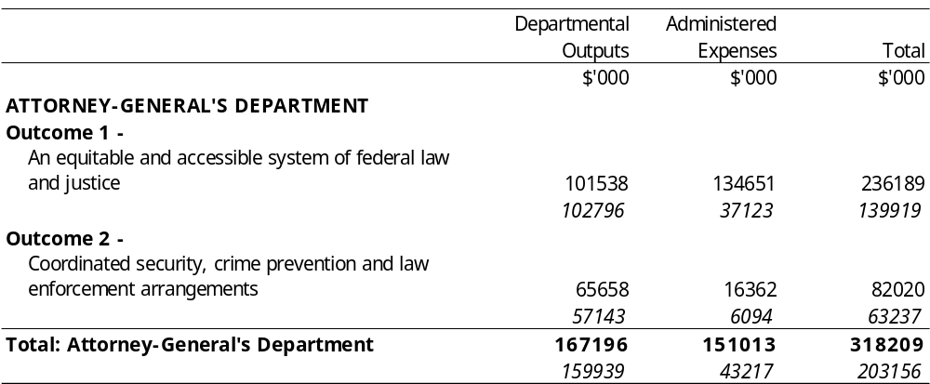
Appropriation Bill (1) 2000-2001
Appropriation (light figures) – 2000-2001
Estimate (italic figures) – 1999-2000
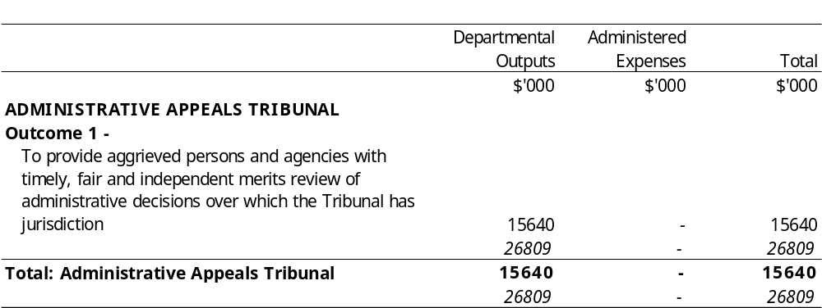
Appropriation Bill (1) 2000-2001
Appropriation (light figures) – 2000-2001
Estimate (italic figures) – 1999-2000
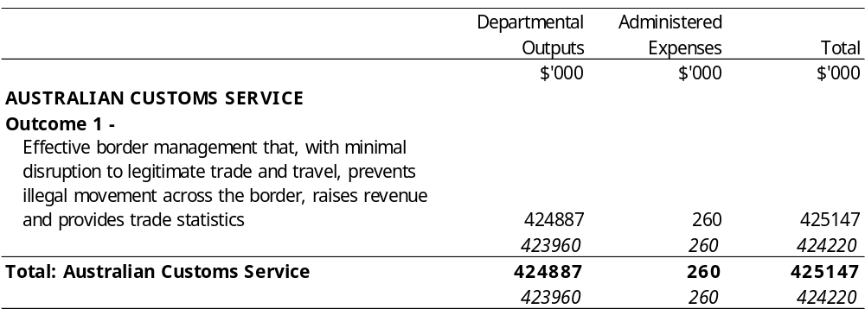
Appropriation Bill (1) 2000-2001
Appropriation (light figures) – 2000-2001
Estimate (italic figures) – 1999-2000
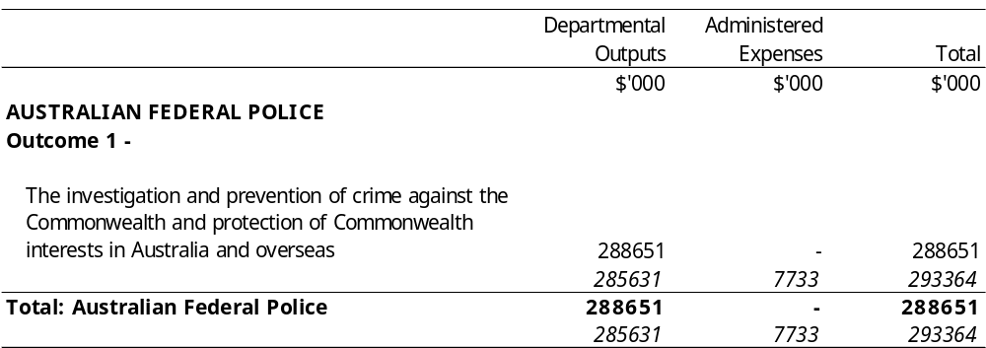
Appropriation Bill (1) 2000-2001
Appropriation (light figures) – 2000-2001
Estimate (italic figures) – 1999-2000
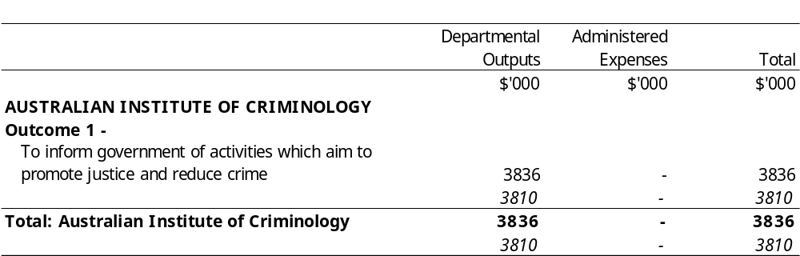
Appropriation Bill (1) 2000-2001
Appropriation (light figures) – 2000-2001
Estimate (italic figures) – 1999-2000
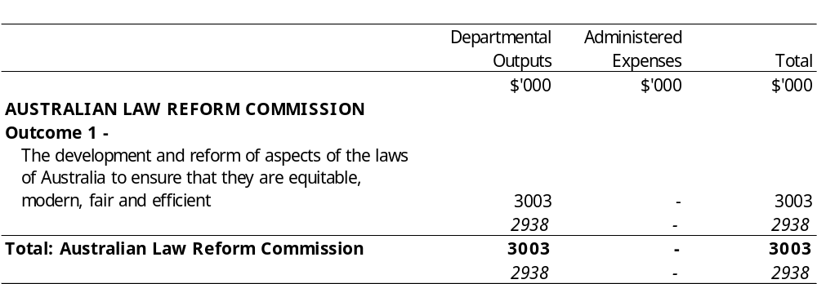
Appropriation Bill (1) 2000-2001
Appropriation (light figures) – 2000-2001
Estimate (italic figures) – 1999-2000
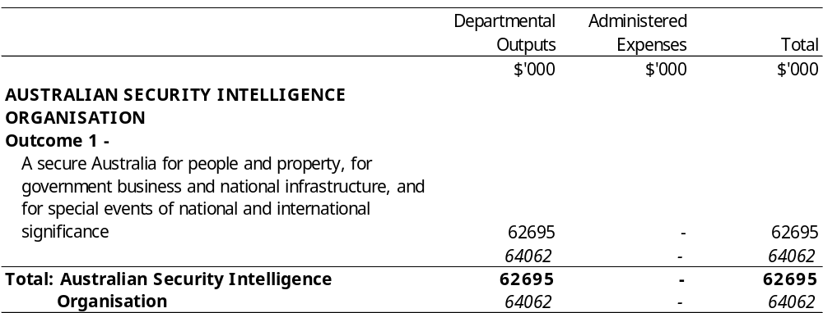
Appropriation Bill (1) 2000-2001
Appropriation (light figures) – 2000-2001
Estimate (italic figures) – 1999-2000
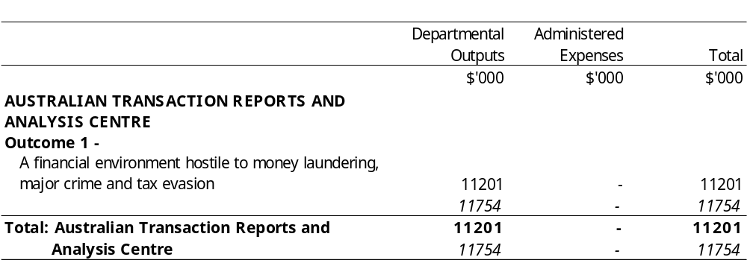
Appropriation Bill (1) 2000-2001
Appropriation (light figures) – 2000-2001
Estimate (italic figures) – 1999-2000
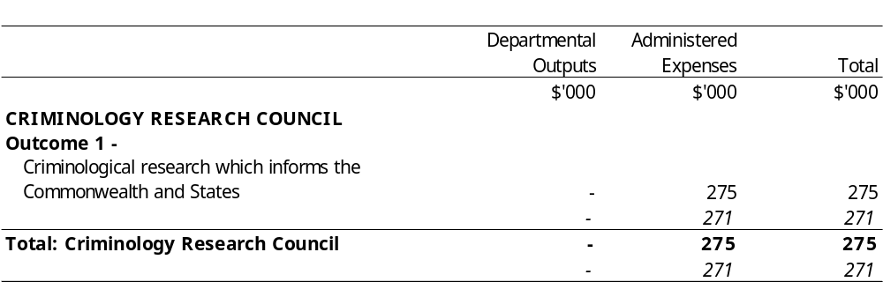
Appropriation Bill (1) 2000-2001
Appropriation (light figures) – 2000-2001
Estimate (italic figures) – 1999-2000
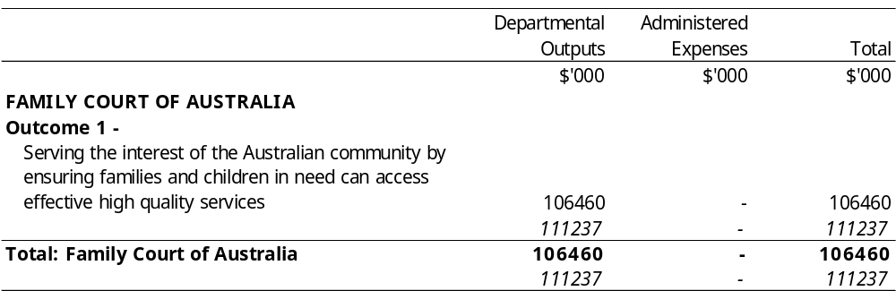
Appropriation Bill (1) 2000-2001
Appropriation (light figures) – 2000-2001
Estimate (italic figures) – 1999-2000
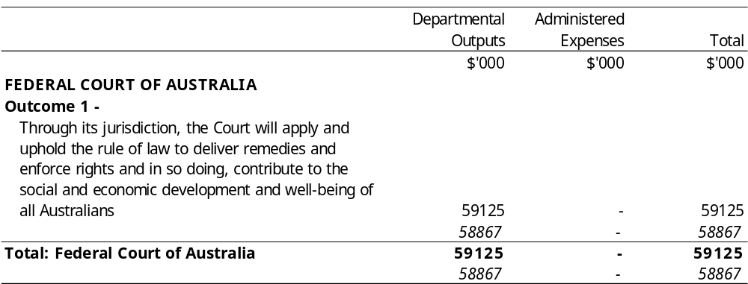
Appropriation Bill (1) 2000-2001
Appropriation (light figures) – 2000-2001
Estimate (italic figures) – 1999-2000
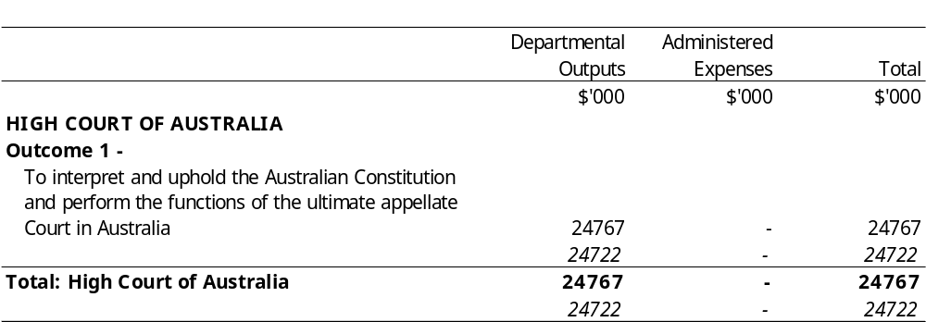
Appropriation Bill (1) 2000-2001
Appropriation (light figures) – 2000-2001
Estimate (italic figures) – 1999-2000
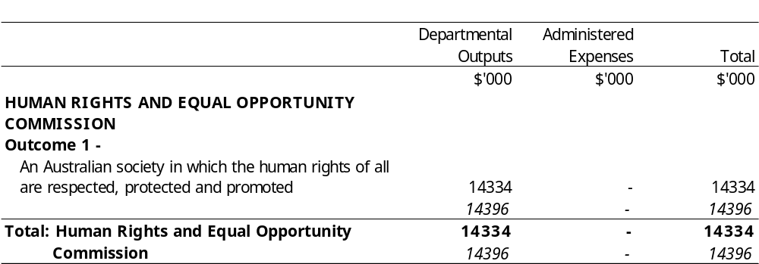
Appropriation Bill (1) 2000-2001
Appropriation (light figures) – 2000-2001
Estimate (italic figures) – 1999-2000
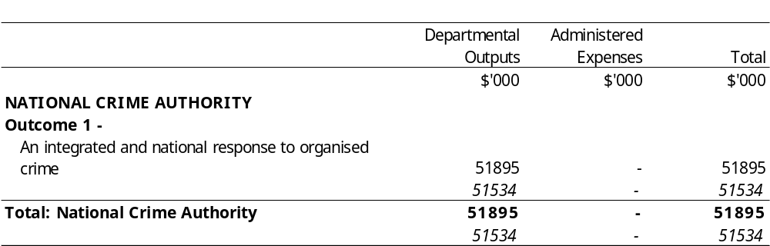
Appropriation Bill (1) 2000-2001
Appropriation (light figures) – 2000-2001
Estimate (italic figures) – 1999-2000
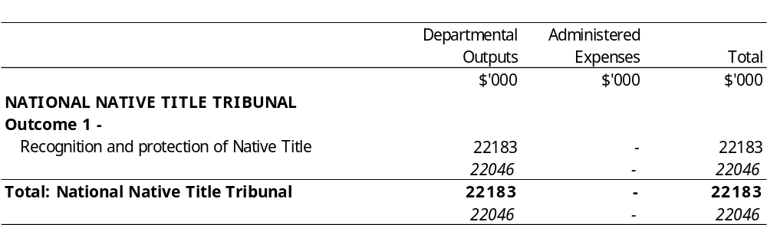
Appropriation Bill (1) 2000-2001
Appropriation (light figures) – 2000-2001
Estimate (italic figures) – 1999-2000
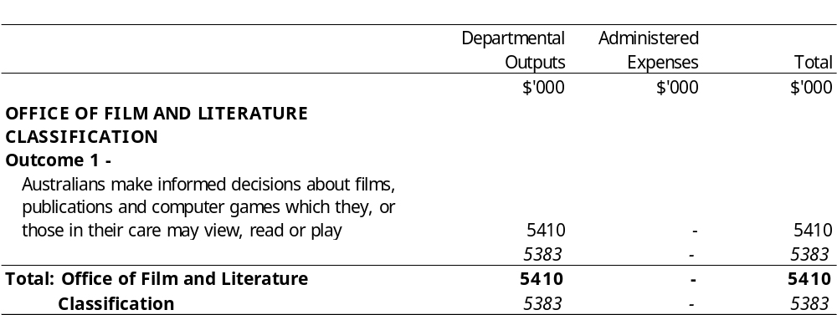
Appropriation Bill (1) 2000-2001
Appropriation (light figures) – 2000-2001
Estimate (italic figures) – 1999-2000
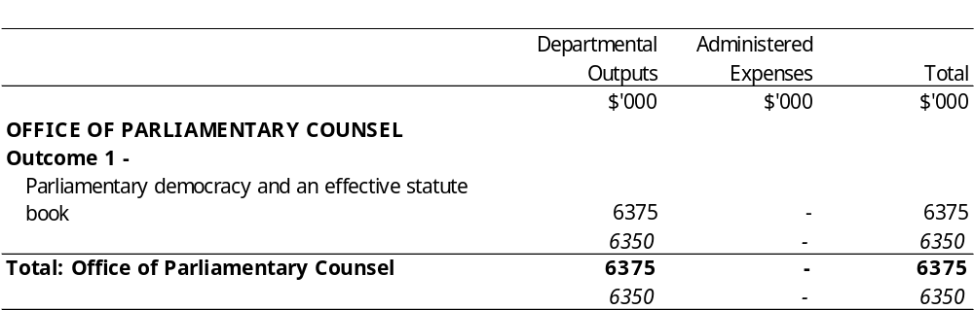
Appropriation Bill (1) 2000-2001
Appropriation (light figures) – 2000-2001
Estimate (italic figures) – 1999-2000
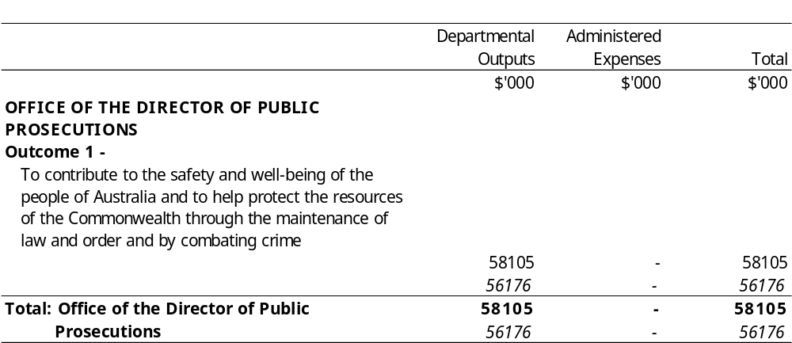
Appropriation Bill (1) 2000-2001
Summary
Appropriation (light figures) – 2000-2001
Estimate (italic figures) – 1999-2000
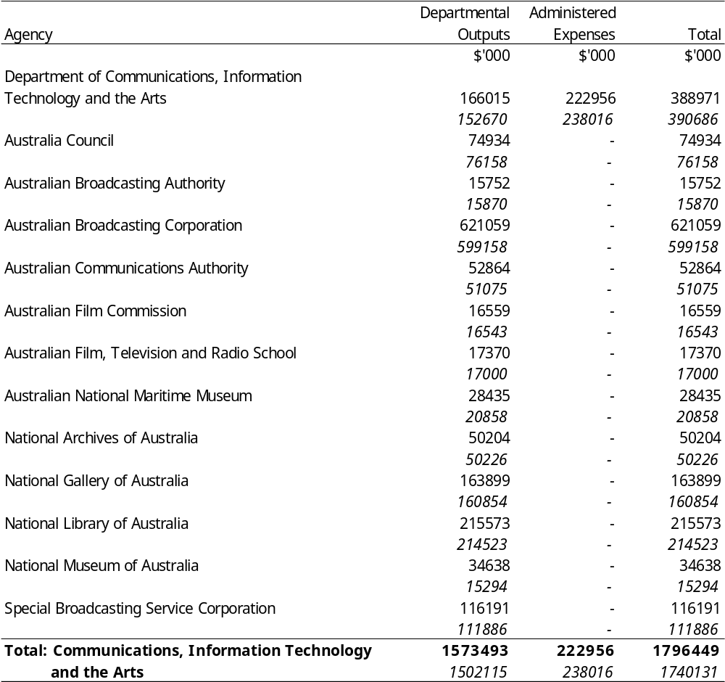
Appropriation Bill (1) 2000-2001
Appropriation (light figures) – 2000-2001
Estimate (italic figures) – 1999-2000
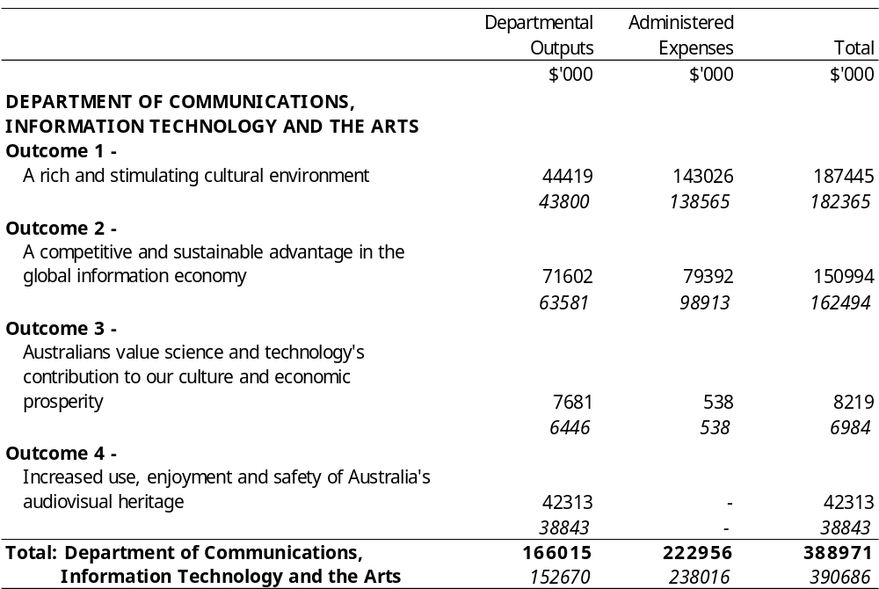
Appropriation Bill (1) 2000-2001
Appropriation (light figures) – 2000-2001
Estimate (italic figures) – 1999-2000
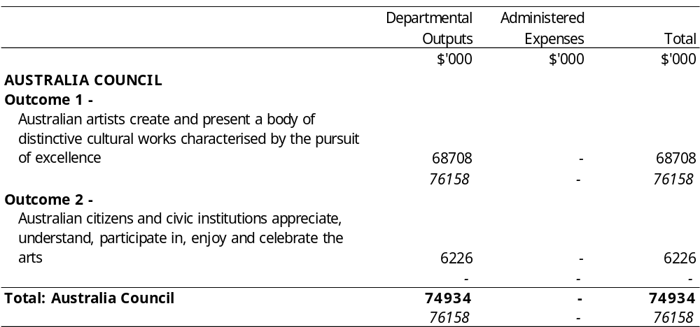
Appropriation Bill (1) 2000-2001
Appropriation (light figures) – 2000-2001
Estimate (italic figures) – 1999-2000
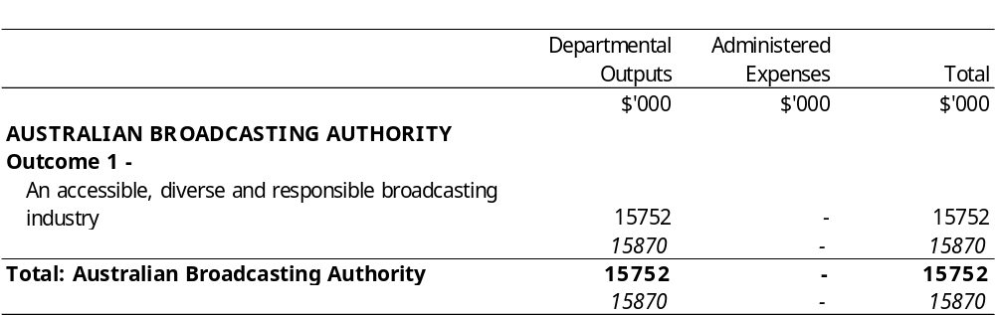
Appropriation Bill (1) 2000-2001
Appropriation (light figures) – 2000-2001
Estimate (italic figures) – 1999-2000
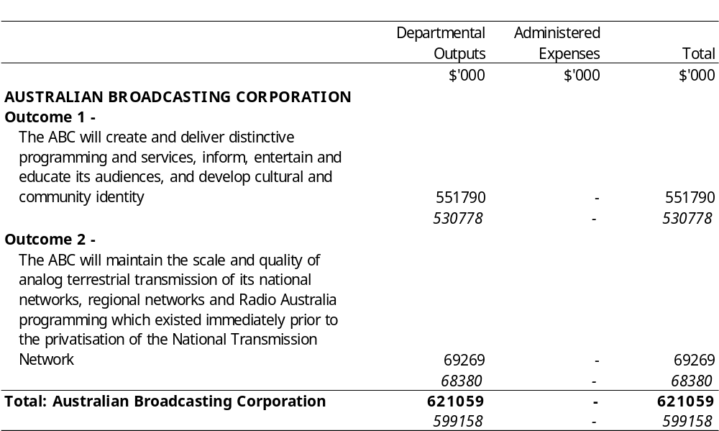
Appropriation Bill (1) 2000-2001
Appropriation (light figures) – 2000-2001
Estimate (italic figures) – 1999-2000
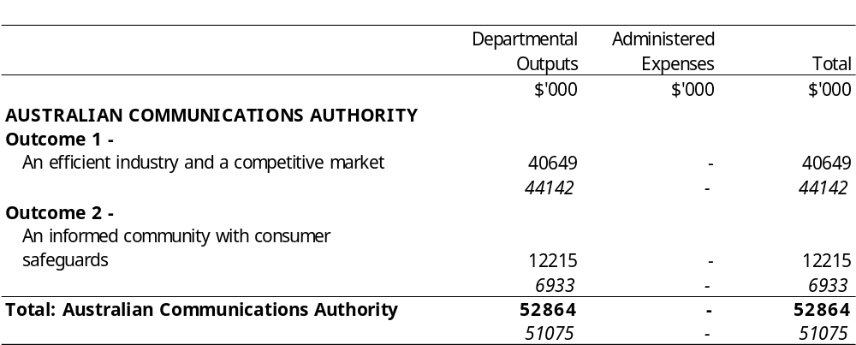
Appropriation Bill (1) 2000-2001
Appropriation (light figures) – 2000-2001
Estimate (italic figures) – 1999-2000
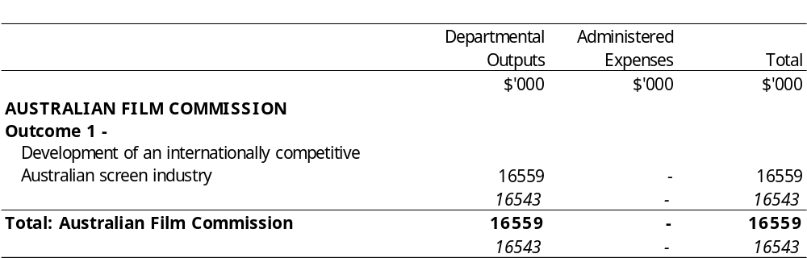
Appropriation Bill (1) 2000-2001
Appropriation (light figures) – 2000-2001
Estimate (italic figures) – 1999-2000
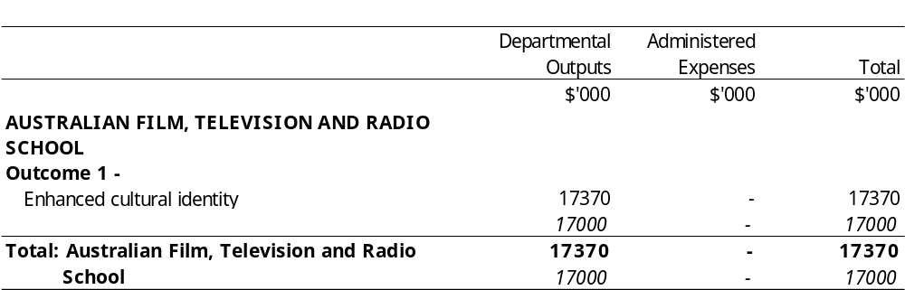
Appropriation Bill (1) 2000-2001
Appropriation (light figures) – 2000-2001
Estimate (italic figures) – 1999-2000
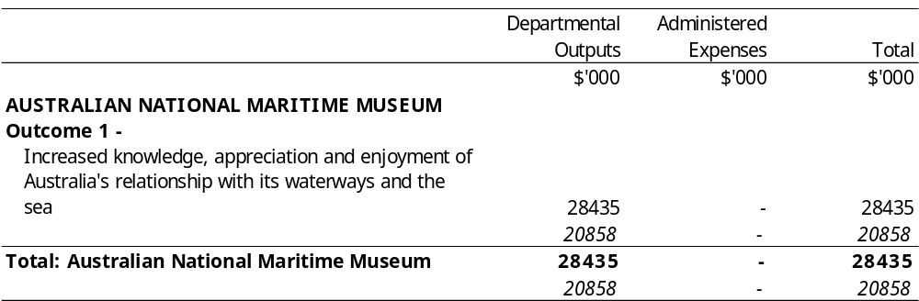
Appropriation Bill (1) 2000-2001
Appropriation (light figures) – 2000-2001
Estimate (italic figures) – 1999-2000
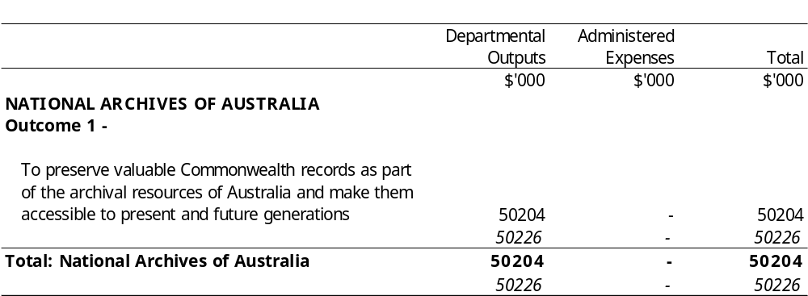
Appropriation Bill (1) 2000-2001
Appropriation (light figures) – 2000-2001
Estimate (italic figures) – 1999-2000
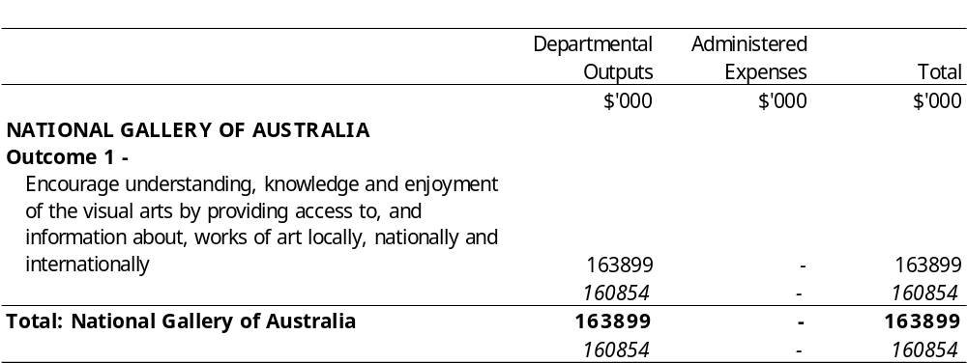
Appropriation Bill (1) 2000-2001
Appropriation (light figures) – 2000-2001
Estimate (italic figures) – 1999-2000
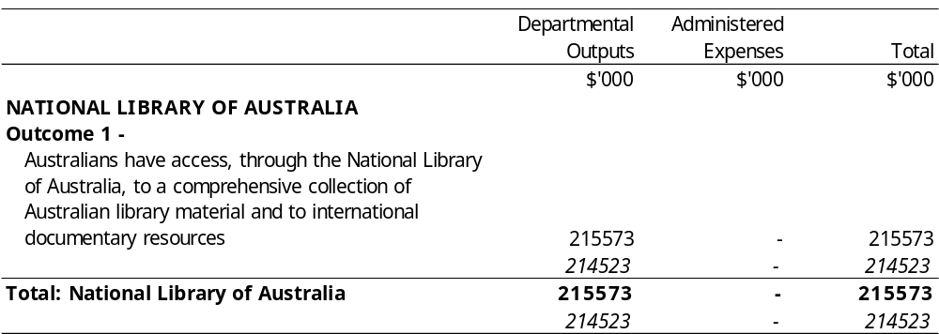
Appropriation Bill (1) 2000-2001
Appropriation (light figures) – 2000-2001
Estimate (italic figures) – 1999-2000
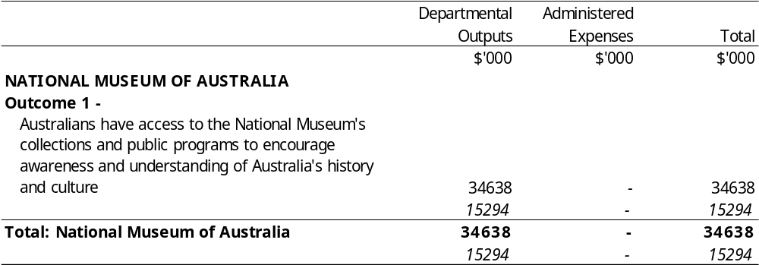
Appropriation Bill (1) 2000-2001
Appropriation (light figures) – 2000-2001
Estimate (italic figures) – 1999-2000
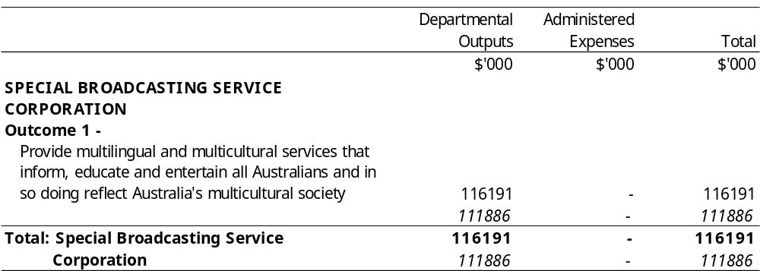
Appropriation Bill (1) 2000-2001
Summary
Appropriation (light figures) – 2000-2001
Estimate (italic figures) – 1999-2000
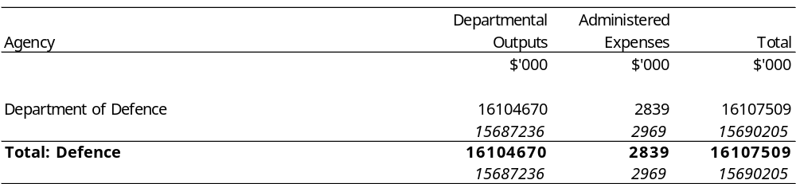
Appropriation Bill (1) 2000-2001
Appropriation (light figures) – 2000-2001
Estimate (italic figures) – 1999-2000
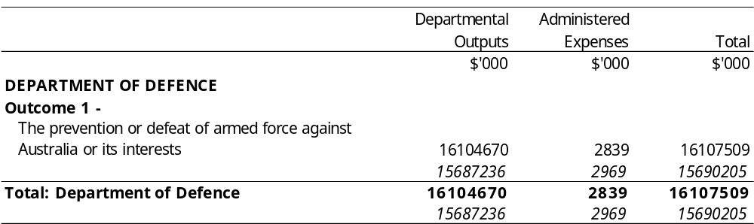
Appropriation Bill (1) 2000-2001
Summary
Appropriation (light figures) – 2000-2001
Estimate (italic figures) – 1999-2000
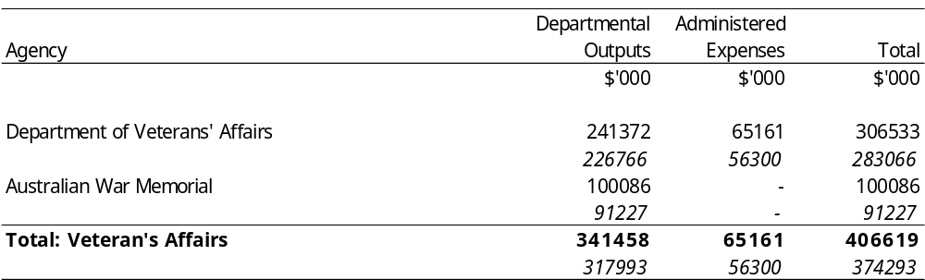
Appropriation Bill (1) 2000-2001
Appropriation (light figures) – 2000-2001
Estimate (italic figures) – 1999-2000
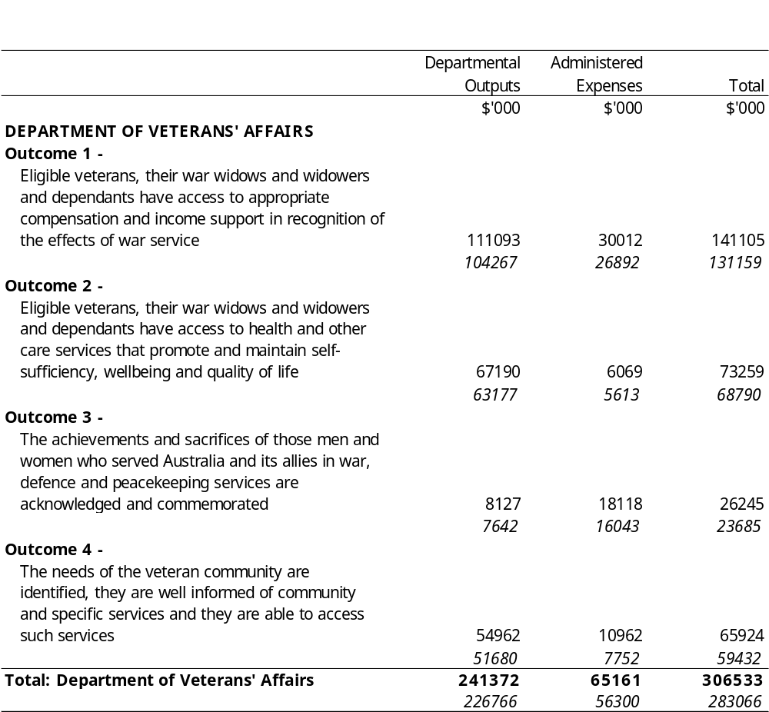
Appropriation Bill (1) 2000-2001
Appropriation (light figures) – 2000-2001
Estimate (italic figures) – 1999-2000
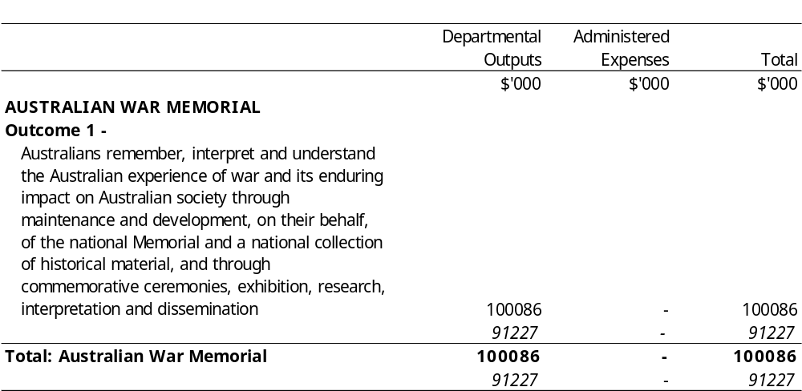
Appropriation Bill (1) 2000-2001
Summary
Appropriation (light figures) – 2000-2001
Estimate (italic figures) – 1999-2000
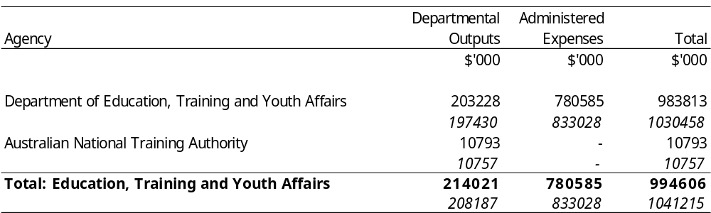
Appropriation Bill (1) 2000-2001
Appropriation (light figures) – 2000-2001
Estimate (italic figures) – 1999-2000
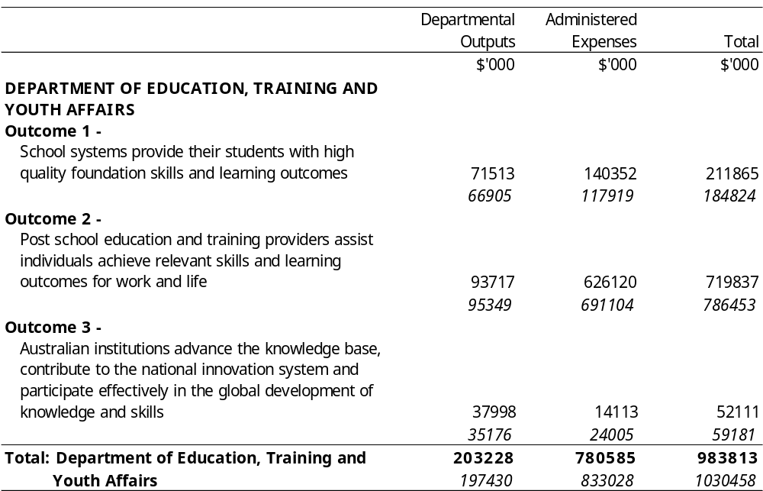
Appropriation Bill (1) 2000-2001
Appropriation (light figures) – 2000-2001
Estimate (italic figures) – 1999-2000
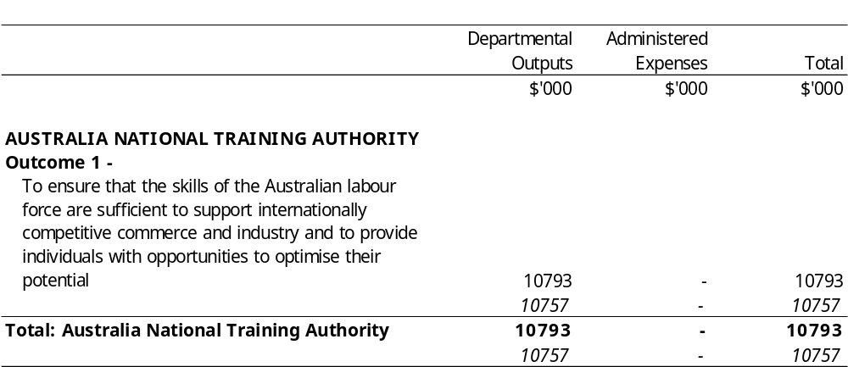
Appropriation Bill (1) 2000-2001
Summary
Appropriation (light figures) – 2000-2001
Estimate (italic figures) – 1999-2000
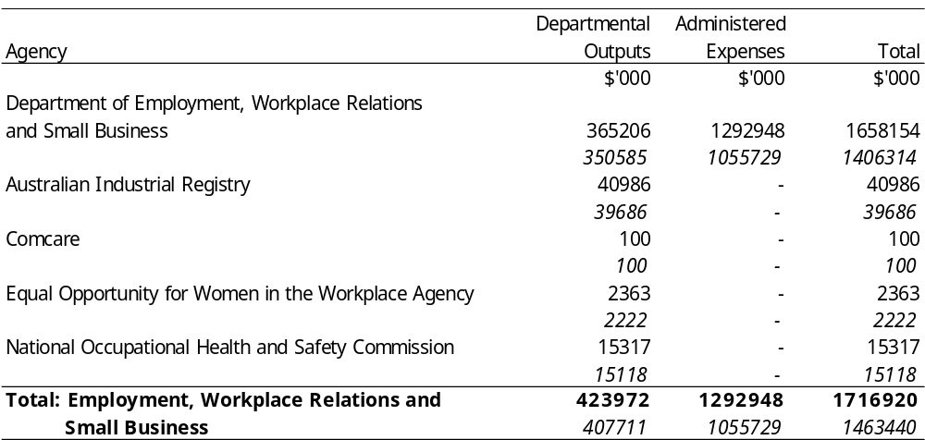
Appropriation Bill (1) 2000-2001
Appropriation (light figures) – 2000-2001
Estimate (italic figures) – 1999-2000
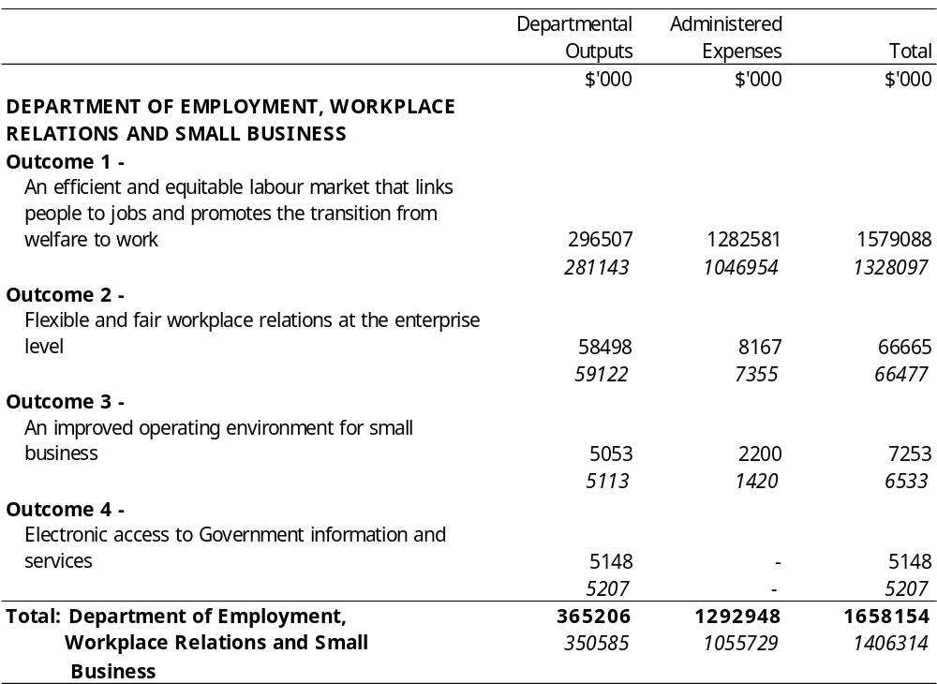
Appropriation Bill (1) 2000-2001
Appropriation (light figures) – 2000-2001
Estimate (italic figures) – 1999-2000
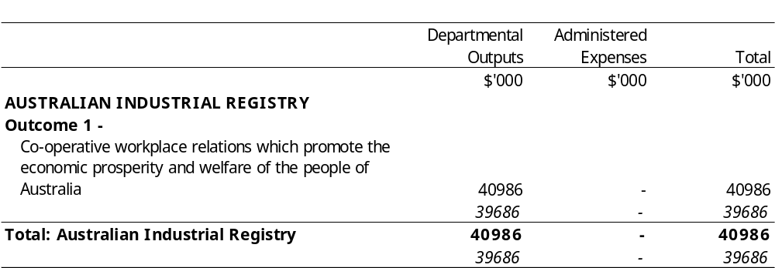
Appropriation Bill (1) 2000-2001
Appropriation (light figures) – 2000-2001
Estimate (italic figures) – 1999-2000
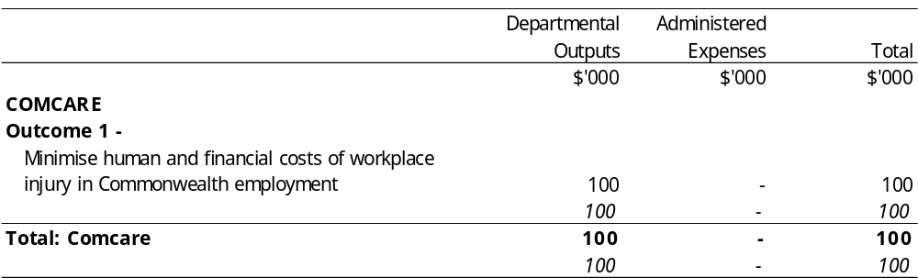
Appropriation Bill (1) 2000-2001
Appropriation (light figures) – 2000-2001
Estimate (italic figures) – 1999-2000
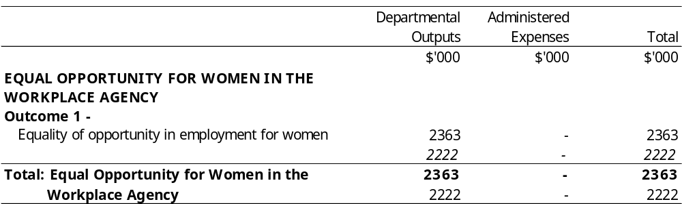
Appropriation Bill (1) 2000-2001
Appropriation (light figures) – 2000-2001
Estimate (italic figures) – 1999-2000
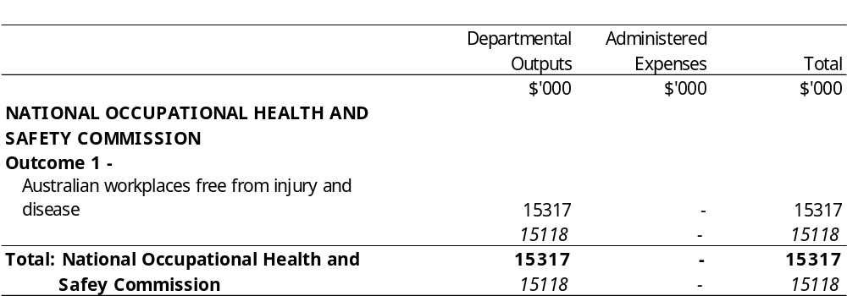
Appropriation Bill (1) 2000-2001
Summary
Appropriation (light figures) – 2000-2001
Estimate (italic figures) – 1999-2000
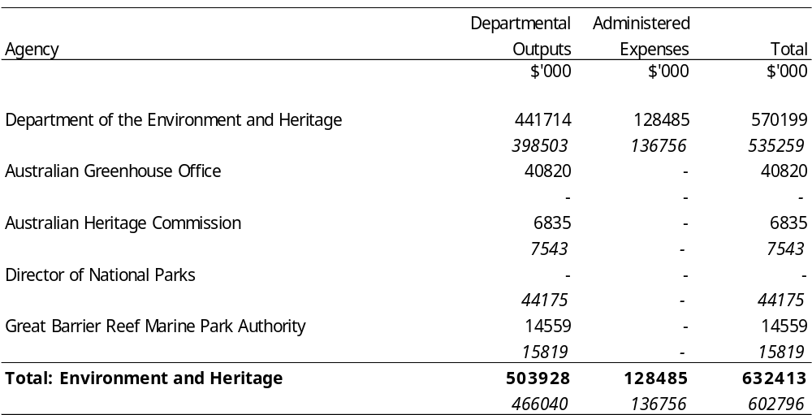
Appropriation Bill (1) 2000-2001
Appropriation (light figures) – 2000-2001
Estimate (italic figures) – 1999-2000
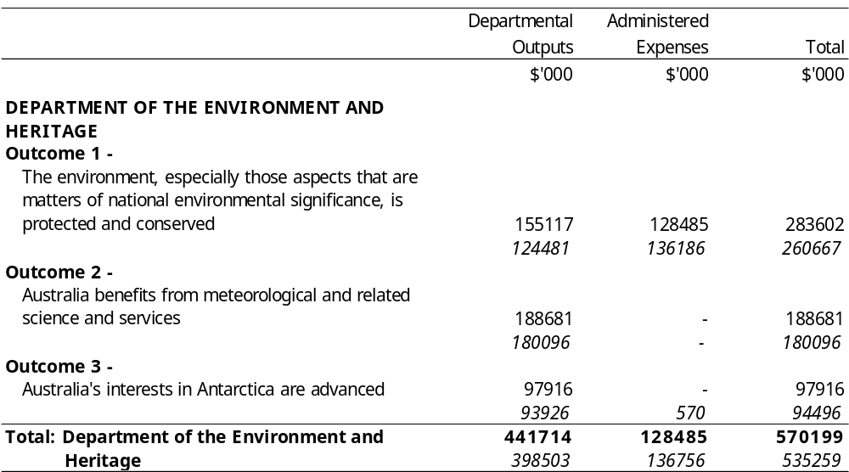
Appropriation Bill (1) 2000-2001
Appropriation (light figures) – 2000-2001
Estimate (italic figures) – 1999-2000
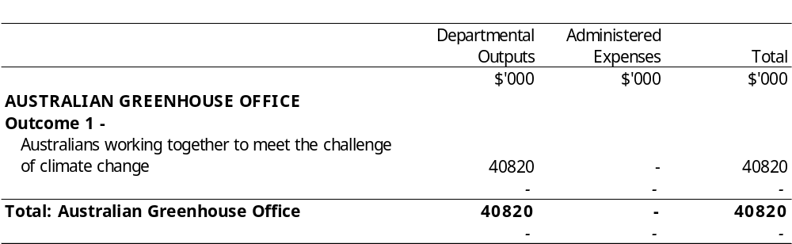
Appropriation Bill (1) 2000-2001
Appropriation (light figures) – 2000-2001
Estimate (italic figures) – 1999-2000
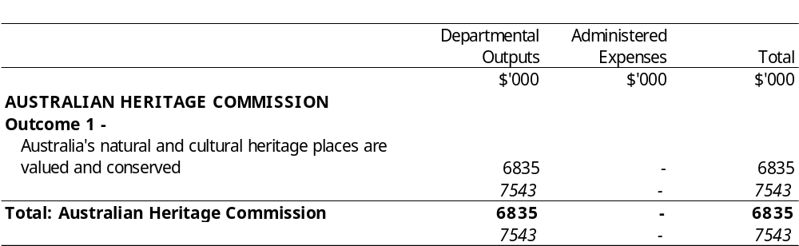
Appropriation Bill (1) 2000-2001
Appropriation (light figures) – 2000-2001
Estimate (italic figures) – 1999-2000
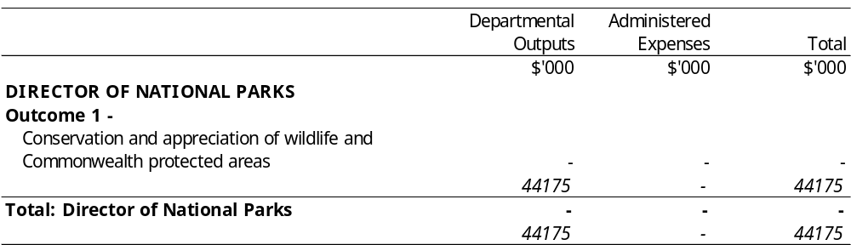
Appropriation Bill (1) 2000-2001
Appropriation (light figures) – 2000-2001
Estimate (italic figures) – 1999-2000
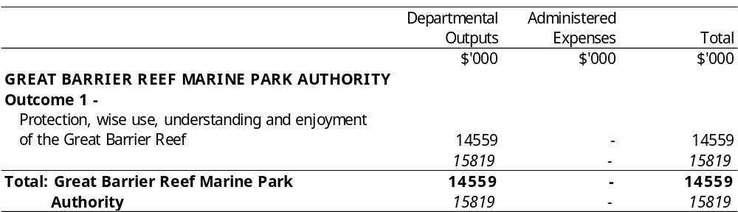
Appropriation Bill (1) 2000-2001
Summary
Appropriation (light figures) – 2000-2001
Estimate (italic figures) – 1999-2000
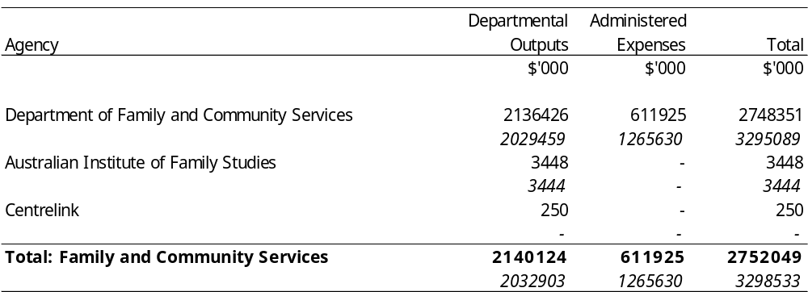
Appropriation Bill (1) 2000-2001
Appropriation (light figures) – 2000-2001
Estimate (italic figures) – 1999-2000
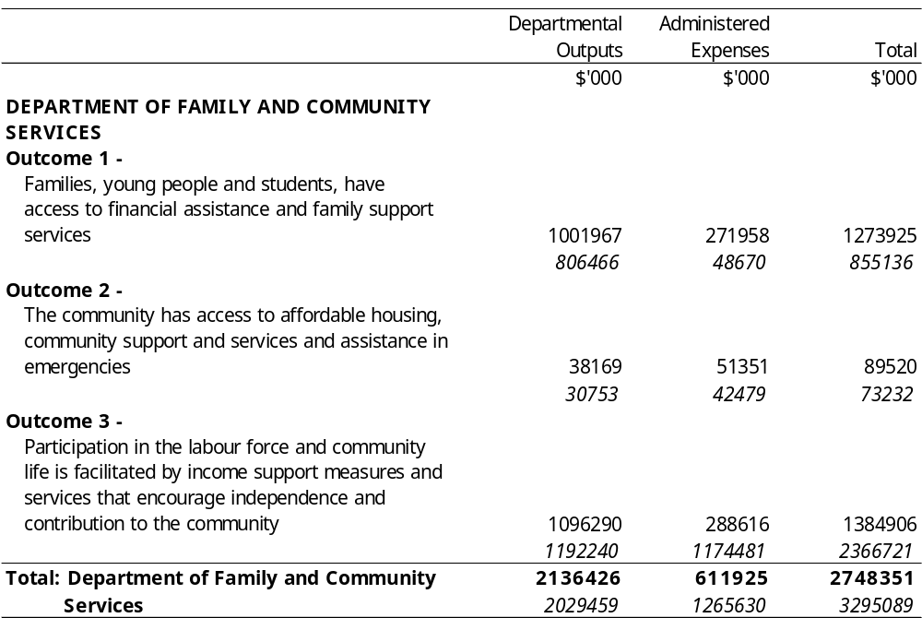
Appropriation Bill (1) 2000-2001
Appropriation (light figures) – 2000-2001
Estimate (italic figures) – 1999-2000
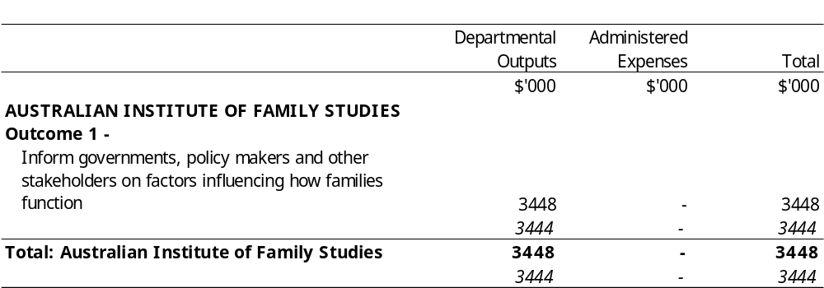
Appropriation Bill (1) 2000-2001
Appropriation (light figures) – 2000-2001
Estimate (italic figures) – 1999-2000
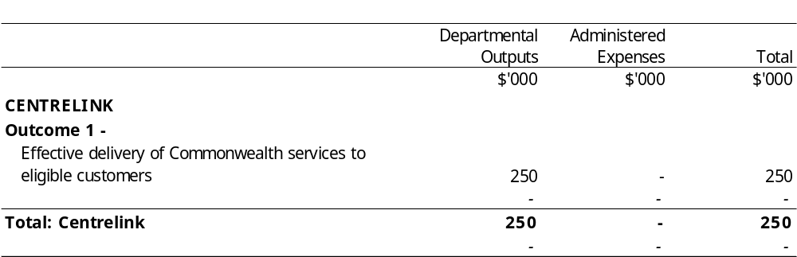
Appropriation Bill (1) 2000-2001
Summary
Appropriation (light figures) – 2000-2001
Estimate (italic figures) – 1999-2000
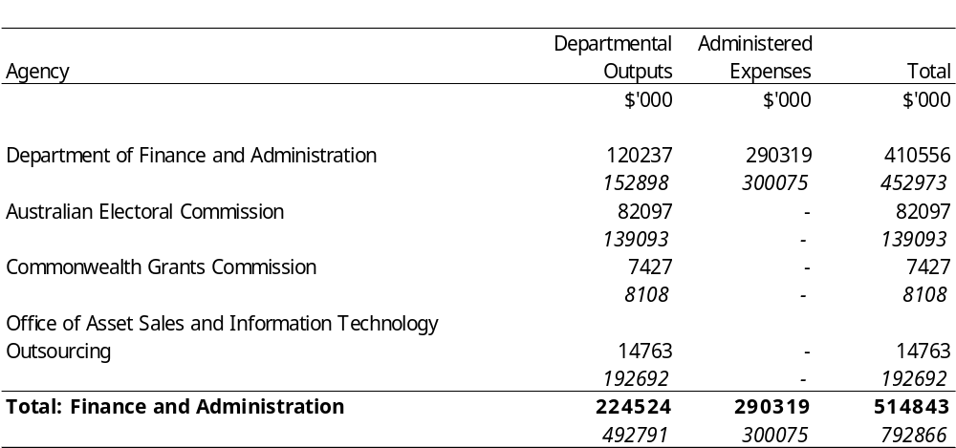
Appropriation Bill (1) 2000-2001
Appropriation (light figures) – 2000-2001
Estimate (italic figures) – 1999-2000
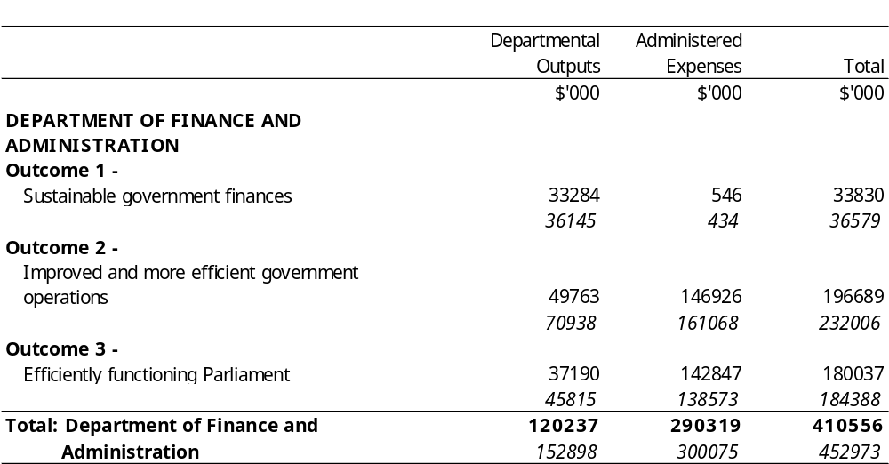
Appropriation Bill (1) 2000-2001
Appropriation (light figures) – 2000-2001
Estimate (italic figures) – 1999-2000
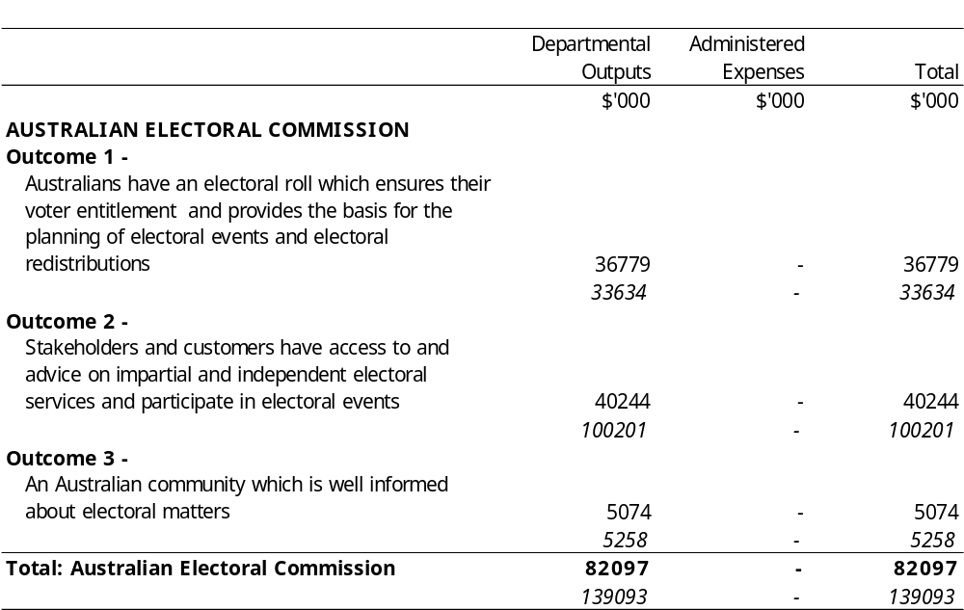
Appropriation Bill (1) 2000-2001
Appropriation (light figures) – 2000-2001
Estimate (italic figures) – 1999-2000
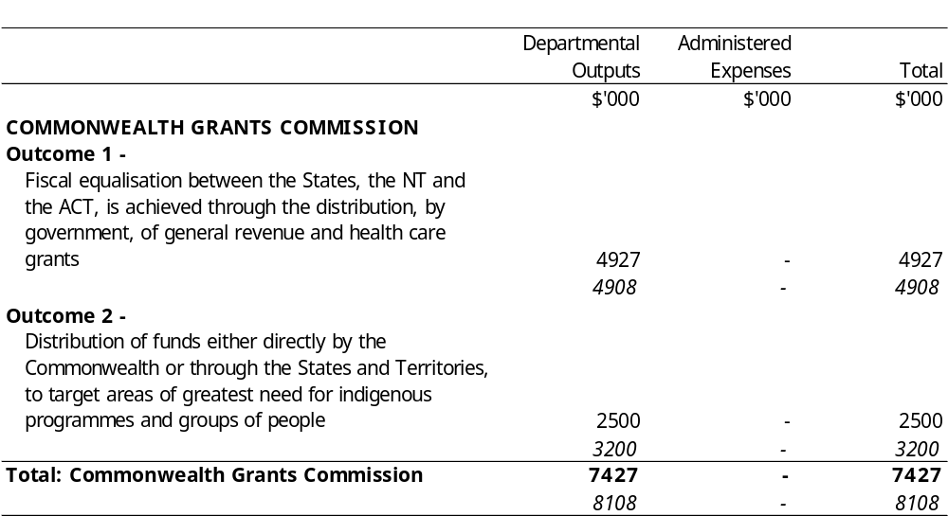
Appropriation Bill (1) 2000-2001
Appropriation (light figures) – 2000-2001
Estimate (italic figures) – 1999-2000
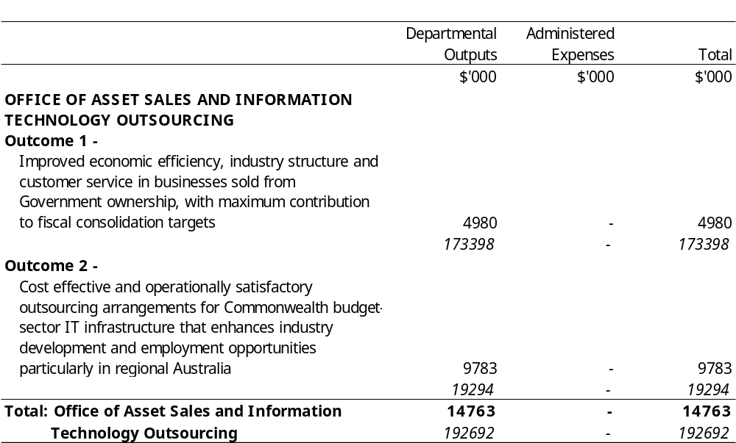
Appropriation Bill (1) 2000-2001
Summary
Appropriation (light figures) – 2000-2001
Estimate (italic figures) – 1999-2000
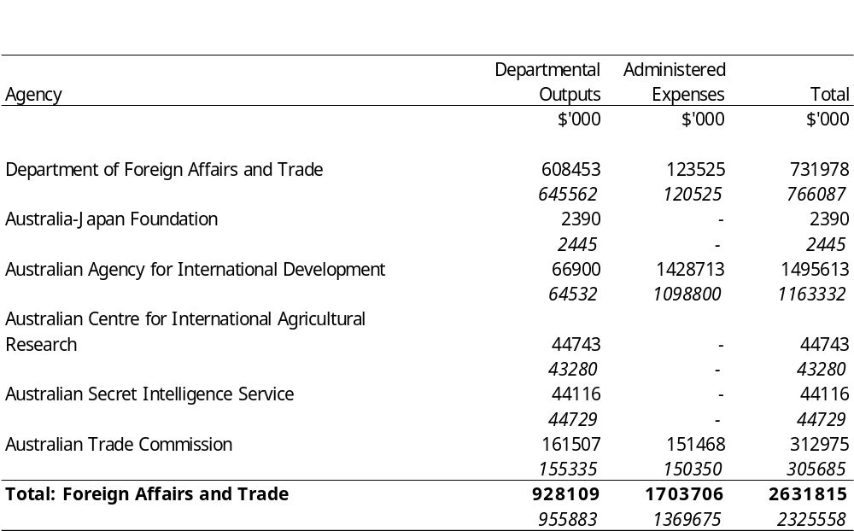
Appropriation Bill (1) 2000-2001
Appropriation (light figures) – 2000-2001
Estimate (italic figures) – 1999-2000
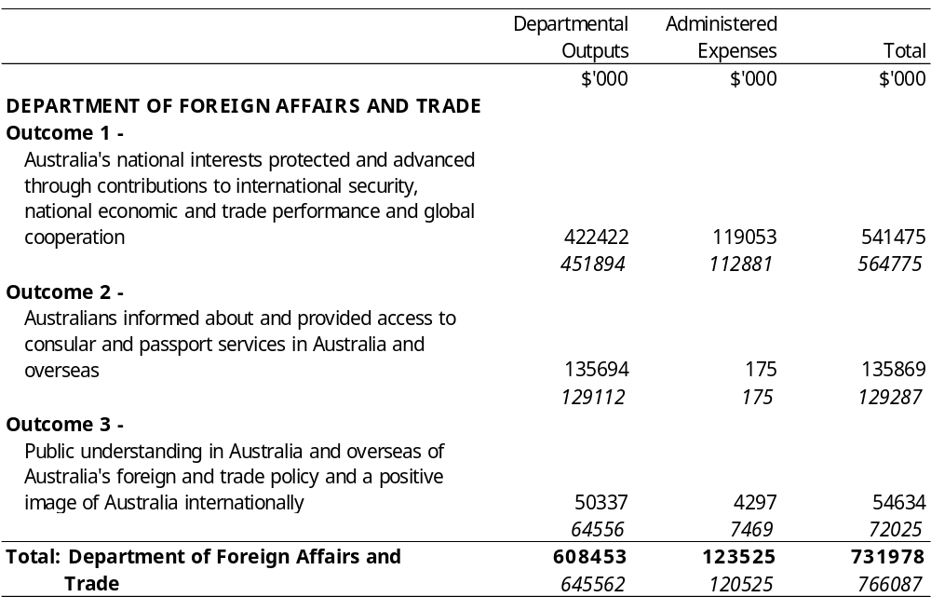
Appropriation Bill (1) 2000-2001
Appropriation (light figures) – 2000-2001
Estimate (italic figures) – 1999-2000
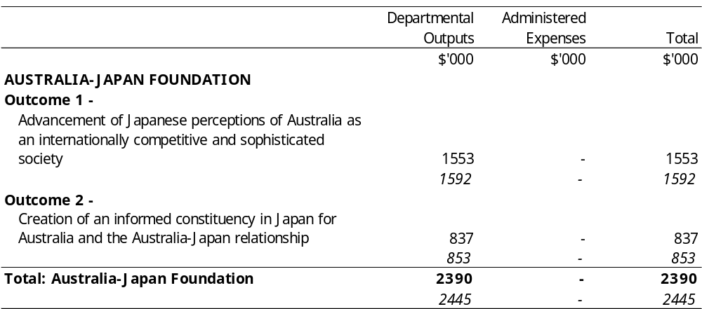
Appropriation Bill (1) 2000-2001
Appropriation (light figures) – 2000-2001
Estimate (italic figures) – 1999-2000
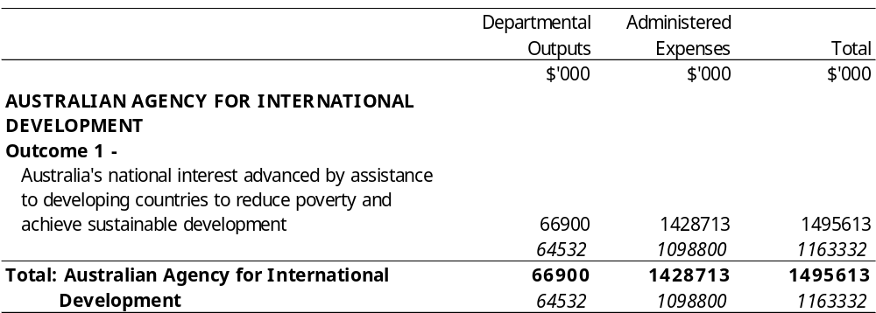
Appropriation Bill (1) 2000-2001
Appropriation (light figures) – 2000-2001
Estimate (italic figures) – 1999-2000
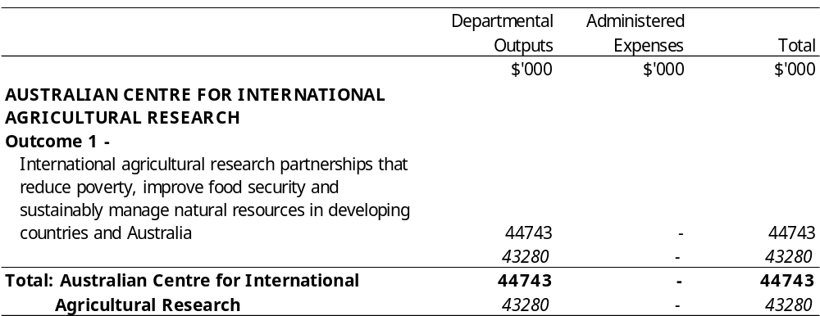
Appropriation Bill (1) 2000-2001
Appropriation (light figures) – 2000-2001
Estimate (italic figures) – 1999-2000
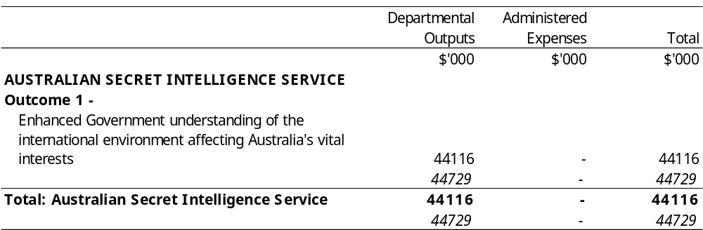
Appropriation Bill (1) 2000-2001
Appropriation (light figures) – 2000-2001
Estimate (italic figures) – 1999-2000
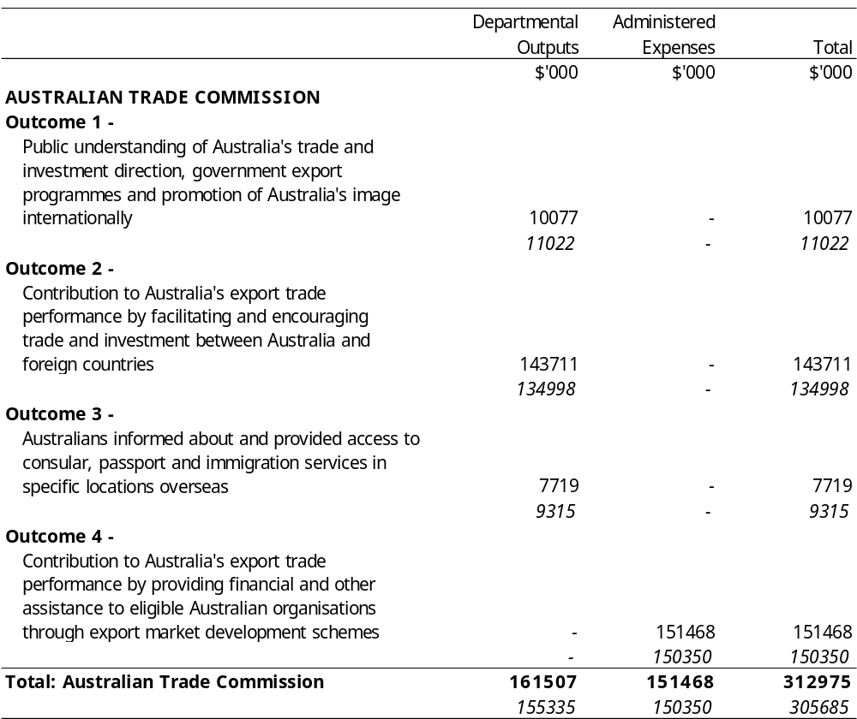
Appropriation Bill (1) 2000-2001
Summary
Appropriation (light figures) – 2000-2001
Estimate (italic figures) – 1999-2000
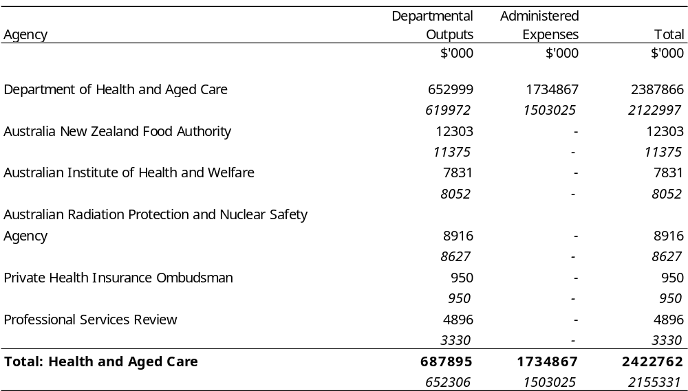
Appropriation Bill (1) 2000-2001
Appropriation (light figures) – 2000-2001
Estimate (italic figures) – 1999-2000
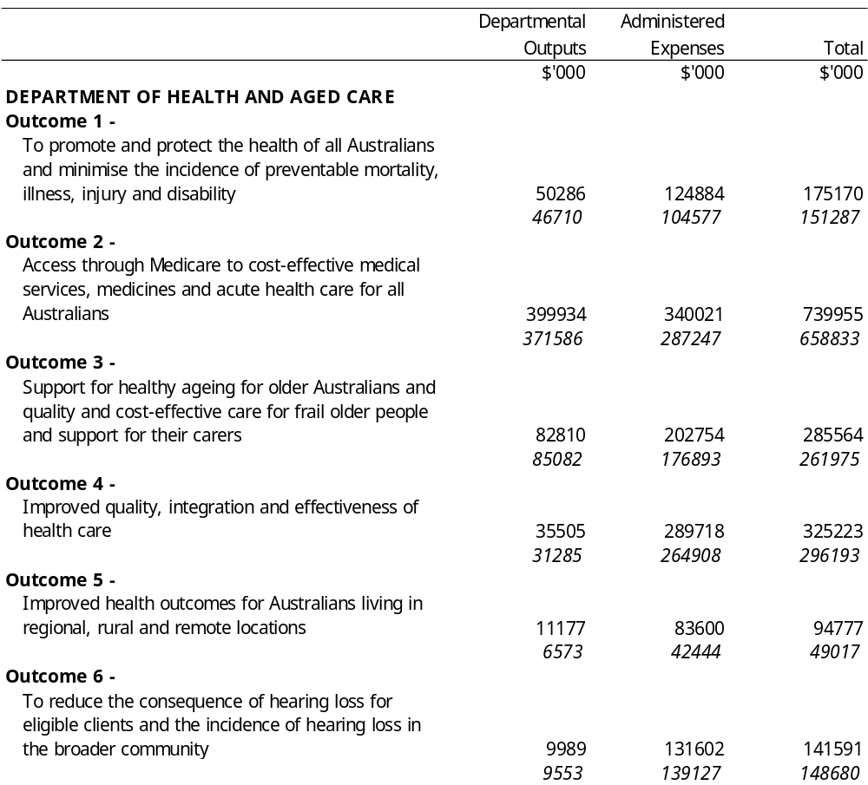

Continued
Appropriation Bill (1) 2000-2001
Appropriation (light figures) – 2000-2001
Estimate (italic figures) – 1999-2000
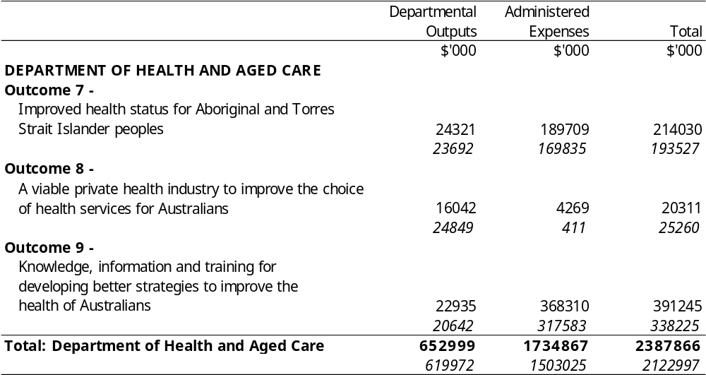
Appropriation Bill (1) 2000-2001
Appropriation (light figures) – 2000-2001
Estimate (italic figures) – 1999-2000
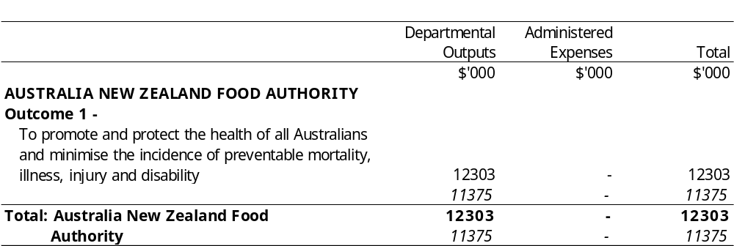
Appropriation Bill (1) 2000-2001
Appropriation (light figures) – 2000-2001
Estimate (italic figures) – 1999-2000
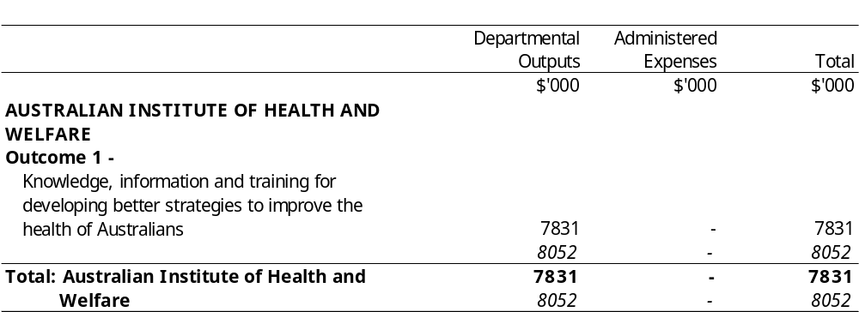
Appropriation Bill (1) 2000-2001
Appropriation (light figures) – 2000-2001
Estimate (italic figures) – 1999-2000
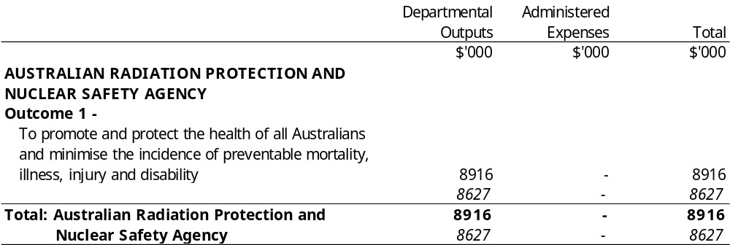
Appropriation Bill (1) 2000-2001
Appropriation (light figures) – 2000-2001
Estimate (italic figures) – 1999-2000
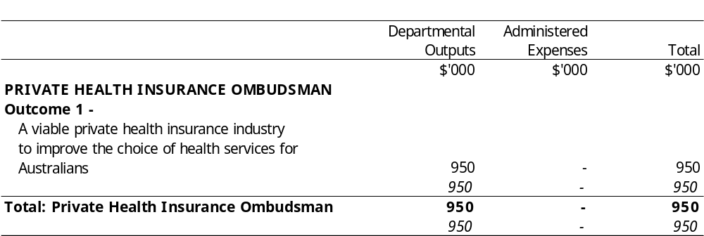
Appropriation Bill (1) 2000-2001
Appropriation (light figures) – 2000-2001
Estimate (italic figures) – 1999-2000
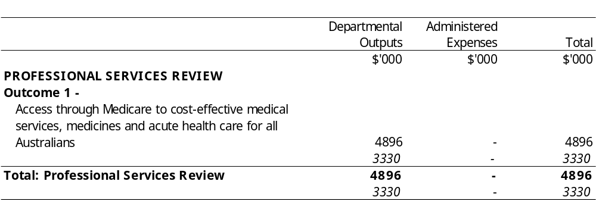
Appropriation Bill (1) 2000-2001
Summary
Appropriation (light figures) – 2000-2001
Estimate (italic figures) – 1999-2000
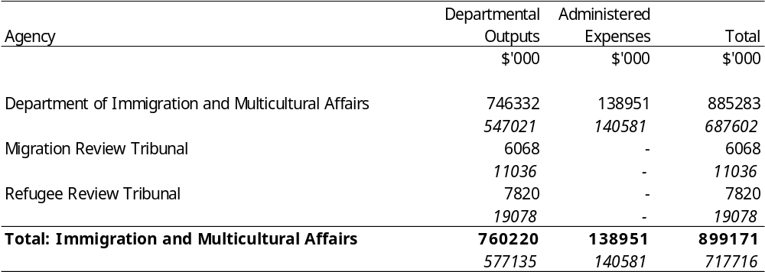
Appropriation Bill (1) 2000-2001
Appropriation (light figures) – 2000-2001
Estimate (italic figures) – 1999-2000
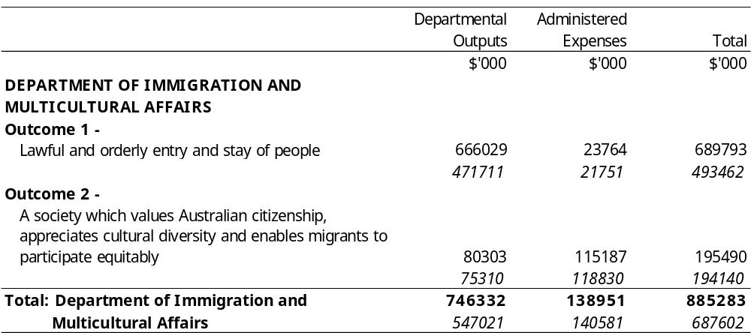
Appropriation Bill (1) 2000-2001
Appropriation (light figures) – 2000-2001
Estimate (italic figures) – 1999-2000
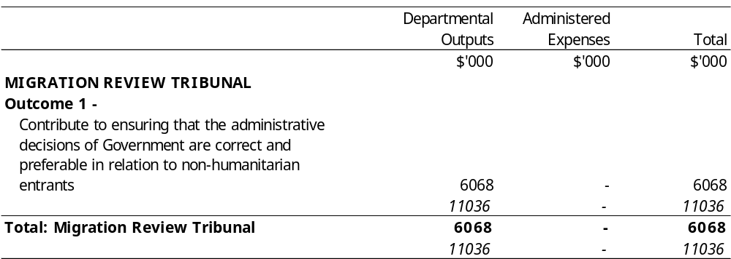
Appropriation Bill (1) 2000-2001
Appropriation (light figures) – 2000-2001
Estimate (italic figures) – 1999-2000
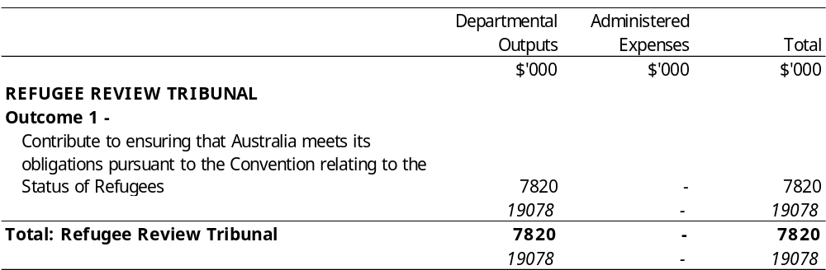
Appropriation Bill (1) 2000-2001
Summary
Appropriation (light figures) – 2000-2001
Estimate (italic figures) – 1999-2000
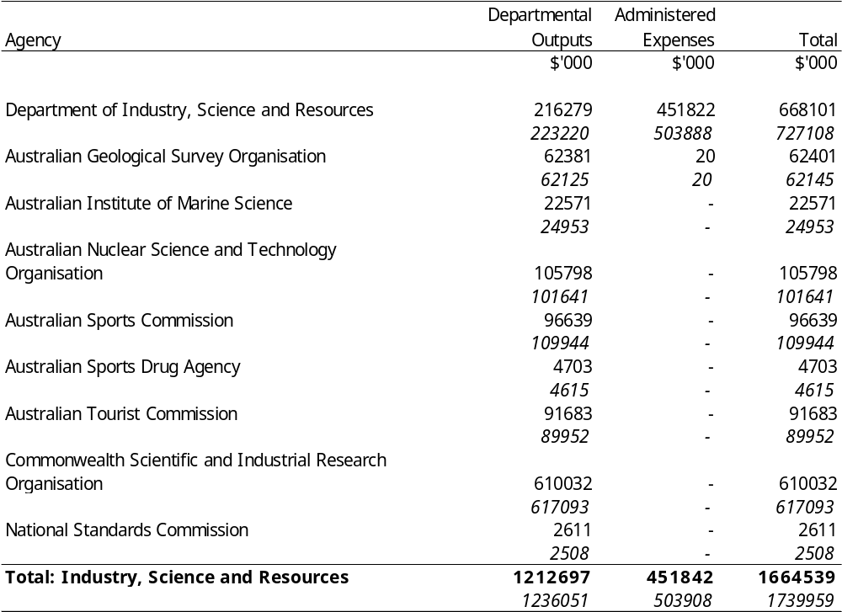
Appropriation Bill (1) 2000-2001
Appropriation (light figures) – 2000-2001
Estimate (italic figures) – 1999-2000
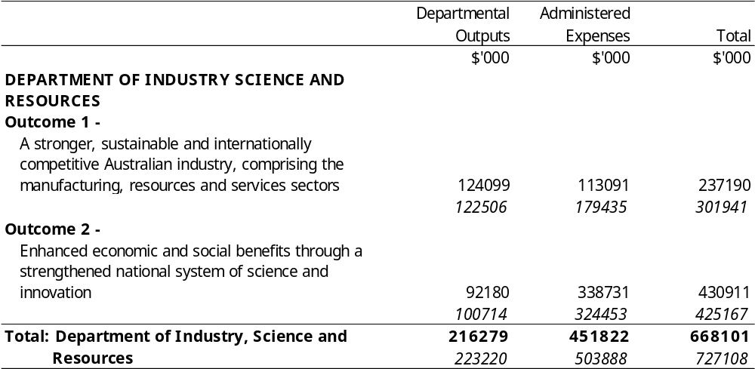
Appropriation Bill (1) 2000-2001
Appropriation (light figures) – 2000-2001
Estimate (italic figures) – 1999-2000
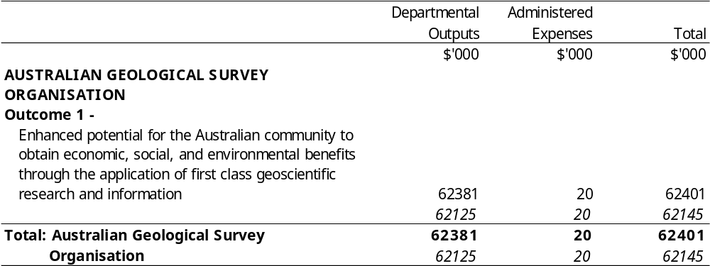
Appropriation Bill (1) 2000-2001
Appropriation (light figures) – 2000-2001
Estimate (italic figures) – 1999-2000
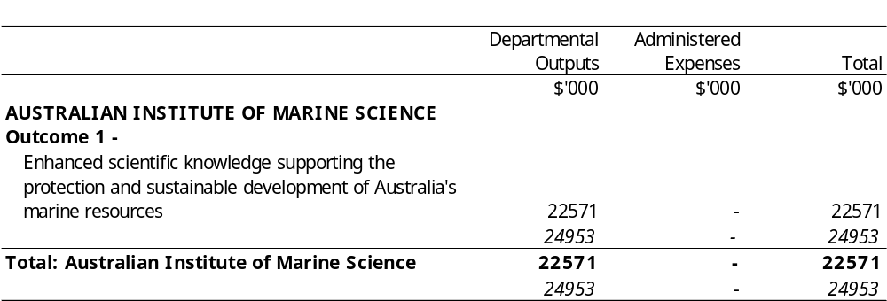
Appropriation Bill (1) 2000-2001
Appropriation (light figures) – 2000-2001
Estimate (italic figures) – 1999-2000
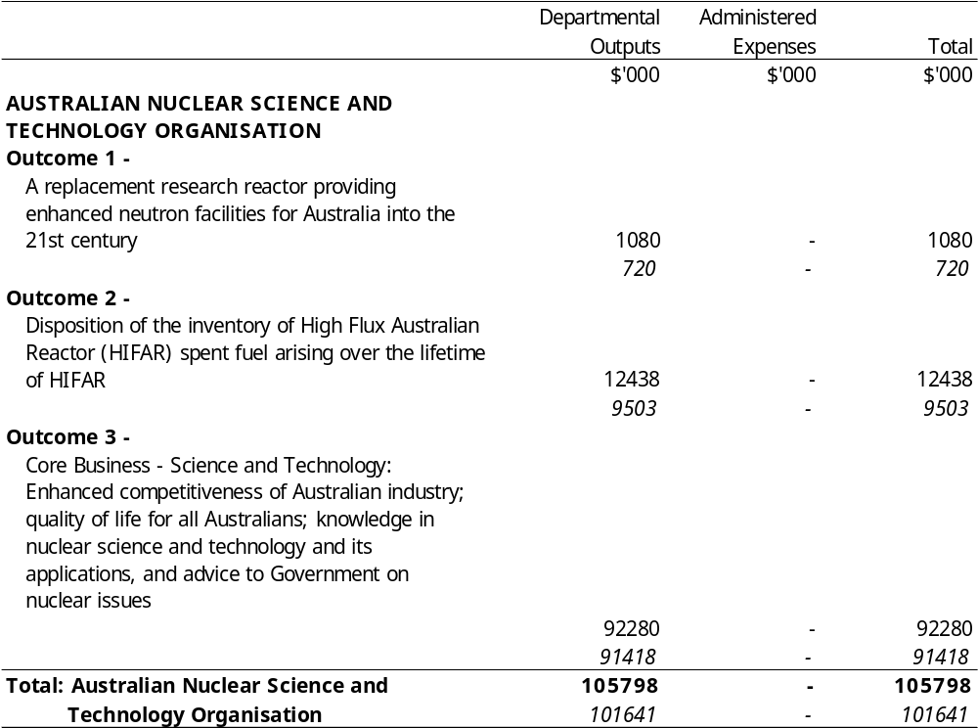
Appropriation Bill (1) 2000-2001
Appropriation (light figures) – 2000-2001
Estimate (italic figures) – 1999-2000
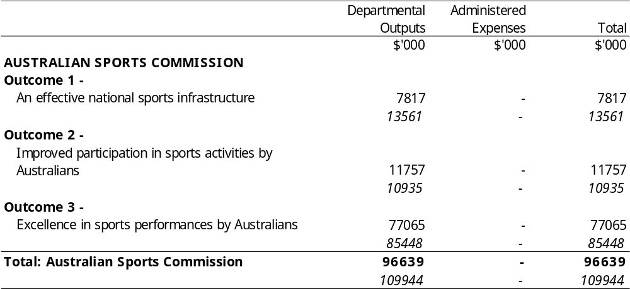
Appropriation Bill (1) 2000-2001
Appropriation (light figures) – 2000-2001
Estimate (italic figures) – 1999-2000
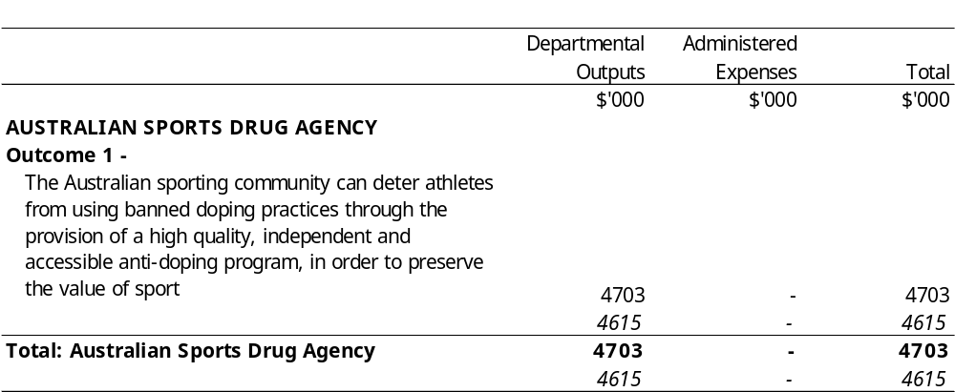
Appropriation Bill (1) 2000-2001
Appropriation (light figures) – 2000-2001
Estimate (italic figures) – 1999-2000
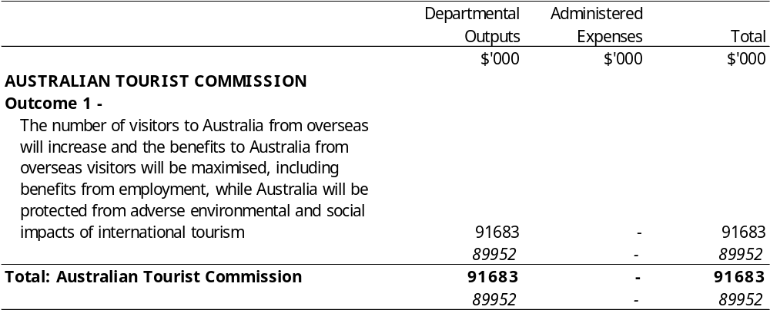
Appropriation Bill (1) 2000-2001
Appropriation (light figures) – 2000-2001
Estimate (italic figures) – 1999-2000
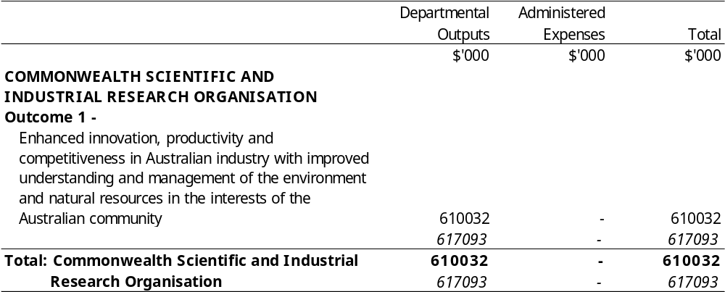
Appropriation Bill (1) 2000-2001
Appropriation (light figures) – 2000-2001
Estimate (italic figures) – 1999-2000
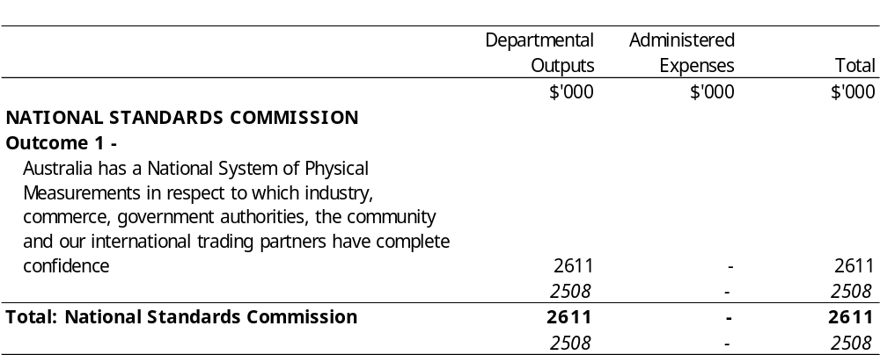
Appropriation Bill (1) 2000-2001
Summary
Appropriation (light figures) – 2000-2001
Estimate (italic figures) – 1999-2000
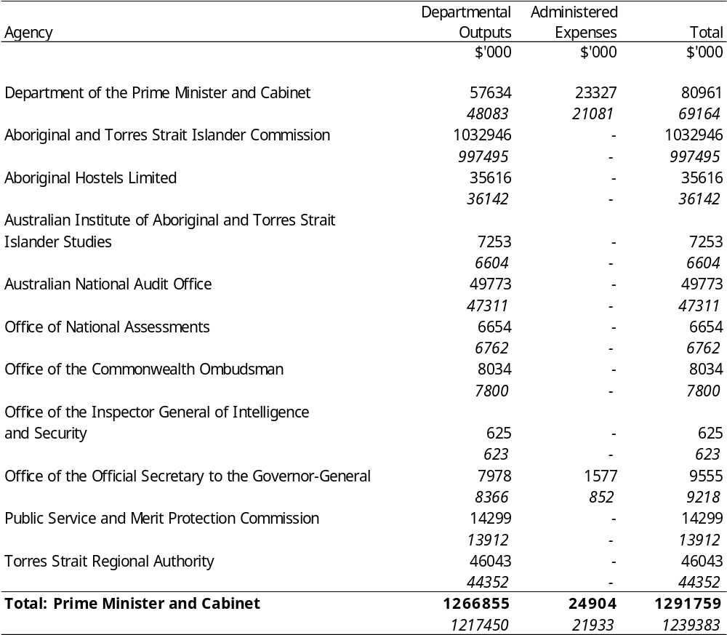
Appropriation Bill (1) 2000-2001
Appropriation (light figures) – 2000-2001
Estimate (italic figures) – 1999-2000
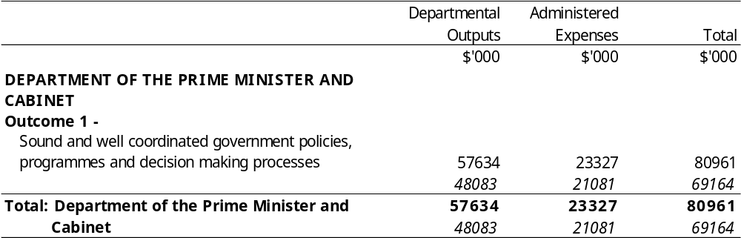
Appropriation Bill (1) 2000-2001
Appropriation (light figures) – 2000-2001
Estimate (italic figures) – 1999-2000
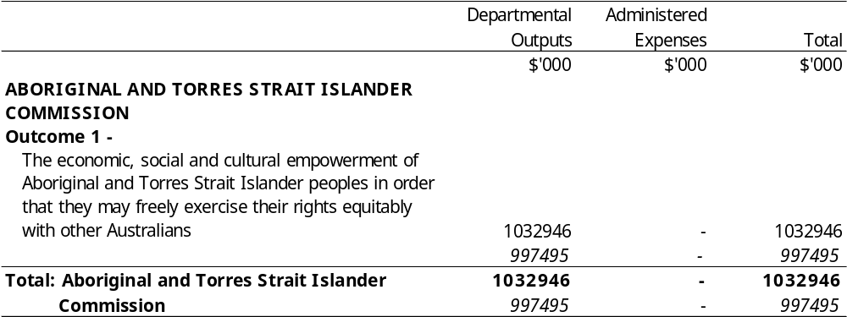
Appropriation Bill (1) 2000-2001
Appropriation (light figures) – 2000-2001
Estimate (italic figures) – 1999-2000
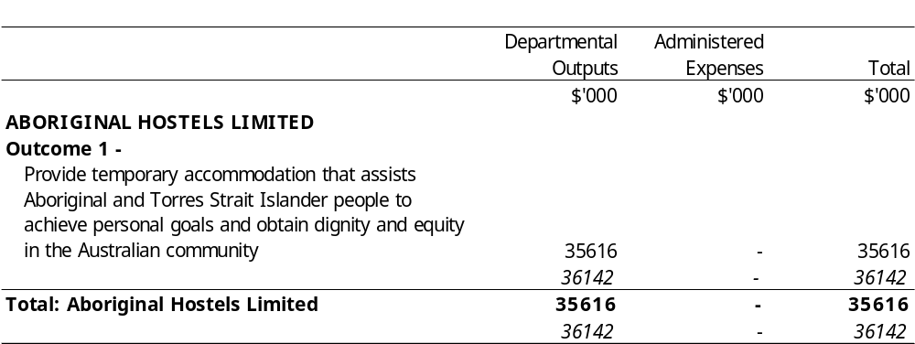
Appropriation Bill (1) 2000-2001
Appropriation (light figures) – 2000-2001
Estimate (italic figures) – 1999-2000
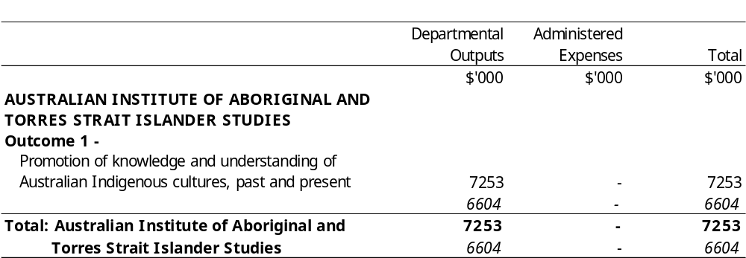
Appropriation Bill (1) 2000-2001
Appropriation (light figures) – 2000-2001
Estimate (italic figures) – 1999-2000
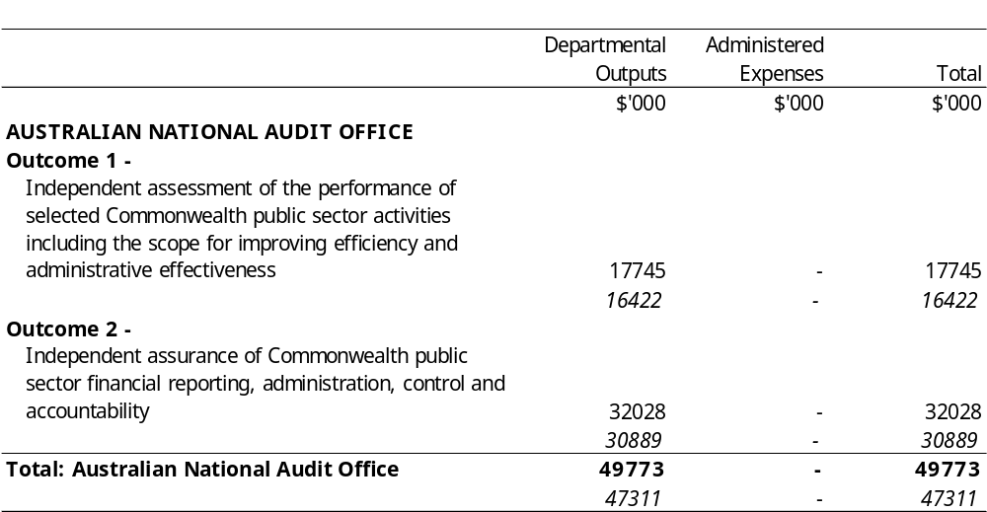
Appropriation Bill (1) 2000-2001
Appropriation (light figures) – 2000-2001
Estimate (italic figures) – 1999-2000
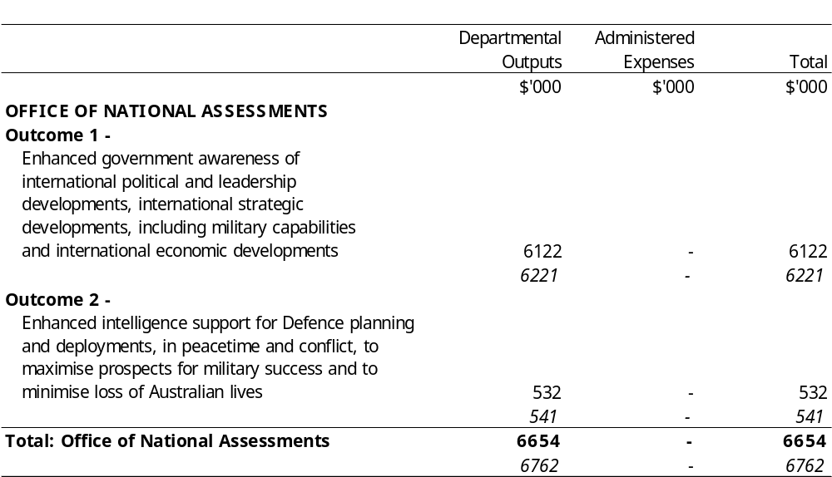
Appropriation Bill (1) 2000-2001
Appropriation (light figures) – 2000-2001
Estimate (italic figures) – 1999-2000
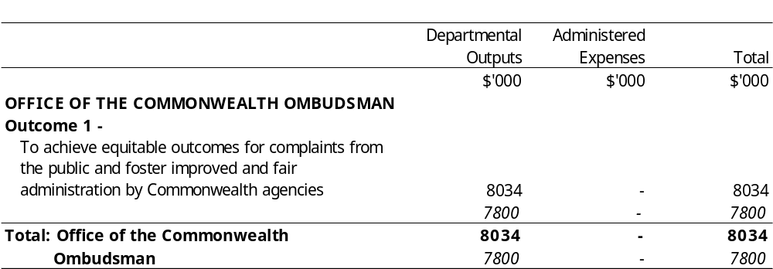
Appropriation Bill (1) 2000-2001
Appropriation (light figures) – 2000-2001
Estimate (italic figures) – 1999-2000
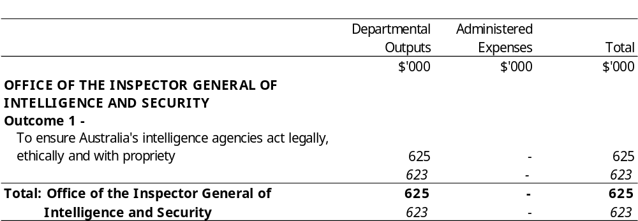
Appropriation Bill (1) 2000-2001
Appropriation (light figures) – 2000-2001
Estimate (italic figures) – 1999-2000
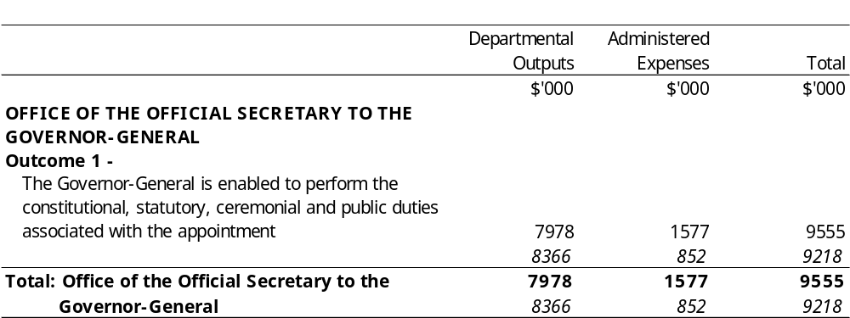
Appropriation Bill (1) 2000-2001
Appropriation (light figures) – 2000-2001
Estimate (italic figures) – 1999-2000
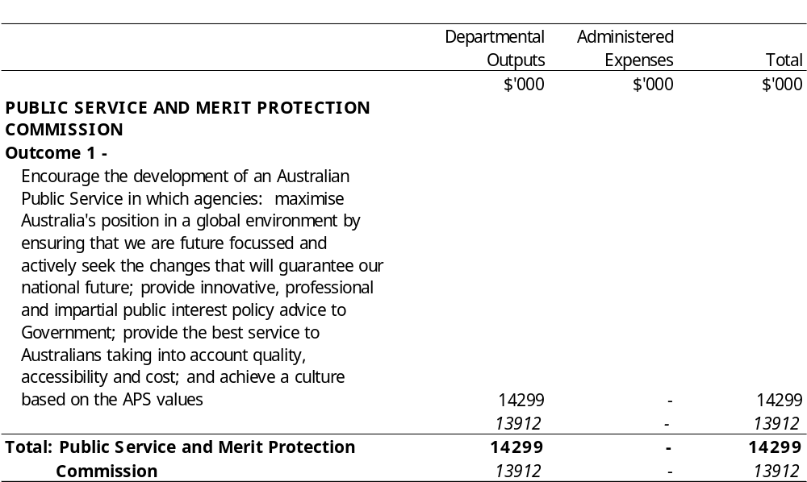
Appropriation Bill (1) 2000-2001
Appropriation (light figures) – 2000-2001
Estimate (italic figures) – 1999-2000
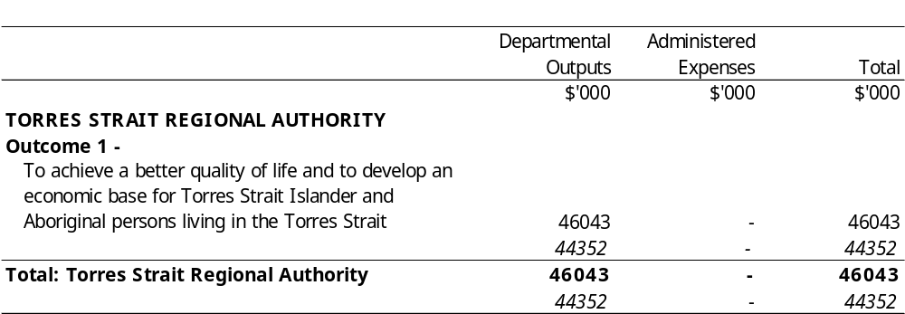
Appropriation Bill (1) 2000-2001
Summary
Appropriation (light figures) – 2000-2001
Estimate (italic figures) – 1999-2000
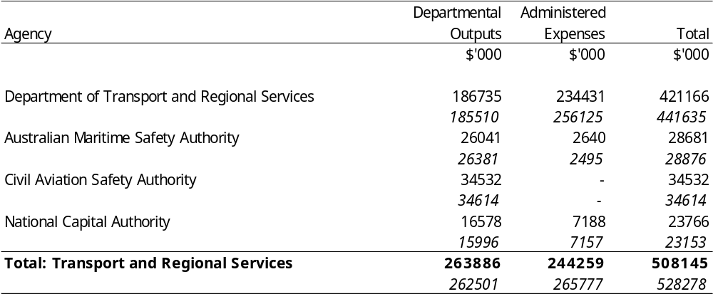
Appropriation Bill (1) 2000-2001
Appropriation (light figures) – 2000-2001
Estimate (italic figures) – 1999-2000
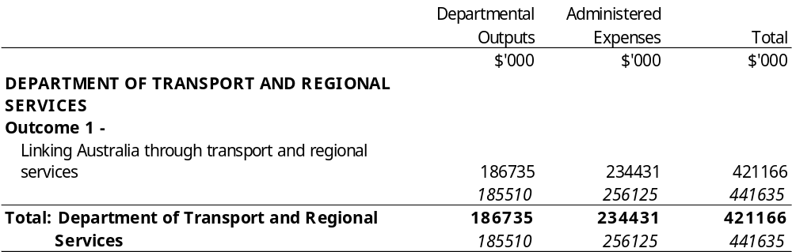
Appropriation Bill (1) 2000-2001
Appropriation (light figures) – 2000-2001
Estimate (italic figures) – 1999-2000
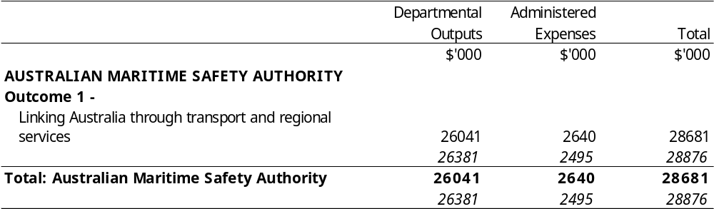
Appropriation Bill (1) 2000-2001
Appropriation (light figures) – 2000-2001
Estimate (italic figures) – 1999-2000
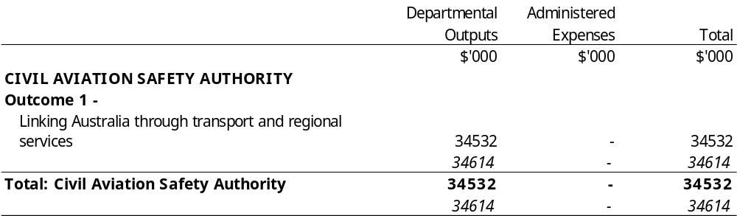
Appropriation Bill (1) 2000-2001
Appropriation (light figures) – 2000-2001
Estimate (italic figures) – 1999-2000
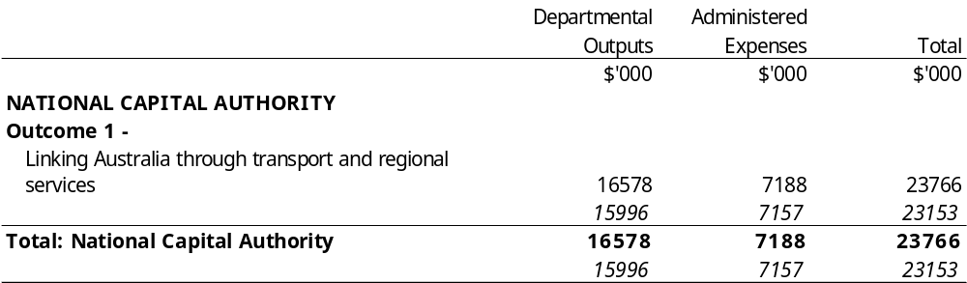
Appropriation Bill (1) 2000-2001
Summary
Appropriation (light figures) – 2000-2001
Estimate (italic figures) – 1999-2000
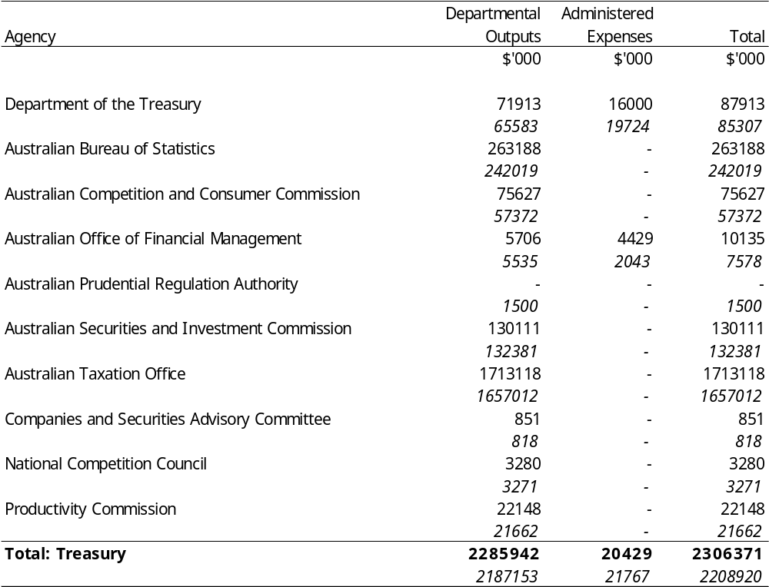
Appropriation Bill (1) 2000-2001
Appropriation (light figures) – 2000-2001
Estimate (italic figures) – 1999-2000
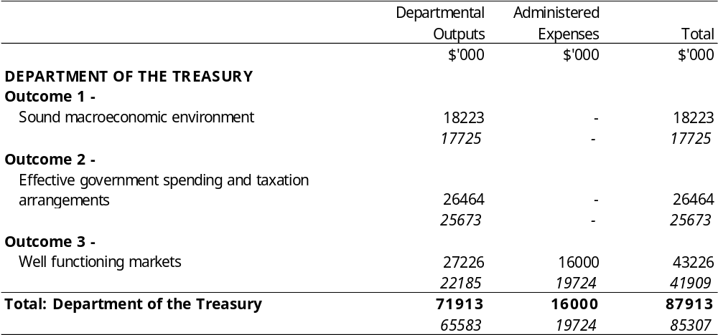
Appropriation Bill (1) 2000-2001
Appropriation (light figures) – 2000-2001
Estimate (italic figures) – 1999-2000
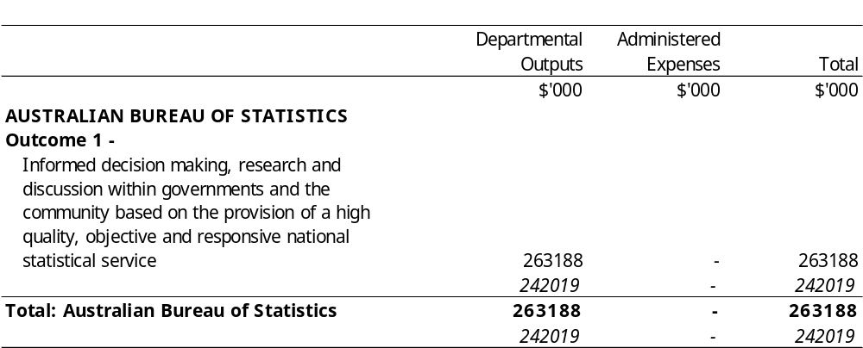
Appropriation Bill (1) 2000-2001
Appropriation (light figures) – 2000-2001
Estimate (italic figures) – 1999-2000
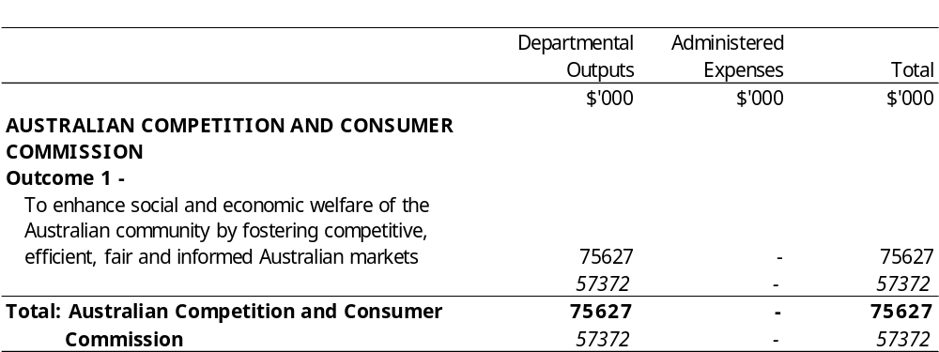
Appropriation Bill (1) 2000-2001
Appropriation (light figures) – 2000-2001
Estimate (italic figures) – 1999-2000
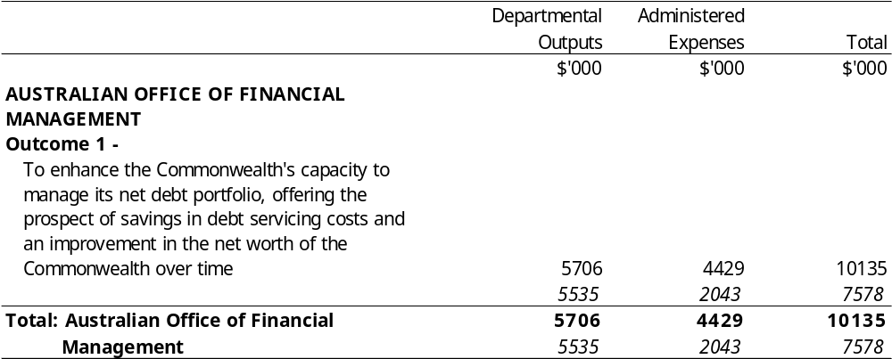
Appropriation Bill (1) 2000-2001
Appropriation (light figures) – 2000-2001
Estimate (italic figures) – 1999-2000
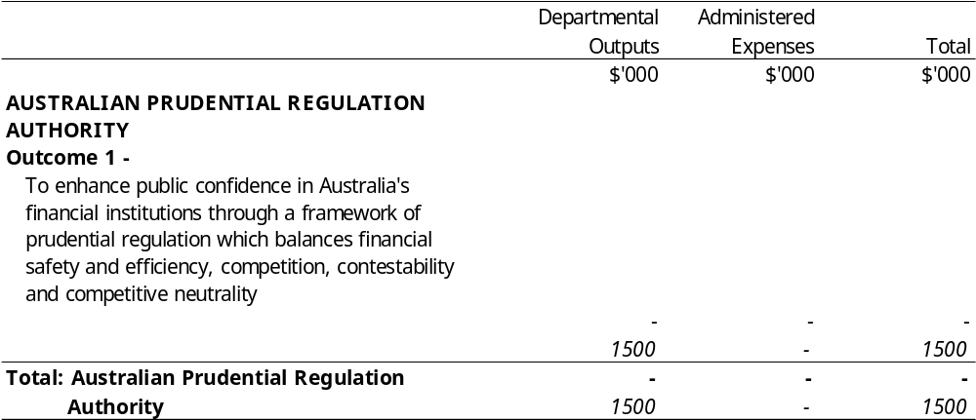
Appropriation Bill (1) 2000-2001
Appropriation (light figures) – 2000-2001
Estimate (italic figures) – 1999-2000
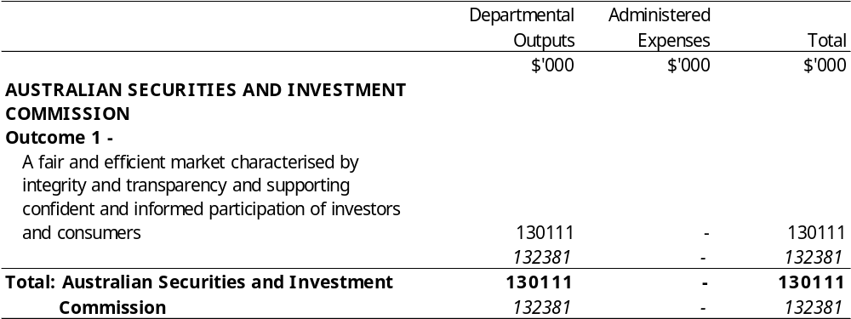
Appropriation Bill (1) 2000-2001
Appropriation (light figures) – 2000-2001
Estimate (italic figures) – 1999-2000
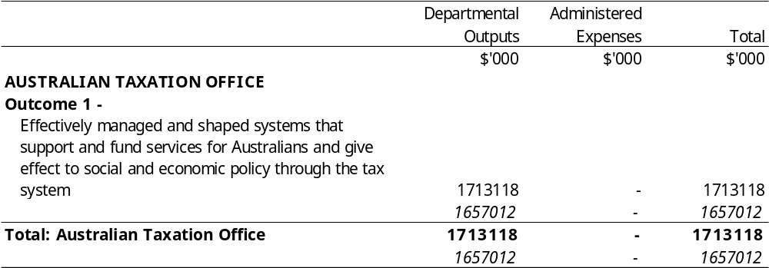
Appropriation Bill (1) 2000-2001
Appropriation (light figures) – 2000-2001
Estimate (italic figures) – 1999-2000
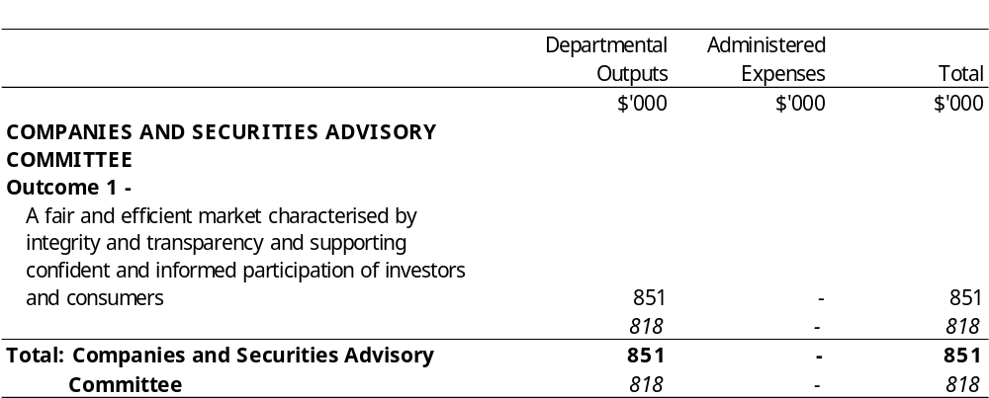
Appropriation Bill (1) 2000-2001
Appropriation (light figures) – 2000-2001
Estimate (italic figures) – 1999-2000
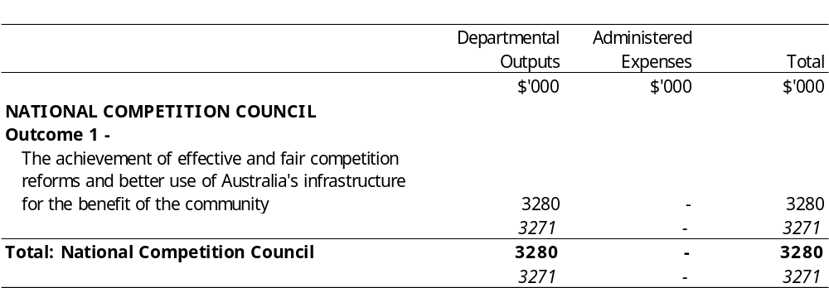
Appropriation Bill (1) 2000-2001
Appropriation (light figures) – 2000-2001
Estimate (italic figures) – 1999-2000
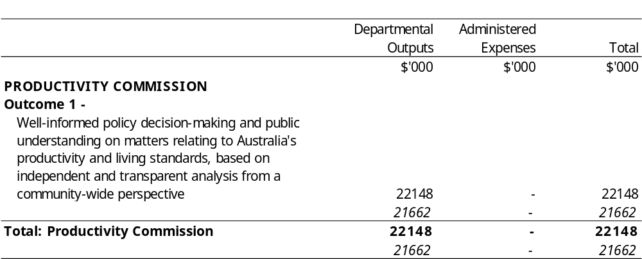
[Minister’s second reading speech made in—
House of Representatives on 9 May 2000
Senate on 22 June 2000]

(71/00)

