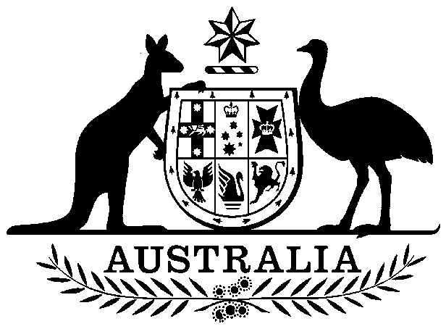

Papua New Guinea Loan Guarantee Act 1973

No. 32 of 1973

An Act to provide for the Giving of a Guarantee by the Commonwealth with respect to a Loan to be raised Overseas by the Administration of Papua New Guinea, and for purposes connected therewith

Contents

1 Short title 2

2 Commencement 2

3 Application of Act 2

4 Interpretation 2

5 Approval of guarantee 3

6 Appropriation 3

7 Moneys to be paid free of taxes etc. 4



Papua New Guinea Loan Guarantee Act 1973

No. 32 of 1973

An Act to provide for the Giving of a Guarantee by the Commonwealth with respect to a Loan to be raised Overseas by the Administration of Papua New Guinea, and for purposes connected therewith

[*Assented to 24 May 1973*]

The Parliament of Australia enacts:

##### 1 Short title

This Act may be cited as the *Papua New Guinea Loan Guarantee Act 1973*.

##### 2 Commencement

This Act shall come into operation on the day on which it receives the Royal Assent.

##### 3 Application of Act

This Act extends to Papua New Guinea.

##### 4 Interpretation

(1) In this Act, unless the contrary intention appears:

***Administration*** means the Administration or Government of Papua New Guinea.

***guarantee*** means the guarantee by the Commonwealth under subsection 5(1), and includes any agreement entered into for the purposes of that guarantee.

***loan agreement*** means the agreement to which the guarantee relates.

(2) For the purposes of this Act, an amount of foreign currency, other than the currency of the United States of America, is, at a specified time, equivalent to Twenty million dollars in the currency of the United States of America if, at that time, that first‑mentioned amount is equivalent to an amount of Australian currency that, at that time, is equivalent to Twenty million dollars in the currency of the United States of America.

(3) For the purposes of subsection (2), the amount in one currency that, at a specified time, is equivalent to an amount in another currency is the amount determined by the Reserve Bank of Australia, having regard to the exchange rates of that bank for Australian Government transactions, to be so equivalent.

##### 5 Approval of guarantee

(1) Subject to this section, if the Administration enters into an agreement under which the Administration is to, or may, borrow, by way of the sale of bonds or otherwise, an amount in a foreign currency that does not exceed:

(a) where the foreign currency is the currency of the United States of America—Twenty million dollars in that currency; or

(b) where the foreign currency is not the currency of the United States of America—an amount in that foreign currency that is, when the agreement is entered into, equivalent to Twenty million dollars in the currency of the United States of America,

the Treasurer, or a person authorized by him, may, on behalf of the Commonwealth, give a guarantee in respect of the payment of all moneys, including interest, payable by the Administration under the agreement and may, for the purposes of the guarantee, enter into an agreement containing such terms as are approved by the Treasurer and the Minister for External Territories.

(2) For the purposes of subsection (1), any form of undertaking of liability to pay any moneys shall be deemed to be a guarantee in respect of the payment of those moneys.

(3) The guarantee, when given, constitutes a valid and binding obligation of the Commonwealth in accordance with its terms.

(4) The power conferred by subsection (1):

(a) is limited to the giving of a guarantee in respect of one agreement only; and

(b) shall not be exercised after the expiration of the period of four months commencing on the date of commencement of this Act.

##### 6 Appropriation

Any payments by the Commonwealth under the guarantee are payable out of the Consolidated Revenue Fund, which is appropriated accordingly.

##### 7 Moneys to be paid free of taxes etc.

A provision of the guarantee or of the loan agreement providing for:

(a) payments to be made without deduction for, or to be free from, taxes, imposts or duties;

(b) documents to be free from taxes or duties; or

(c) payments to be free from restrictions, regulations, controls or moratoria,

has effect as if enacted by this Act and operates notwithstanding anything in any law of the Commonwealth or of a State or Territory, whether passed or made before or after the commencement of this Act.