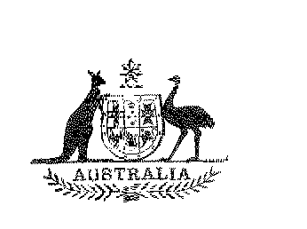
Statutory Rules
1975 No. 225
REGULATION UNDER THE STATES GRANTS (SCHOOLS) ACT 1973-1974.*
I, THE ADMINISTRATOR of the Government of Australia, acting with the advice of the Executive Council, hereby make the following Regulation under the States Grants (Schools) Act 1973-1974.
Dated this twenty-third day of December, 1975.
A. R. CUTLER
Administrator.
By His Excellency’s Command,
J. L. CARRICK
Minister of State for Education.
_______
Amendments of the States Grants (Schools) Regulations†
Regulation 3 of the States Grants (Schools) Regulations is repealed and the following regulations substituted:—
Variation of amounts in Schedule 5 of the Act under sub-section 39 (2) of the Act.
“ 3. (1) The Act has effect as if the amounts specified in columns 3, 4 and 5 of Table 2 in Schedule 5 to the Act opposite to the name of the State of New South Wales were varied to read $2,905,939, $632,147 and $1,135,914, respectively.
“ (2) The Act has effect as if the amounts specified in columns 3 and 5 of Table 2 in Schedule 5 to the Act opposite the name of the State of Western Australia were varied to read $650,870 and $75,130, respectively.
Variation of amounts in Schedule 5 of the Act under sub-section 41 (5) of the Act.
“ 4. The Act has effect as if the amounts specified in column 2 of Table 3 in Schedule 5 to the Act opposite to the names of the States of Victoria, Queensland, Western Australia and Tasmania were varied to read $417,030, $123,770, $139,000 and $46,200, respectively.”.

* Notified in the Australian Government Gazette on 23 December 1975.
† Statutory Rules 1975, No. 171.

