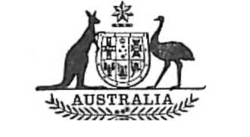
Statutory Rules
1975 No. 35
REGULATIONS UNDER THE MEAT EXPORT CHARGE COLLECTION ACT 1973.*
I, THE GOVERNOR-GENERAL of Australia, acting with the advice of the Executive Council, hereby make the following Regulations under the Meat Export Charge Collection Act 1973.
Dated this twentieth day of March, 1975.
JOHN R. KERR
Governor-General.
By His Excellency’s Command,
K. S. WRIEDT
Minister of State for Agriculture.
_________
MEAT EXPORT CHARGE COLLECTION REGULATIONS
Citation.
1. These Regulations may be cited as the Meat Export Charge Collection Regulations.
Commencement.
2. These Regulations shall be deemed to have come into operation on 27 November 1973.
Definition.
3. In these Regulations, “ the Act ” means the Meat Export Charge Collection Act 1973.
Fraction prescribed under paragraph 9 (2) (b) of the Act.
4. For the purpose of paragraph 9 (2) (b) of the Act, the fraction, in respect of a class of meat specified in regulation 6 of the Meat Export Charge Regulations, is five-eighths.

* Notified in the Australian Government Gazette on 21 March 1975.

