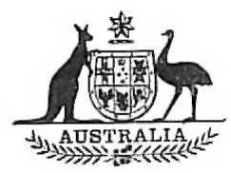
Statutory Rules
1974 No. 60
RULES OF COURT OF THE SUPREME COURT OF THE AUSTRALIAN CAPITAL TERRITORY.*
Pursuant to the Australian Capital Territory Supreme Court Act 1933-1973, IT IS ORDERED that the Rules of the Supreme Court of the Australian Capital Territory† be amended, as follows:—
Repeal of Order 70.
1. Order 70 is repealed.
Repeal of Order 76 rule 18.
2. Order 76 rule 18 is repealed.
Repeal of the Fifth Schedule.
3. The Fifth Schedule is repealed.
Dated this seventeenth day of April, 1974.
R. W. FOX
R. A. BLACKBURN
XAVIER CONNOR
Judges of the Supreme Court of the
Australian Capital Territory.
Z. HARTSTEIN
Registrar.

* Notified in the Australian Government Gazette on 18 April 1974.
† Statutory Rules 1937, No. 85, as amended by Statutory Rules 1938, No. 99; 1939, Nos. 48 and 61; 1950, No. 22; 1956, No. 135; 1958, No. 64; 1962, Nos. 47 and 76; 1966, No. 132; 1967, No. 68; 1968, No. 13; 1969, Nos. 57, 66, 221 and 222; 1972, No. 189; 1973, Nos. 95 and 149; and 1974, No. 25.

