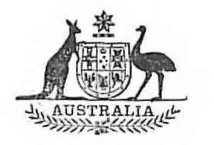
Statutory Rules
1973 No. 35
REGULATION UNDER THE SEAMEN’S WAR PENSIONS AND ALLOWANCES ACT 1940-1972.*
I, THE GOVERNOR-GENERAL in and over the Commonwealth of Australia, acting with the advice of the Federal Executive Council, hereby make the following Regulation under the Seamen’s War Pensions and Allowances Act 1940-1972.
Dated this eighth day of February, 1973.
PAUL HASLUCK
Governor-General.
By His Excellency’s Command,
C. K. JONES
Minister of State for Transport.

Amendments of the Seamen’s War Pensions and Allowances Regulations†
Medical treatment for disabilities not due to war service.
Regulation 26a of the Seamen’s War Pensions and Allowances Regulations is amended—
(a) by adding at the end of paragraph (a) of sub-regulation (2.) the word “or”; and
(b) by omitting paragraph (b).

* Notified in the Commonwealth Gazette on 15 February 1973.
† Statutory Rules 1961, No. 105, as amended by Statutory Rules 1961, No. 145; 1963, No. 120; 1964, No. 107; 1965, No. 89; 1966, No. 110; 1967, No. 44; 1968, Nos. 106 and 120; 1969, Nos. 109 and 179; 1970, Nos. 84 and 155; 1972, No. 119; and 1973, No. 27.

