STATUTORY RULES
1967 No.
________
REGULATIONS UNDER THE AIR NAVIGATION ACT 1920-1966. *
I, THE ADMINISTRATOR of the Government of the Commonwealth of Australia, acting with the advice of the Federal Executive Council, hereby make the following Regulations under the Air Navigation Act 1920-1966.
Dated this day of 1967.
Administrator.
By His Excellency’s Command,
Minister of State for Civil Aviation.
________
Amendments of the Air Navigation (Buildings Control) Regulations †
Prohibition of the construction of buildings in specified areas.
1. Regulation 3 of the Air Navigation (Buildings Control) Regulations is amended by omitting from sub-regulation (2.) the words “Fourth Schedule” and inserting in their stead the words “Fifth Schedule”.
Prohibition of the construction of buildings of more than 25′ in height in specified areas.
2. Regulation 4 of the Air Navigation (Buildings Control) Regulations is amended by omitting from sub-regulation (2.) the words “Fourth Schedule” and inserting in their stead the words “Fifth Schedule”.
Prohibition of the construction of buildings of more than 50′ in height in specified areas.
3. After regulation 4 of the Air Navigation (Buildings Control) Regulations the following regulation is inserted:—
“4a.—(1.) A person shall not, except in accordance with an approval given under these Regulations, construct within an area to which this regulation applies a building or other structure having a greater height above the ground than fifty feet.
Penalty: One thousand dollars or imprisonment for six months.
“(2.) In this regulation, ‘an area to which this regulation applies’ means an area described in the Third Schedule to these Regulations by reference to the plan in the Fifth Schedule to these Regulations bearing the number specified in the description.”.
Prohibition of the construction of buildings of more than 150′ in height in specified areas.
4. Regulation 5 of the Air Navigation (Buildings Control) Regulations is amended—
(a) by omitting from sub-regulation (2.) the words “Third Schedule” and inserting in their stead the words “Fourth Schedule”; and
(b) by omitting from that sub-regulation the words “Fourth Schedule” and inserting in their stead the words “Fifth Schedule”,
Application for approval..
5. Regulation 6 of the Air Navigation (Buildings Control) Regulations is amended by inserting after the figure “4” the figure and the letter “, 4a”.
_________________________________________________________________________________
“Notified in the Commonwealth Gazette on 1967.
† Statutory Rules 1966, No. 6.
21844/66.—Price 10c 10/3.5.1967
Grant or refusal of approval.
6. Regulation 7 of the Air Navigation (Buildings Control) Regulations is amended—
(a) by inserting in sub-regulation (1.) after the figure “4”, the figure and letter “, 4a.”; and
(b) by omitting paragraph (d) of sub-regulation (3.) and inserting in its stead the following paragraph:—
“(d) impose conditions with respect to the marking of the building or other structure additional to the conditions subject to which an approval was given,”.
Removal or marking of hazards to air navigation.
7. Regulation 9 of the Air Navigation (Buildings Control) Regulations is amended—
(a) by omitting from paragraph (a) of sub-regulation (1.) the words “situated within that area” and inserting in their stead the words “named in the description of that area”;
(b) by omitting from paragraph (b) of that sub-regulation the words “situated within that area; or” and inserting in their stead the words “named in the description of that area;”;
(c) by inserting after paragraph (b) of that sub-regulation the following paragraph:—
“(ba) there is, in an area to which regulation 4a of these Regulations applies, a building, other structure or object having a greater height above the ground than fifty feet that constitutes or may constitute an obstruction, hazard or potential hazard to aircraft flying in the vicinity of the aerodrome named in the description of that area; or”; and
(d) by omitting from paragraph (e) of that sub-regulation the words “situated within that area” and inserting in their stead the words “named in the description of that area”.
The Schedules.
8. The Schedules to the Air Navigation (Buildings Control) Regulations are repealed and the Schedules set out in the Schedule to these Regulations are inserted in their stead.
Compensation.
9.—(1.) In this regulation—
“interest”, in relation to land, means—
(a) a legal or equitable estate or interest in the land; or
(b) a right, power or privilege over, or in connexion with, the land;
“the prescribed date” means the twentieth day of January, 1966, being the date of commencement of the Air Navigation (Buildings Control) Regulations.
(2.) This regulation applies to land comprised in an area of land delineated by cross hachuring on a plan in the Fifth Schedule to the Air Navigation (Buildings Control) Regulations amended by these Regulations.
(3.) Where the value that any land to which this regulation applies had immediately before the prescribed date was diminished by reason of the restrictions that were, on and from the prescribed date, imposed on the construction of buildings or other structures on the land by the Air Navigation (Buildings Control) Regulations, the Commonwealth is, subject to the succeeding provisions of this regulation, liable to pay an amount equal to the amount by which the value of the land was so diminished as compensation in respect of that diminution in value.
(4.) Where compensation is payable by the Commonwealth in respect of the diminution in the value of land to which this regulation applies, a person who, on the prescribed date, was the owner of an interest in that land is entitled to be paid by the Commonwealth—
(a) if he is the only person who, on that date, was the owner of an interest in that land—the whole of the compensation so payable; or
(b) in any other case—such proportion of the compensation payable as is reasonable having regard to the other interests in that land.
(5.) Compensation is not payable under this regulation in respect of any particular land to which this regulation applies unless the owner of an interest in that land at the prescribed date furnishes to the Director-General in writing, not later than six months after an owner of such an interest is notified in writing by the Director-General of the making of this regulation, an application for compensation containing particulars of—
(a) the interest in that land that he claims to have had at the prescribed date;
(b) the amount claimed by him to be the amount of compensation payable by the Commonwealth in respect of that land;
(c) the name and address of any of or person known to him to have had, at the prescribed date, an interest in that land and the nature of that interest; and
(d) the amount claimed by him in respect of his interest in that land.
(6.) In determining the amount of compensation payable by the Commonwealth in respect of land to which this regulation applies—
(a) it shall be taken that approval will not be granted under the Air Navigation (Buildings Control) Regulations as amended by these Regulations for the construction of any building or structure on the land unless an approval to construct such a building or other structure has been so given or is to be deemed to have been so given under the next succeeding sub-regulation; and
(b) if such an approval has been so given or is to be deemed to have been so given, it shall be taken that the approval was given on the prescribed date.
(7.) Within two months after the first application for compensation under this regulation in respect of any particular land has been furnished to the Director-General, the Minister may, by notice in writing given to the person who made the application, specify a type of building or structure, being a type of building or structure having a specified height above the ground, that may be erected in a specified position on the land and conditions (if any) with respect to the construction of the building or structure or with respect to the marking of the building or structure and, if the Minister does so, approval is, for the purposes of the Air Navigation (Buildings Control) Regulations as amended by these Regulations, to be deemed to have been given under those Regulations as so amended to construct a building or structure of that kind and that height above the ground in that position on the land subject to compliance with those conditions.
THE SCHEDULE. Regulation 9.
“THE SCHEDULES.
“FIRST SCHEDULE.
Regulation 3.
Item No. | Area
1 | Each of the areas of land in the vicinity of the aerodrome known as Sydney (Kingsford Smith) Airport in the State of New South Wales delineated by cross hachuring on Plan No. 1 in the Fifth Schedule to these Regulations.
2 | Each of the areas of land in the vicinity of the aerodrome known as Sydney (Kingsford Smith) Airport in the State of New South Wales delineated by cross hachuring on Plan No. 2 in the Fifth Schedule to these Regulations.
3 | Each of the areas of land in the vicinity of the aerodrome known as Bankstown Airport in the State of New South Wales delineated by cross hachuring on Plan No. 7 in the Fifth Schedule to these Regulations.
4 | The area of land in the vicinity of the aerodrome known as Bankstown Airport in the State of New South Wales delineated by cross hachuring on Plan No. 8 in the Fifth Schedule to these Regulations.
5 | The area of land in the vicinity of the aerodrome known as Moorabbin Airport in the State of Victoria delineated by cross hachuring on Plan No. 11 in the Fifth Schedule to these Regulations.
6 | The area of land in the vicinity of the aerodrome known as Moorabbin Airport in the Slate of Victoria delineated by cross hachuring on Plan No. 12 in the Fifth Schedule to these Regulations.
7 | Each of the areas of land in the vicinity of the aerodrome known as Moorabbin Airport in the State of Victoria delineated by cross hachuring on Plan No. 13 in the Fifth Schedule to these Regulations.
8 | The area of land in the vicinity of the aerodrome known as Moorabbin Airport in the State of Victoria delineated by cross hachuring on Plan No. 14 in the Fifth Schedule to these Regulations.
9 | The area of land in the vicinity of the aerodrome known as Adelaide Airport in the State of South Australia delineated by cross hachuring on Plan No. 17 in the Fifth Schedule to these Regulations.
10 | Each of the areas of land in the vicinity of the aerodrome known as Adelaide Airport in the State of South Australia delineated by cross hachuring on Plan No. 18 in the Fifth Schedule to these Regulations.
11 | The area of land in the vicinity of the aerodrome known as Adelaide Airport in the State of South Australia delineated by cross hachuring on Plan No. 20 in the Fifth Schedule to these Regulations.
12 | The area of land in the vicinity of the aerodrome known as Adelaide Airport in the State of South Australia delineated by cross hachuring on Plan No. 21 in the Fifth Schedule to these Regulations.
THE SCHEDULE—continued.
“SECOND SCHEDULE.
Regulation 4.
Item No. | Area
1 | Each of the areas of land in the vicinity of the aerodrome known as Sydney (Kingsford Smith) Airport in the State of New South Wales delineated by oblique hachuring on Plan No. 1 in the Fifth Schedule to these Regulations.,
2 | The area of land in the vicinity of the aerodrome known as Sydney (Kingsford Smith) Airport in the State of New South Wales delineated by oblique hachuring on Plan No. 2 in the Fifth Schedule to these Regulations.
3 | The area of land in the vicinity of, the aerodrome known as Sydney (Kingsford Smith) Airport in the State of New South Wales delineated by oblique hachuring on Plan No. 3 in the Fifth Schedule to these Regulations.
4 | The area of land in the vicinity of the aerodrome known as Sydney (Kingsford Smith) Airport in the State of New South Wales delineated by oblique hachuring on Plan No. 4 in the Fifth Schedule to these Regulations.
5 | Each of the areas of land in the vicinity of the aerodrome known as Bankstown Airport in the State of New South Wales delineated by oblique hachuring on Plan No. 7 in the Fifth Schedule to these Regulations.
6 | The area of land in the vicinity of the aerodrome known as Bankstown Airport in the Slate of New South Wales delineated by oblique hachuring on Plan No. 8 in the Fifth Schedule to these Regulations.
7 | The area of land in the vicinity of the aerodrome known as Moorabbin Airport in the State of Victoria delineated by oblique hachuring on Plan No. 11 in the Fifth Schedule to these Regulations.
8 | The area of land in the vicinity of the aerodrome known as Moorabbin Airport in the State of Victoria delineated by oblique hachuring on Plan No. 12 in the Fifth Schedule to these Regulations.
9 | The area of land in the vicinity of the aerodrome known as Moorabbin Airport in the State of Victoria delineated by oblique hachuring on Plan No. 13 in the Fifth Schedule to those Regulations.
10 | Each of the areas of land in the vicinity of the aerodrome known as Moorabbin Airport in the State of Victoria delineated by oblique hachuring on Plan No. 14 in the Fifth Schedule to these Regulations.
11 | Each of the areas of land in the vicinity of the aerodrome known as Adelaide Airport in the State of South Australia delineated by oblique hachuring on Plan No. 17 in the Fifth Schedule to these Regulations.
12 | The area of land in the vicinity of the aerodrome known as Adelaide Airport in the State of South Australia delineated by oblique hachuring on Plan No. 18 in the Fifth Schedule to these Regulations.
13 | The area of land in the vicinity of the aerodrome known as Adelaide Airport in the State of South Australia delineated by oblique hachuring on Plan No. 19 in the Fifth Schedule to these Regulations.
14 | The area of land in the vicinity of the aerodrome known as Adelaide Airport in the State of South Australia delineated by oblique hachuring on Plan No. 20 in the Fifth Schedule to these Regulations.
15 | The area of land in the vicinity of the aerodrome known as Adelaide Airport in the State of South Australia delineated by oblique hachuring on Plan No. 21 in the Fifth Schedule to these Regulations.
THE SCHEDULE—continued.
“THIRD SCHEDULE.
Regulation 4a.
Item No. | Area
1 | The area of land in the vicinity of the aerodrome known as Sydney (Kingsford Smith) Airport in the State of New South Wales delineated by vertical hachuring on Plan No. 5 in the Fifth Schedule to these Regulations, other than the areas of land delineated by oblique hachuring on Plans Nos. 3 and 4 in that Schedule.
2 | The area of land in the vicinity of the aerodrome known as Sydney (Kingsford Smith) Airport in the State of New South Wales delineated by vertical hachuring on Plan No, 6 in the Fifth Schedule to these Regulations.
3 | The area of land in the vicinity of the aerodrome known as Bankstown Airport in the State of New South Wales delineated by vertical hachuring on Plan No. 9 in the Fifth Schedule to these Regulations.
4 | The area of land in the vicinity of the aerodrome known as Bankstown Airport in the State or New South Wales delineated by vertical hachuring on Plan No. 10 in the Fifth Schedule to these Regulations.
5 | The area of land in the vicinity of the aerodrome known as Moorabbin Airport in the State of Victoria delineated by vertical hachuring on Plan No. 15 in the Fifth Schedule to these Regulations.
6 | The area of land in the vicinity of the aerodrome known as Moorabbin Airport in the State of Victoria delineated by vertical hachuring on Plan No. 16 in the Fifth Schedule to these Regulations.
7 | The area of land in the vicinity of the aerodrome known as Adelaide Airport in the State of South Australia delineated by vertical hachuring on Plan No. 22 in the Fifth Schedule to these Regulations.
THE SCHEDULE—continued,
“FOURTH SCHEDULE.
Regulation 5.
Item No. | Area
1 | Each of the areas of land in the vicinity of the aerodrome known as Sydney (Kingsford Smith) Airport in the State of New South Wales delineated by horizontal hachuring on Plan No. 5 in the Fifth Schedule to these Regulations.
2 | Each of the areas of land in the vicinity of the aerodrome known as Sydney (Kingsford Smith) Airport in the State of New South Wales delineated by horizontal hachuring on Plan No. 6 in the Fifth Schedule to these Regulations.
3 | The area of land in the vicinity of the aerodrome known as Bankstown Airport in the State of New South Wales delineated by horizontal hachuring on Plan No. 9 in the Fifth Schedule to these Regulations.
4 | The area of land in the vicinity of the aerodrome known as Bankstown Airport in the State of New South Wales delineated by horizontal hachuring on Plan No. 10 in the Fifth Schedule to these Regulations.
5 | Each of the areas of land in the vicinity of the aerodrome known as Moorabbin Airport in the State of Victoria delineated by horizontal hachuring on Plan No. 15 in the Fifth Schedule to these Regulations.
6 | The area of land in the vicinity of the aerodrome known as Moorabbin Airport in the State of Victoria delineated by horizontal hachuring on Plan No. 16 in the Fifth Schedule to these Regulations.
7 | Each of the areas of land in the vicinity of the aerodrome known as Adelaide Airport in the State of South Australia delineated by horizontal hachuring on Plan No. 22 in the Fifth Schedule to these Regulations.

FIFTH SCHEDULE
Plan No. I—Sydney (Kingsford Smith) Airport
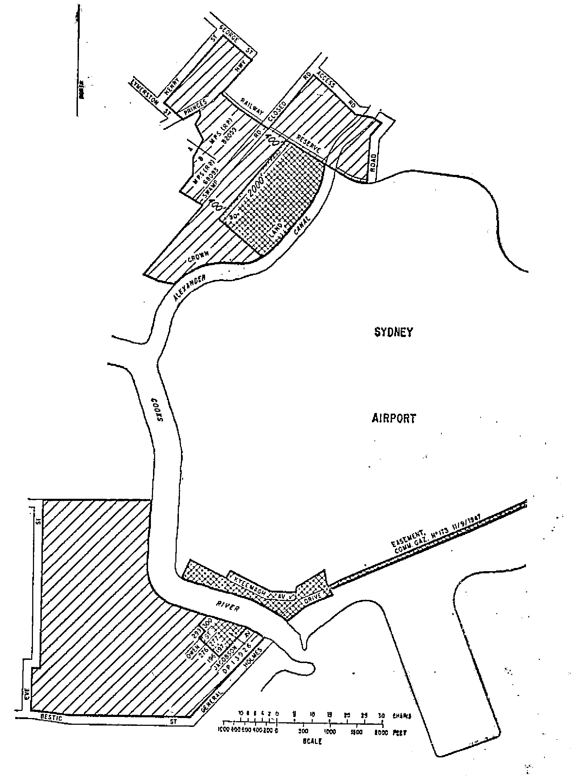
Fifth Schedule—continued
Plan No. 2—Sydney (Kingsford Smith) Airport
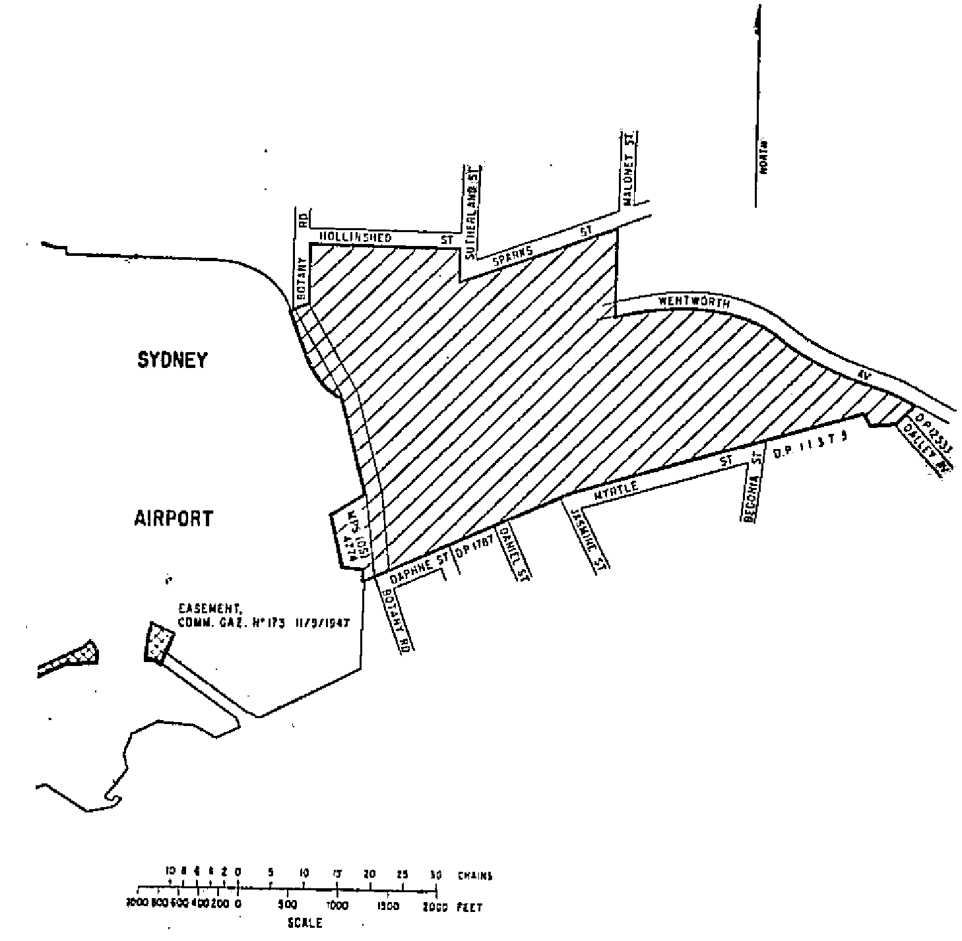
Fifth Schedule—continued
Plan No. 3—Sydney (Kingsford Smith) Airport
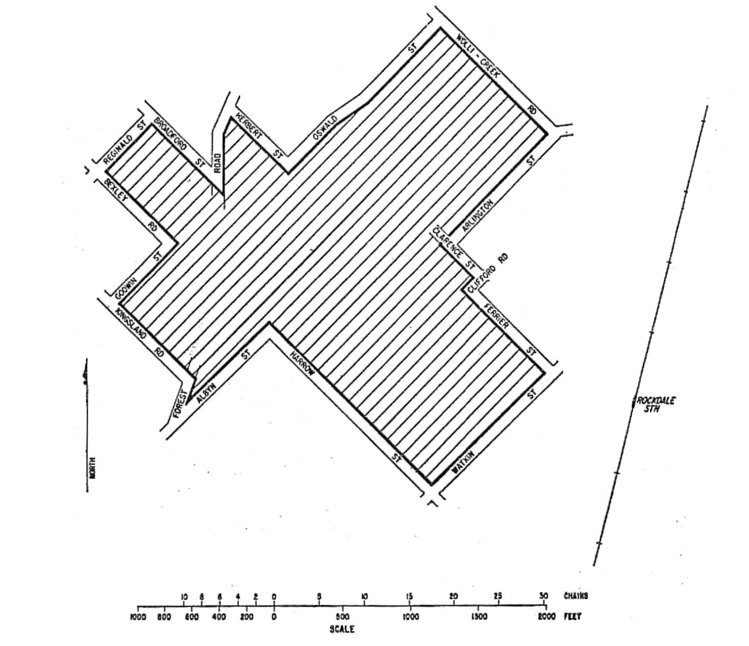
FIFTH Schedule—continued
Plan No. 4—Sydney (Kingsford Smith) Airport
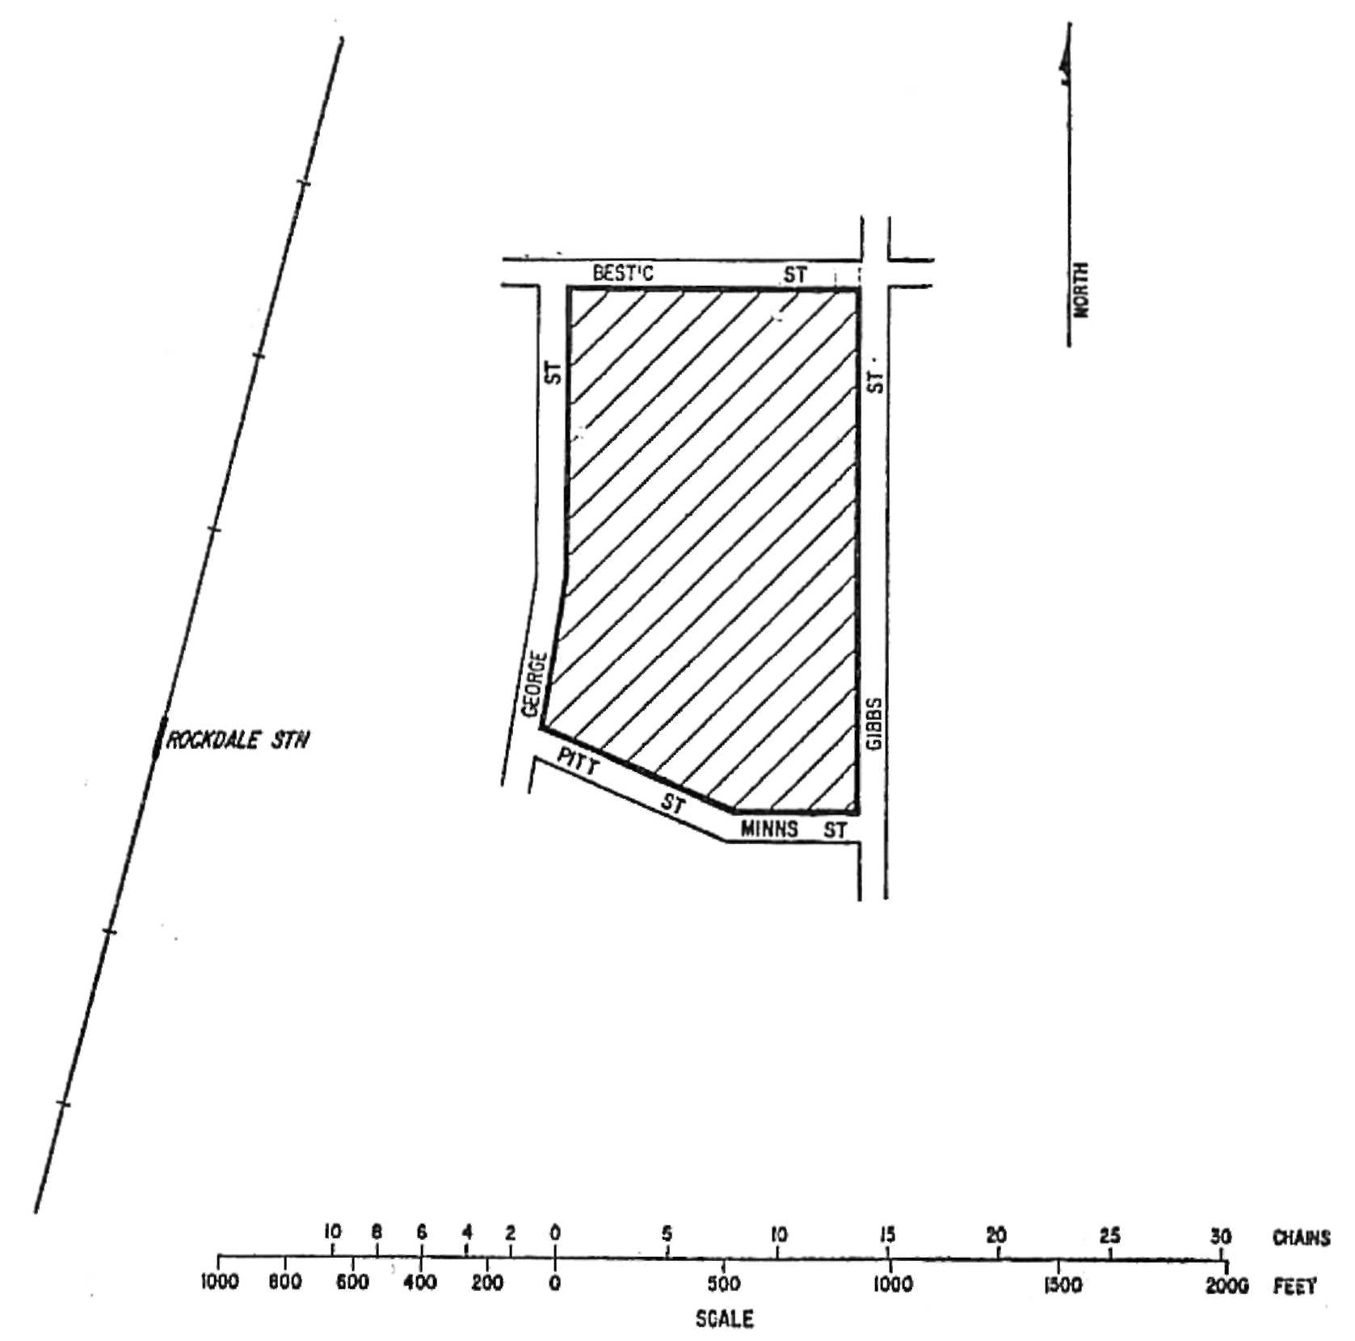
Fifth Schedule—continued
Plan No. 5—Sydney (Kingsford Smith) Airport
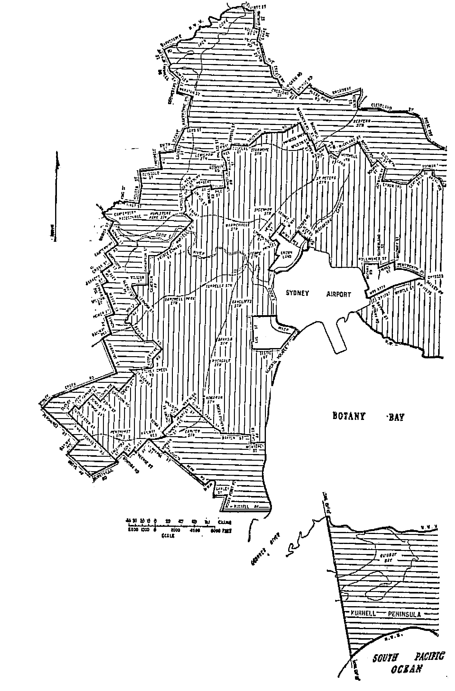
Fifth Schedule—continued
Plan No. 6—Sydney (Kingsford Smith) Airport
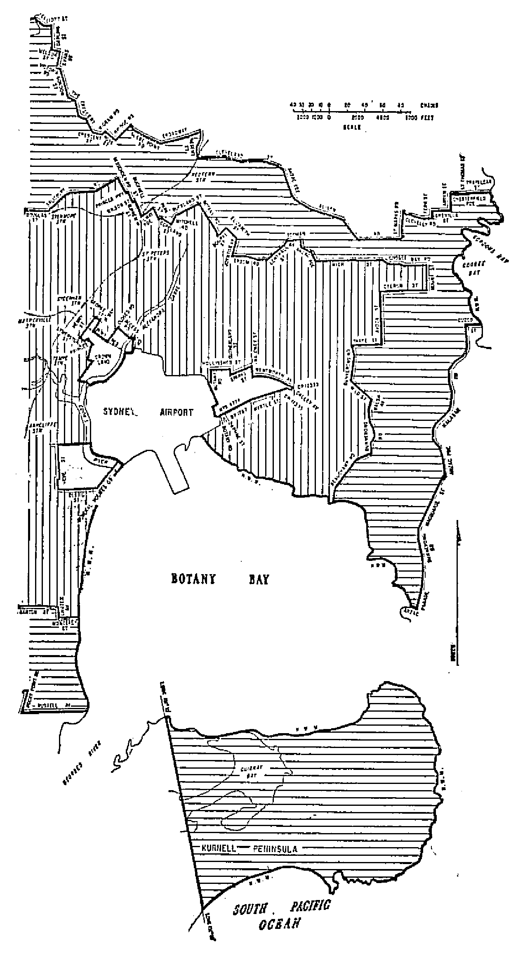
Fifth Schedule—continued
Plan No. 7—Bankstown Airport
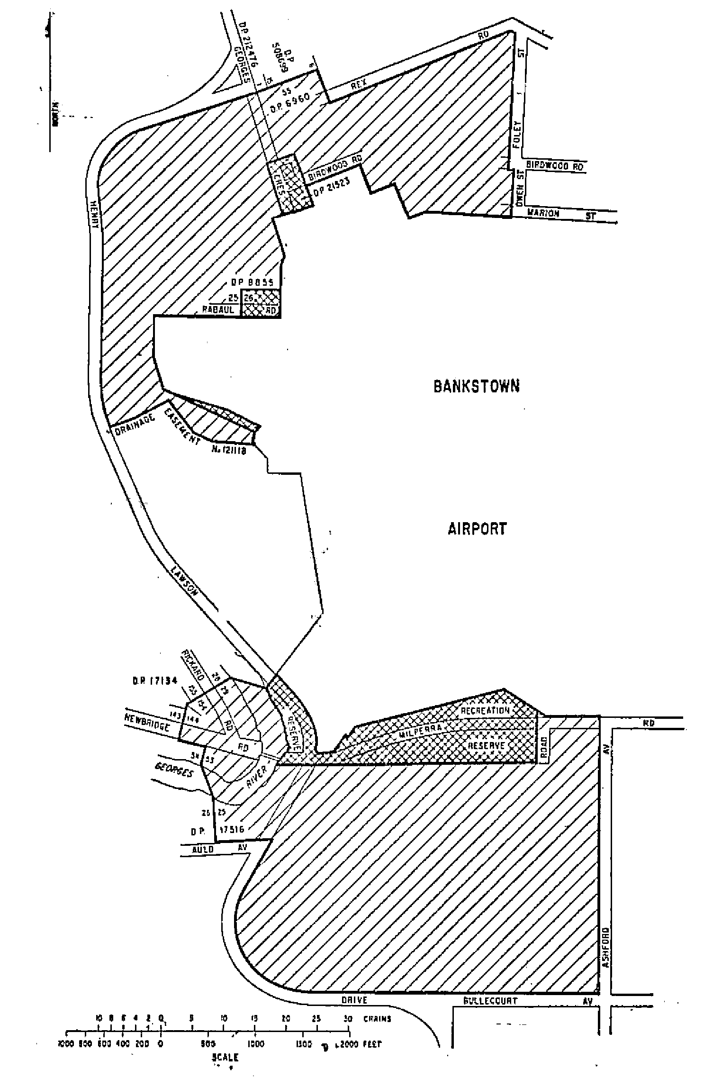
Fifth Schedule—continued
Plan No. 8—Bankstown Airport
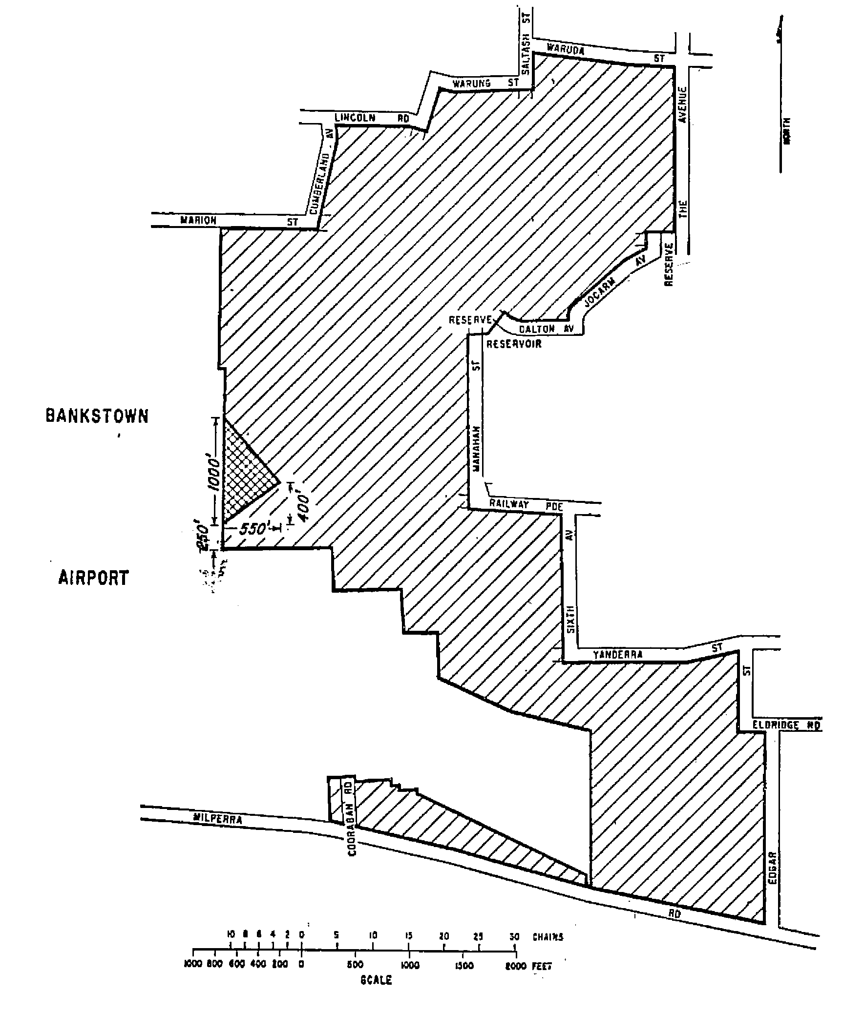
Fifth Schedule—continued
Plan No. 9—Bankstown Airport
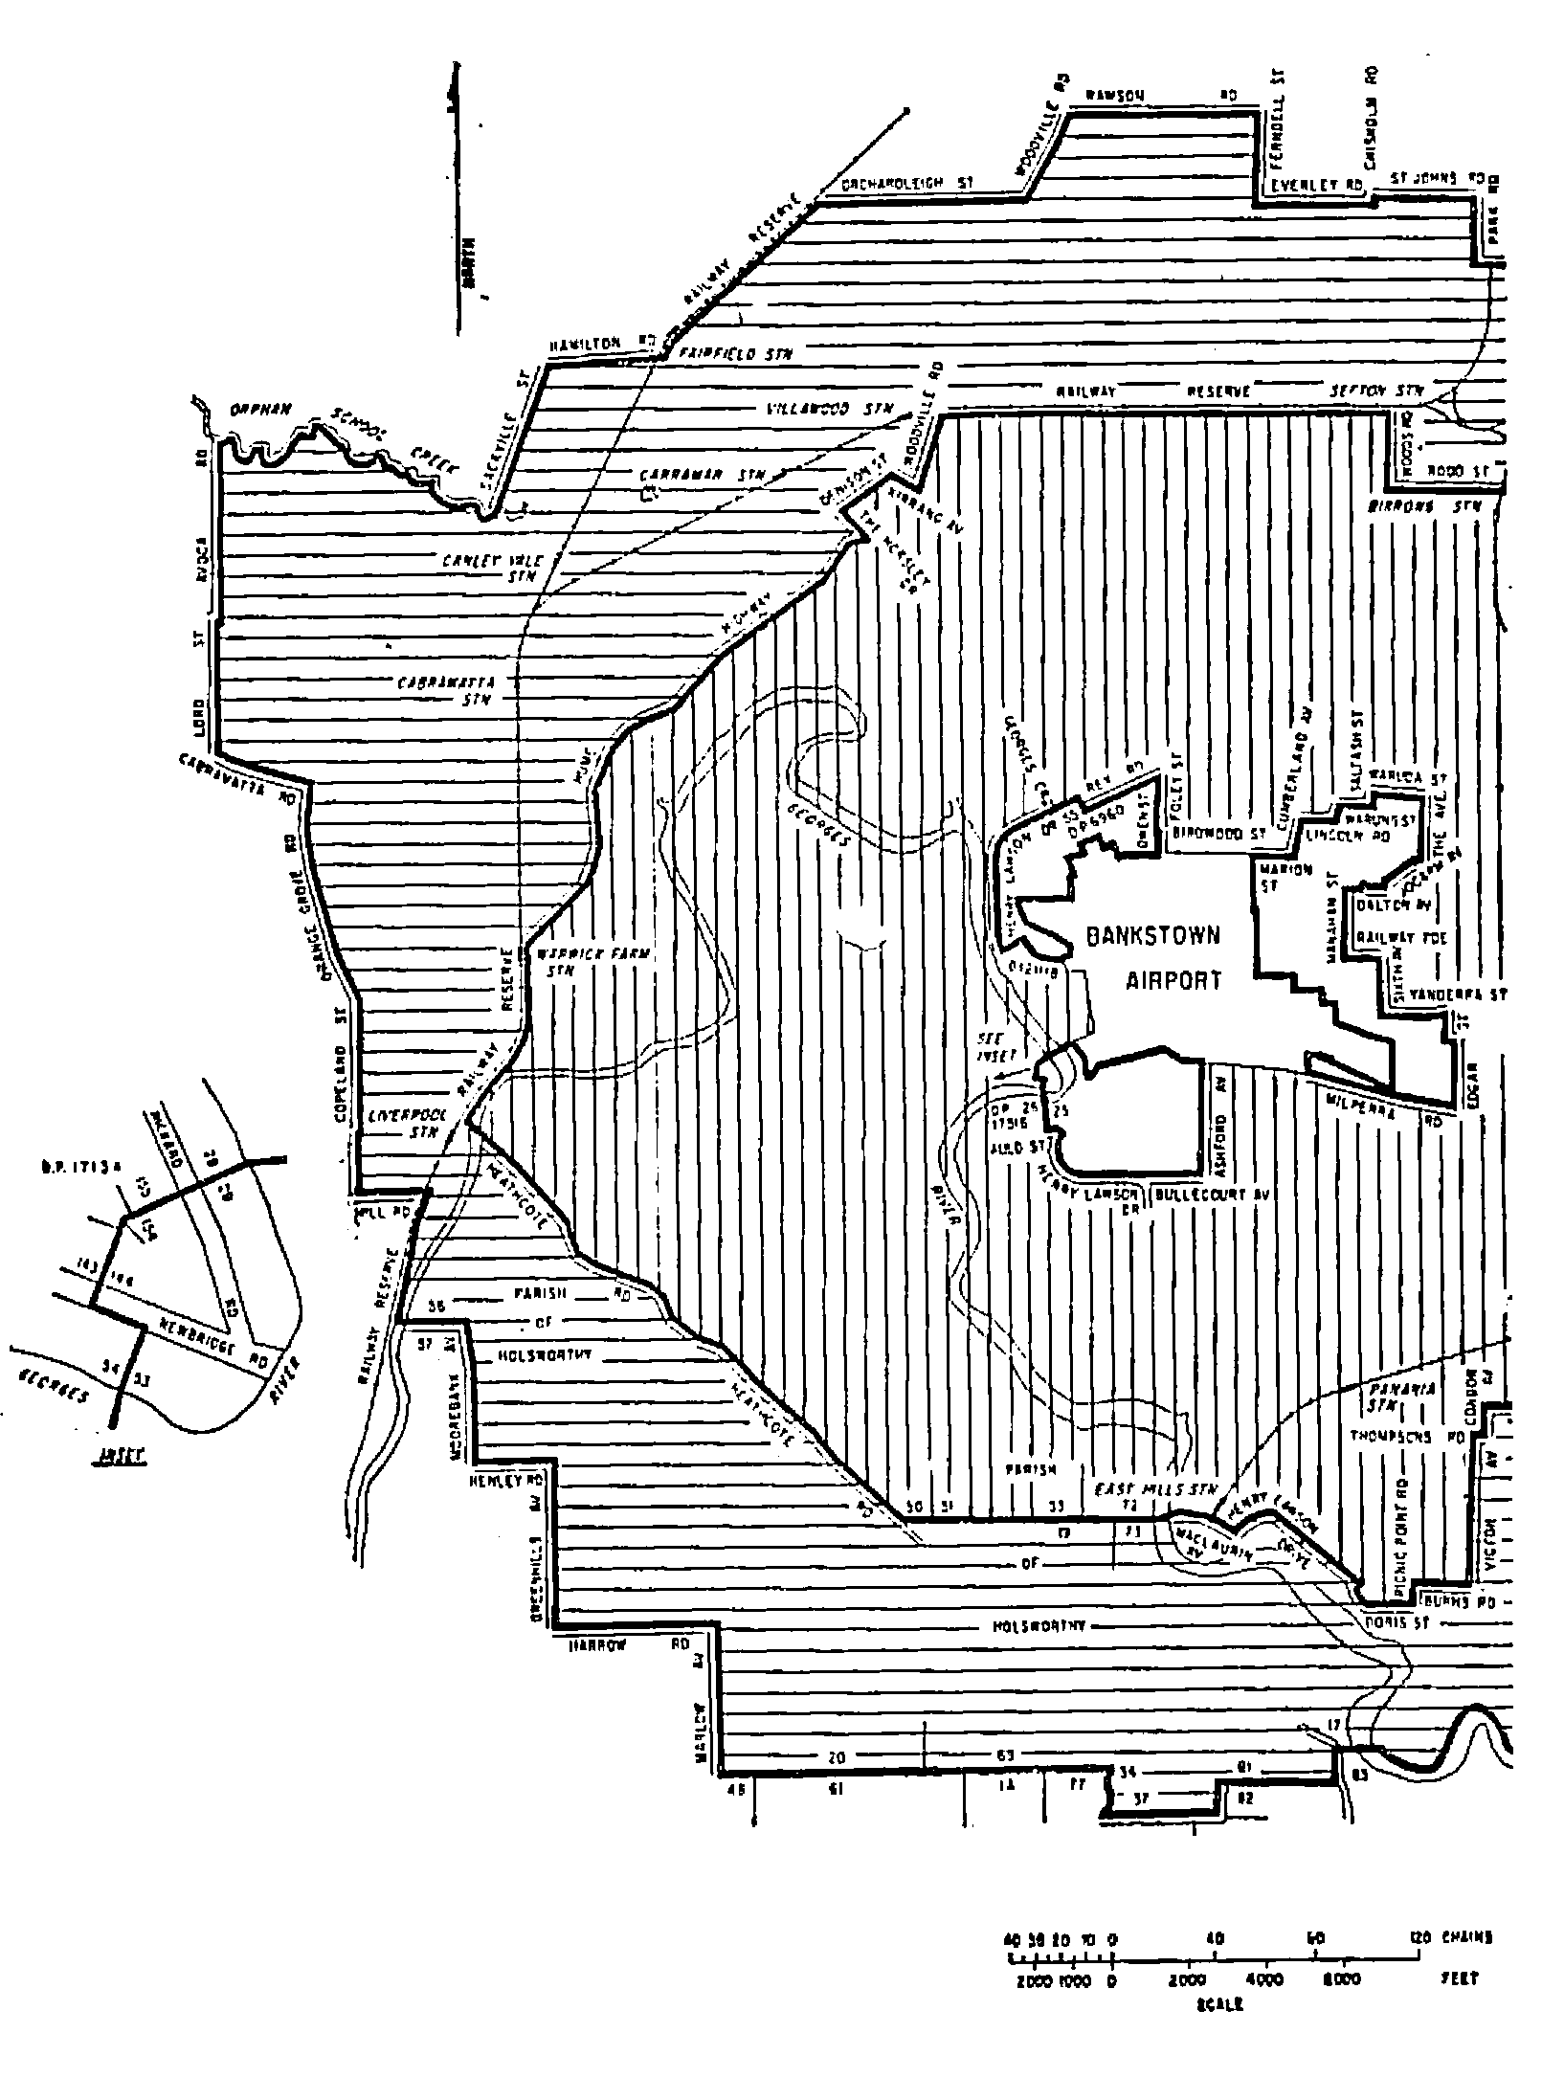
Fifth Schedule—continued
Plan No. 10—Bankstown Airport
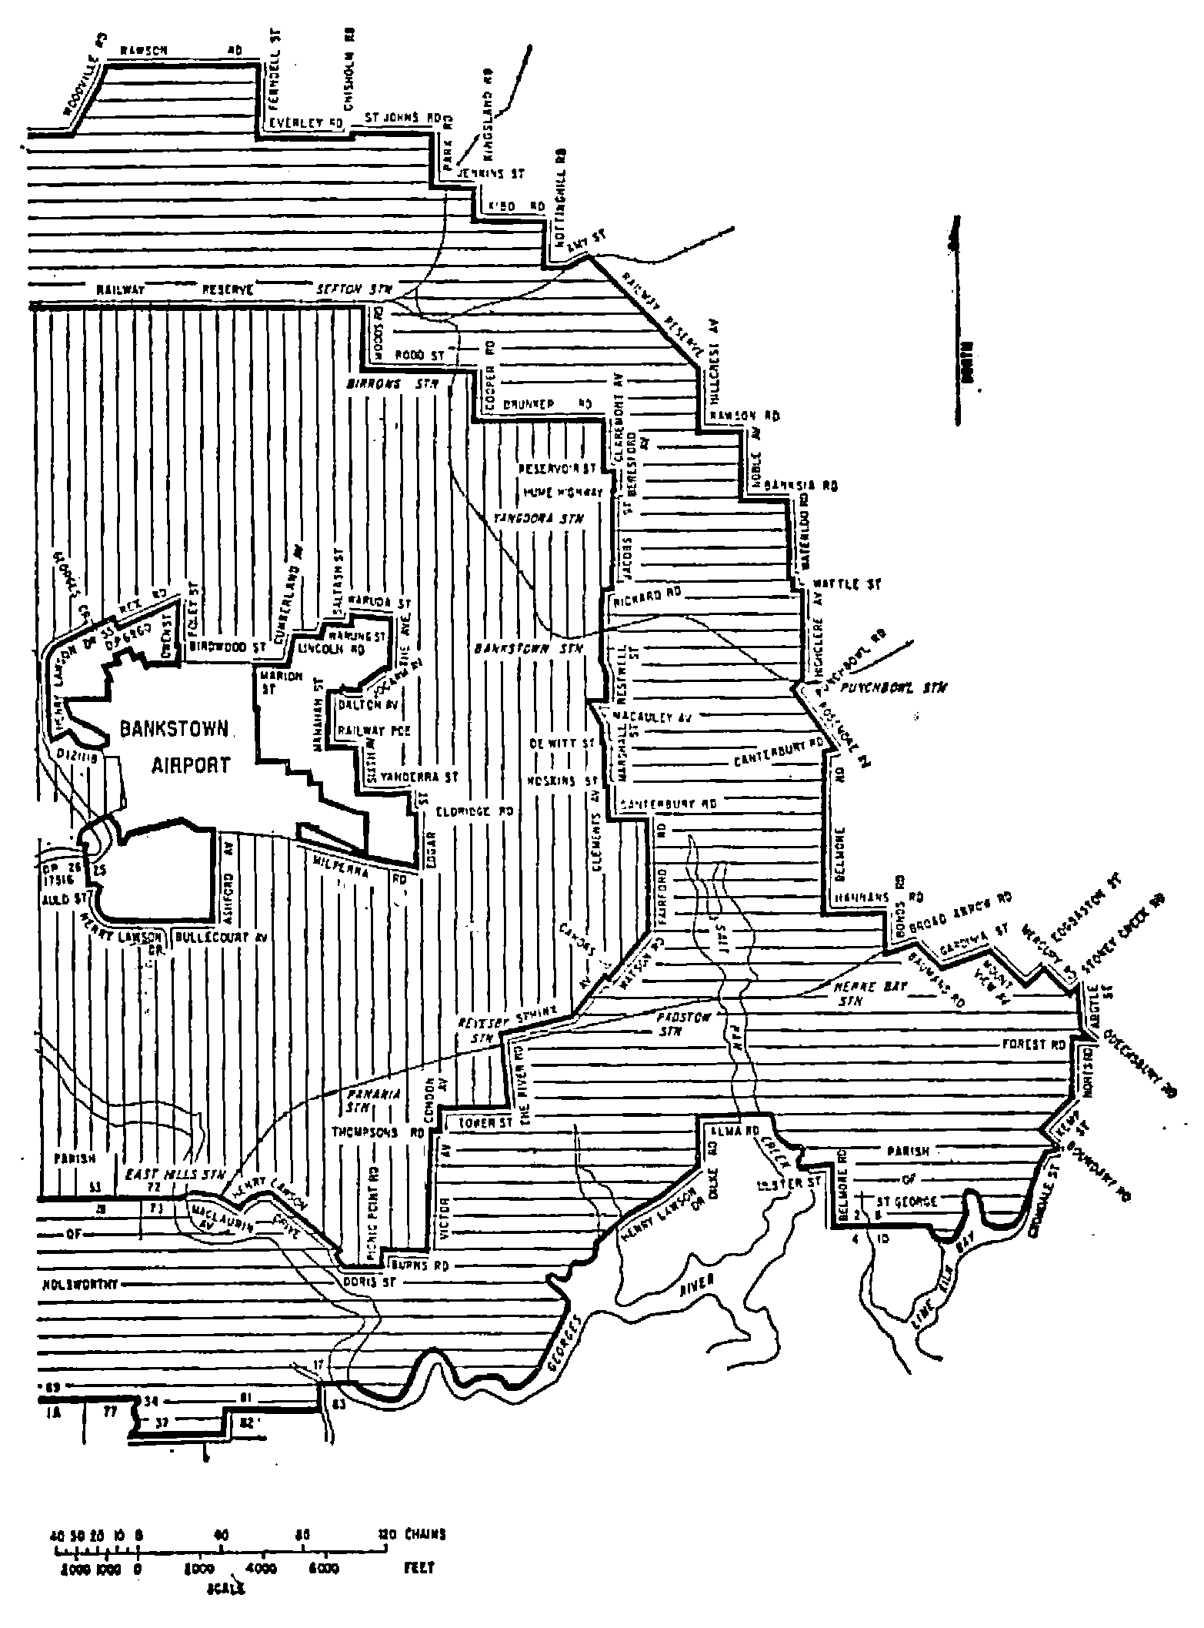
Fifth Schedule—continued
Plan No. 11—Moorabbin Airport
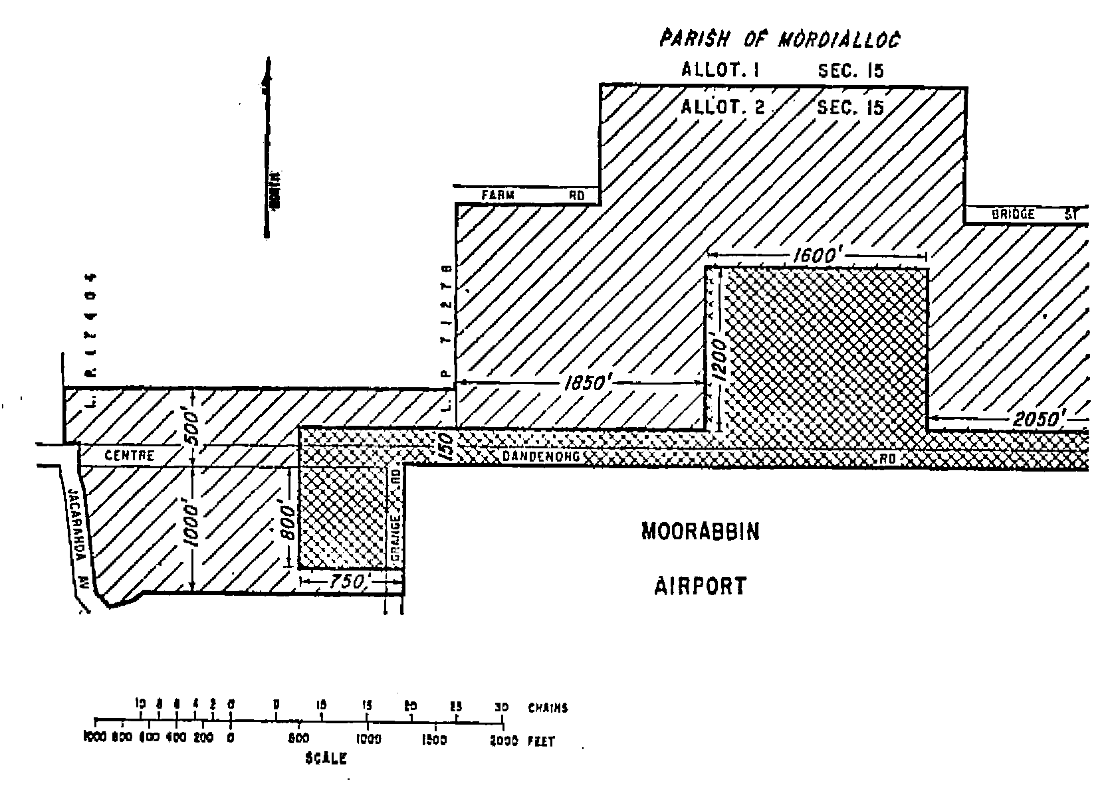
Fifth Schedule—continued
Plan No: 12—Moorabbin Airport
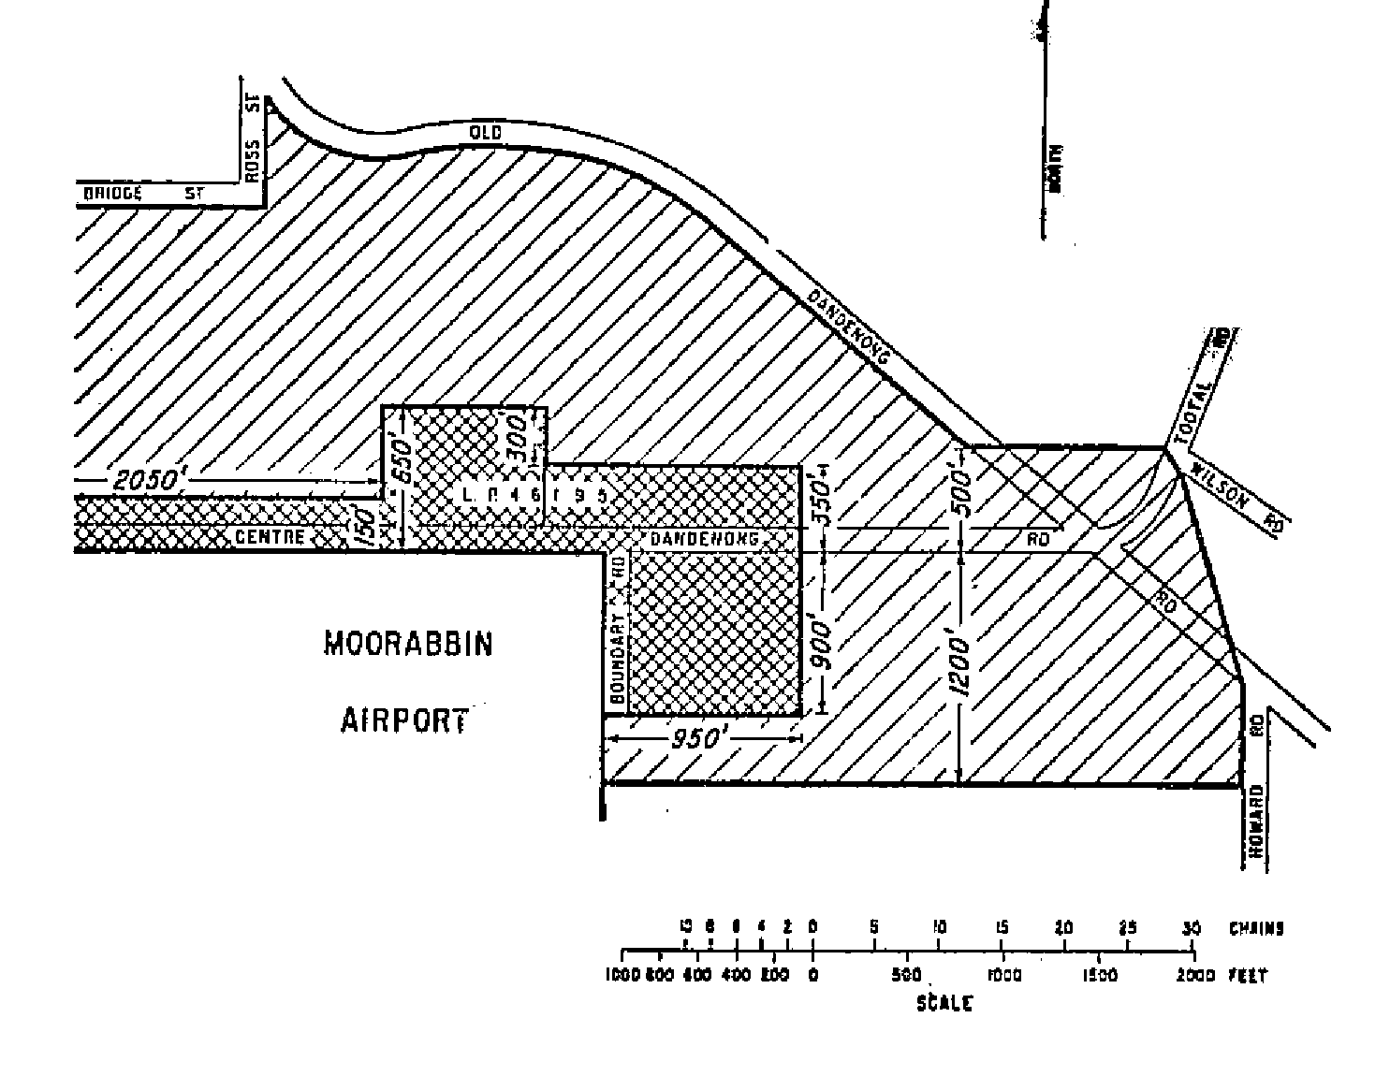
Fifth Schedule—continued
Plan No. 13—Moorabbin Airport
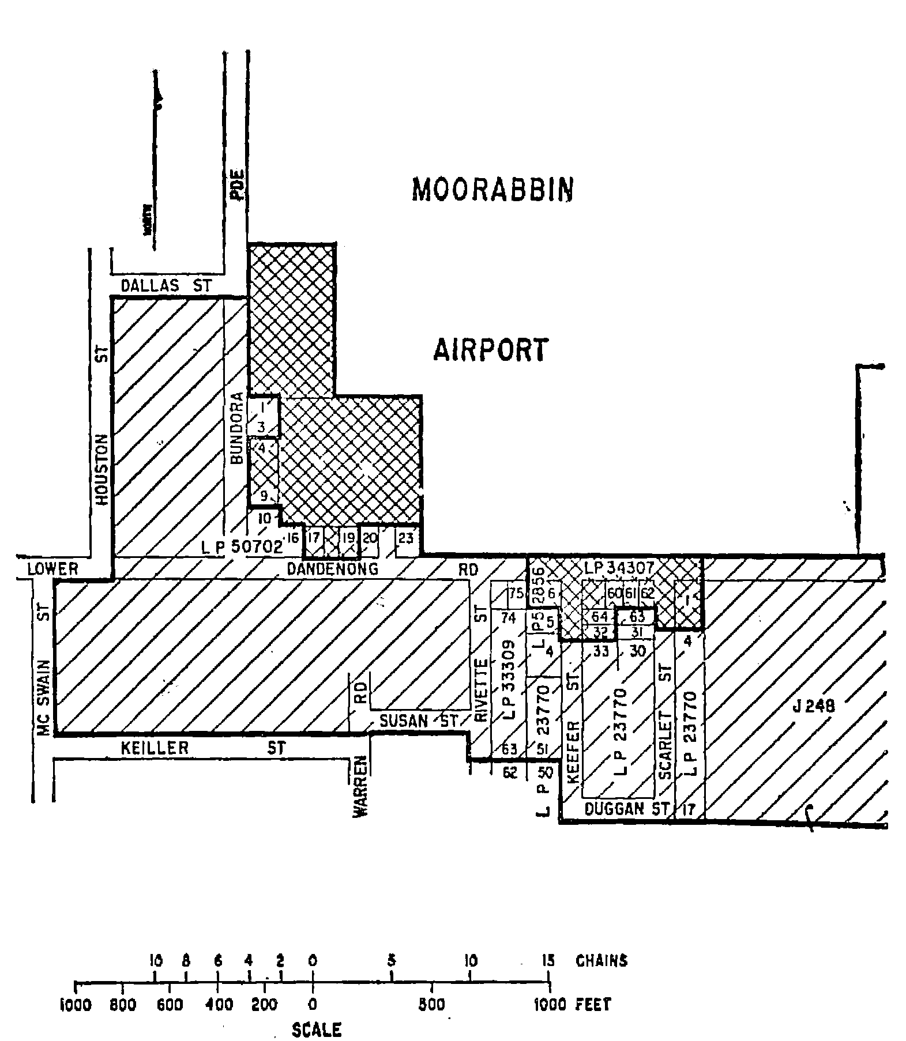
Fifth Schedule—continued
Plan No. 14—Moorabbin Airport
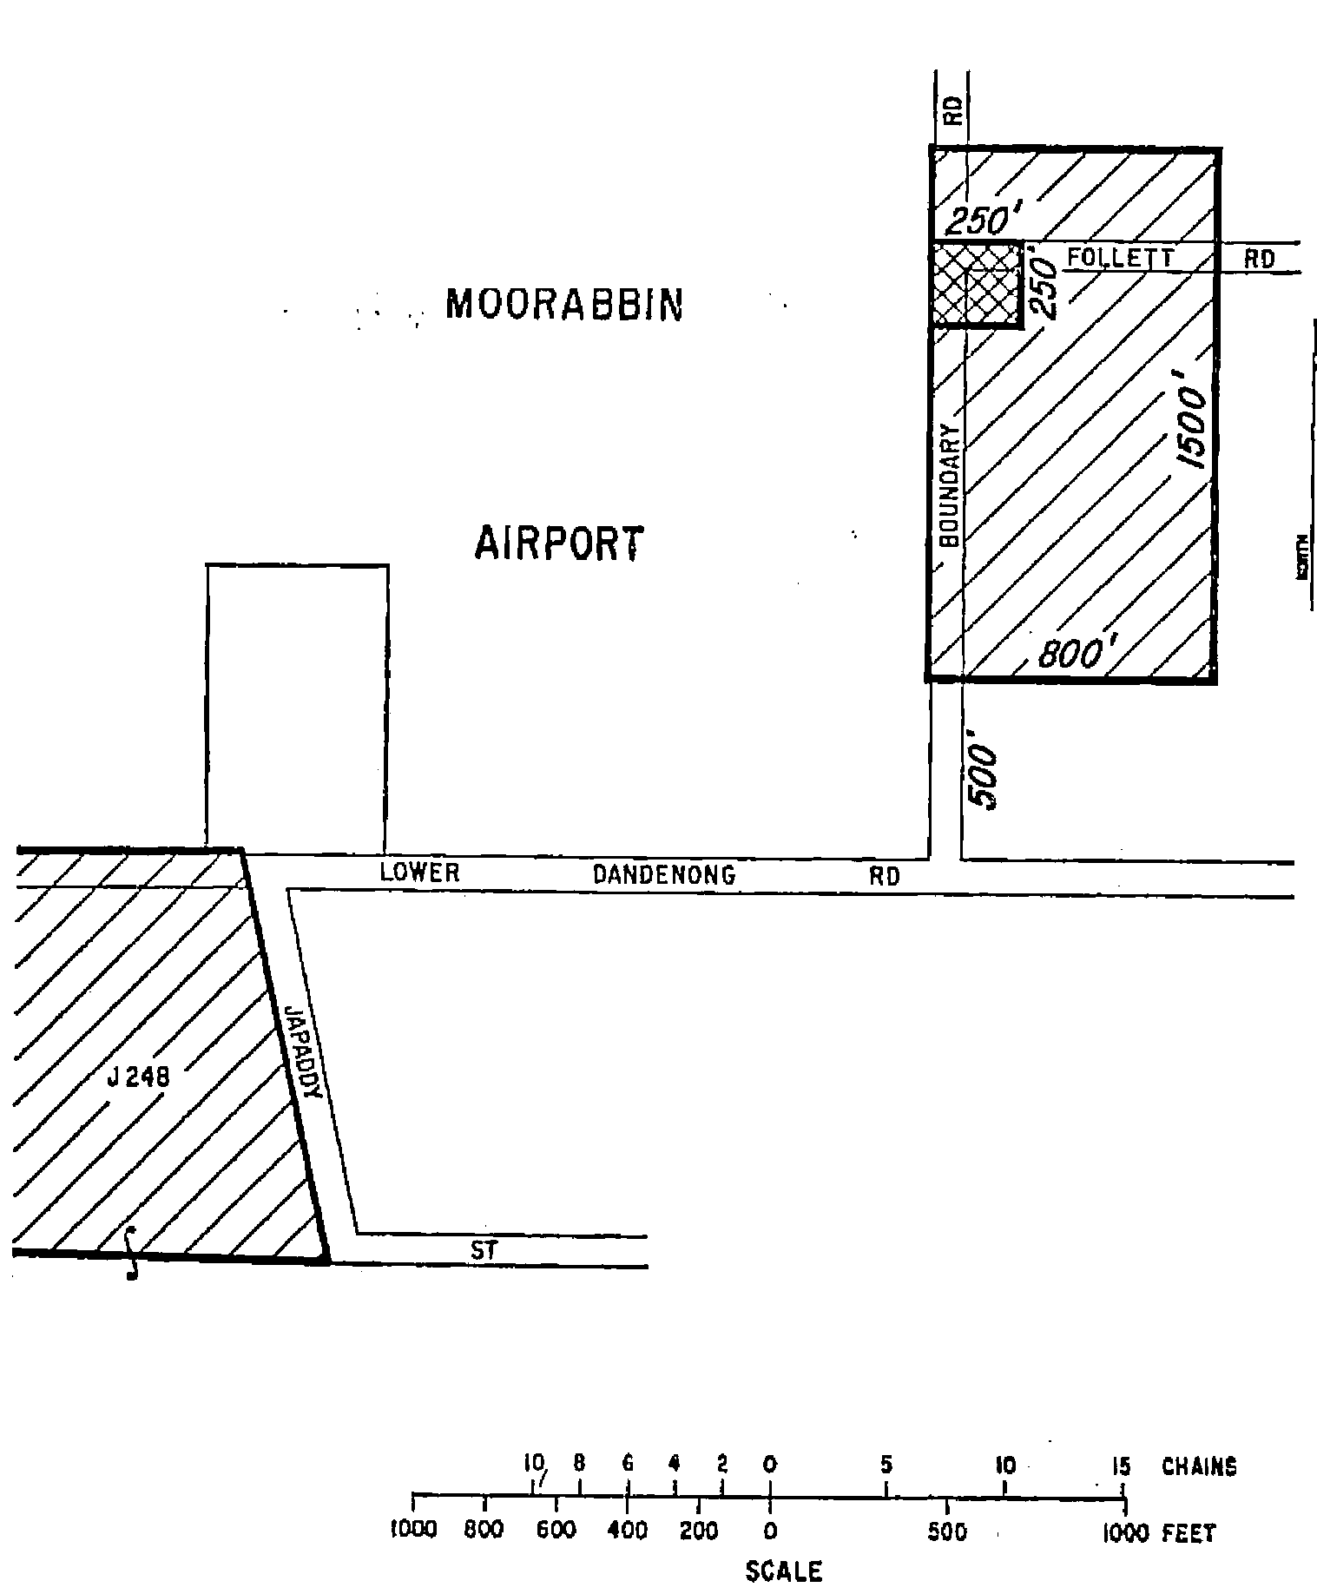
Fifth Schedule—continued
Plan No. 15—Moorabbin Airport
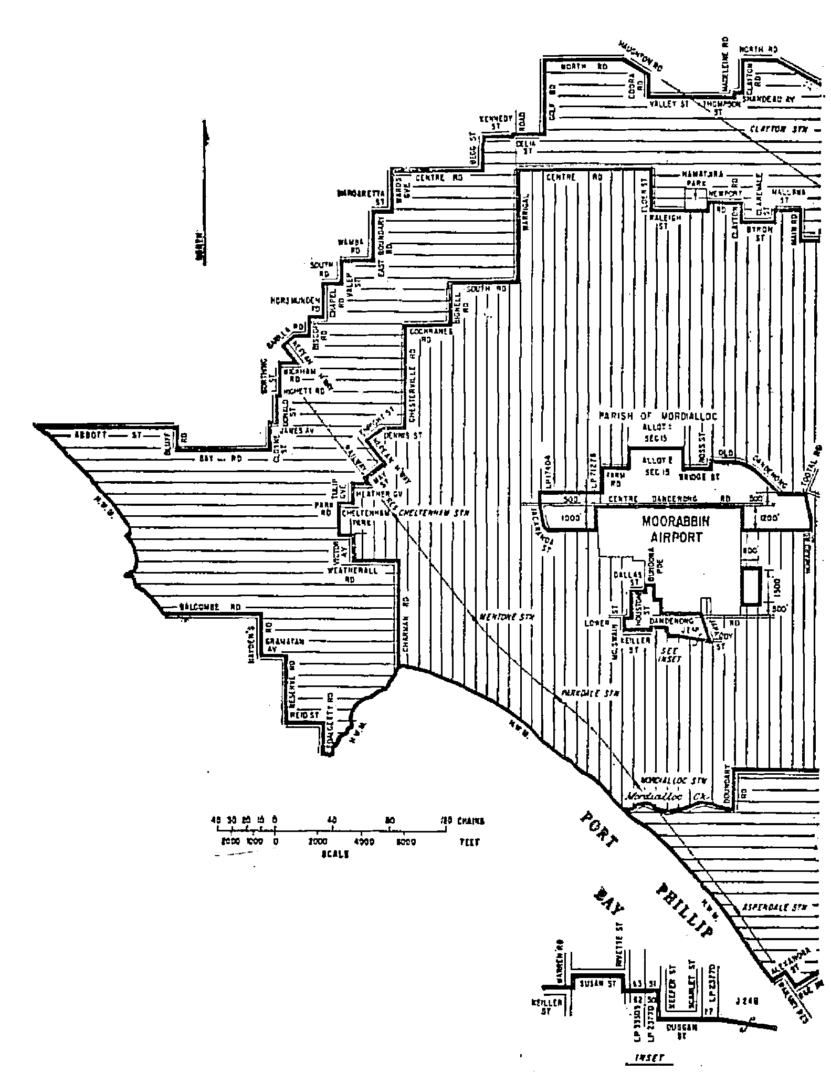
Fifth Schedule—continued
Plan No. 16—Moorabbin Airport
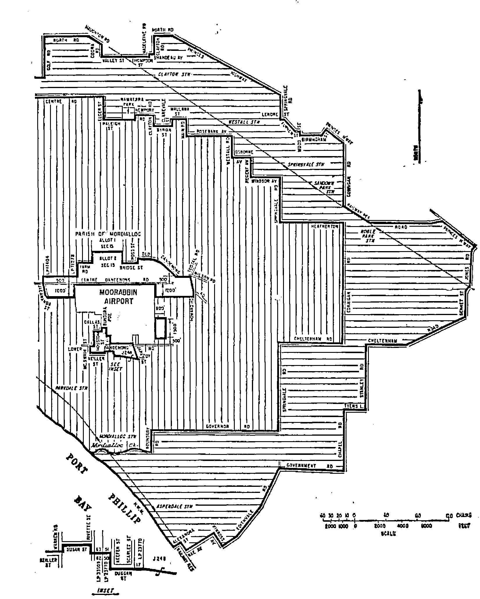
Fifth Schedule—continued
Plan No. 17—Adelaide Airport
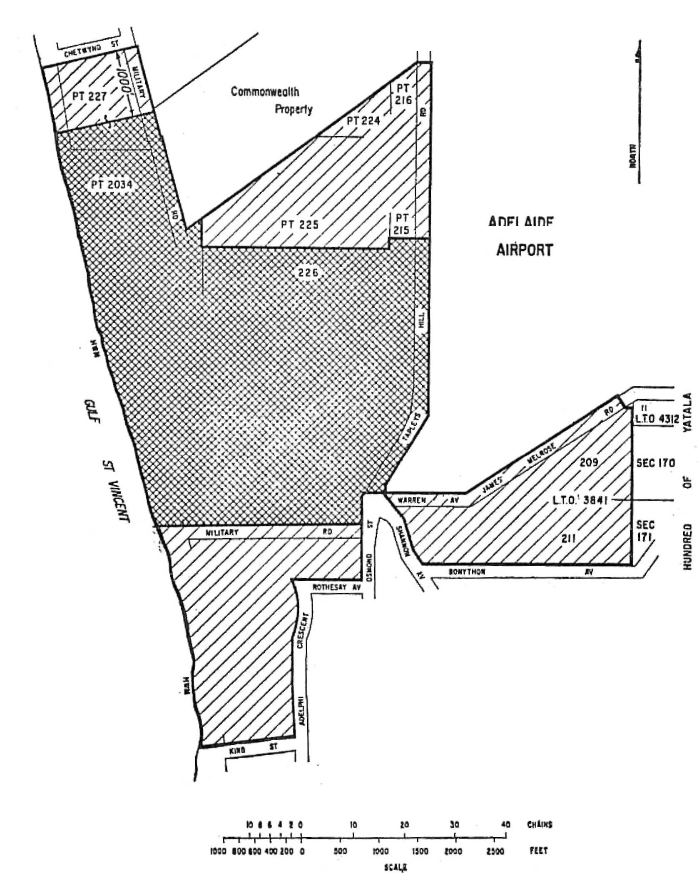
Fifth Schedule—continued
Plan No. 18—Adelaide Airport
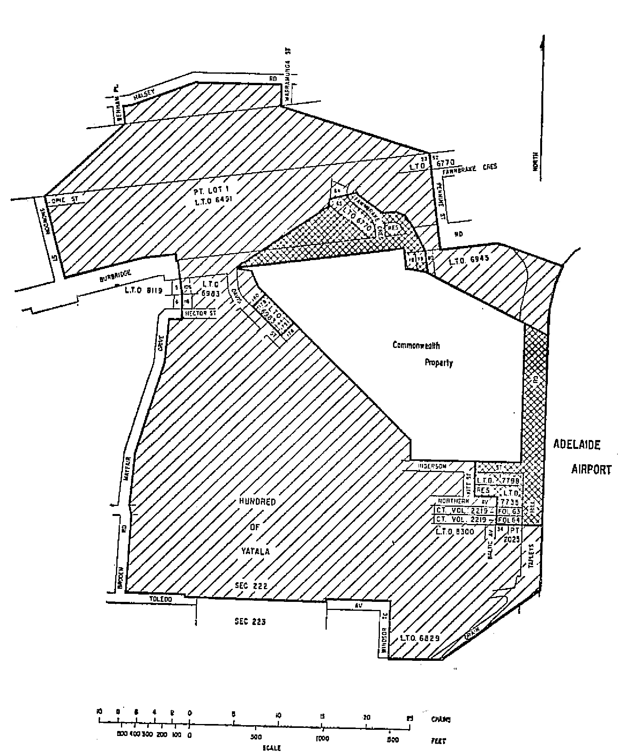
Fifth Schedule—continued
Plan No. 19—Adelaide Airport
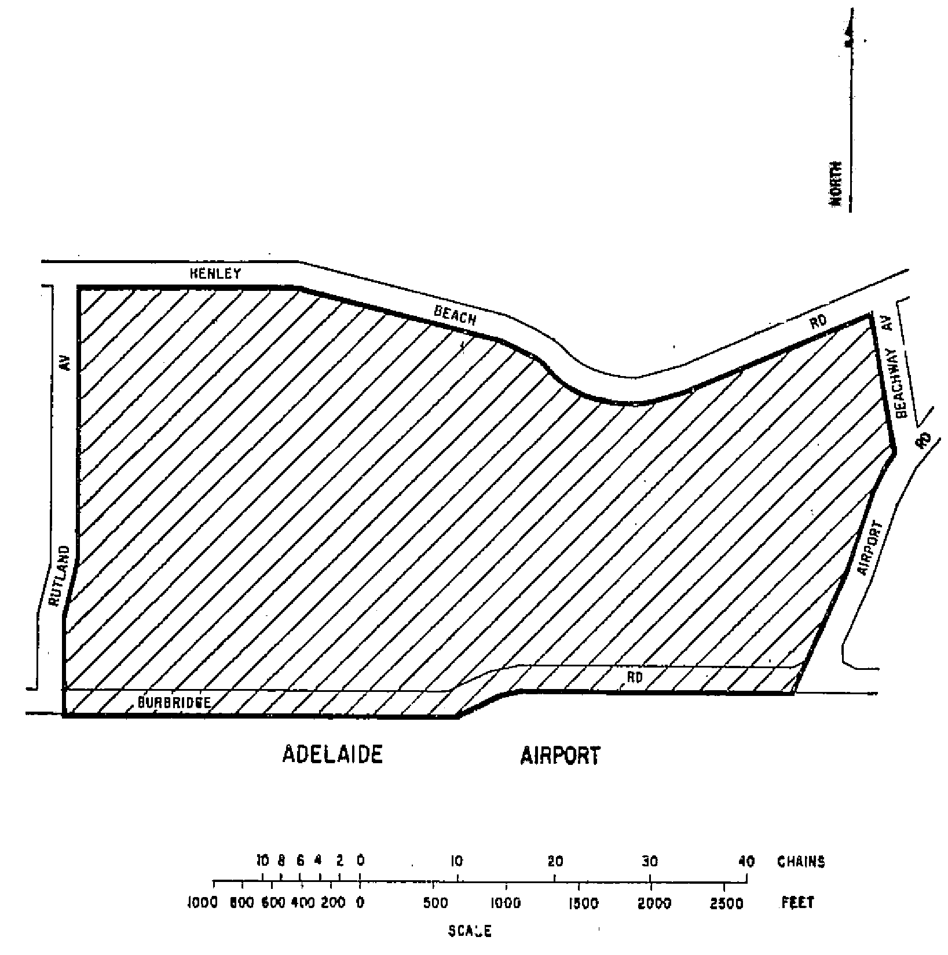
Fifth Schedule—continued
Plan No. 20—Adelaide Airport
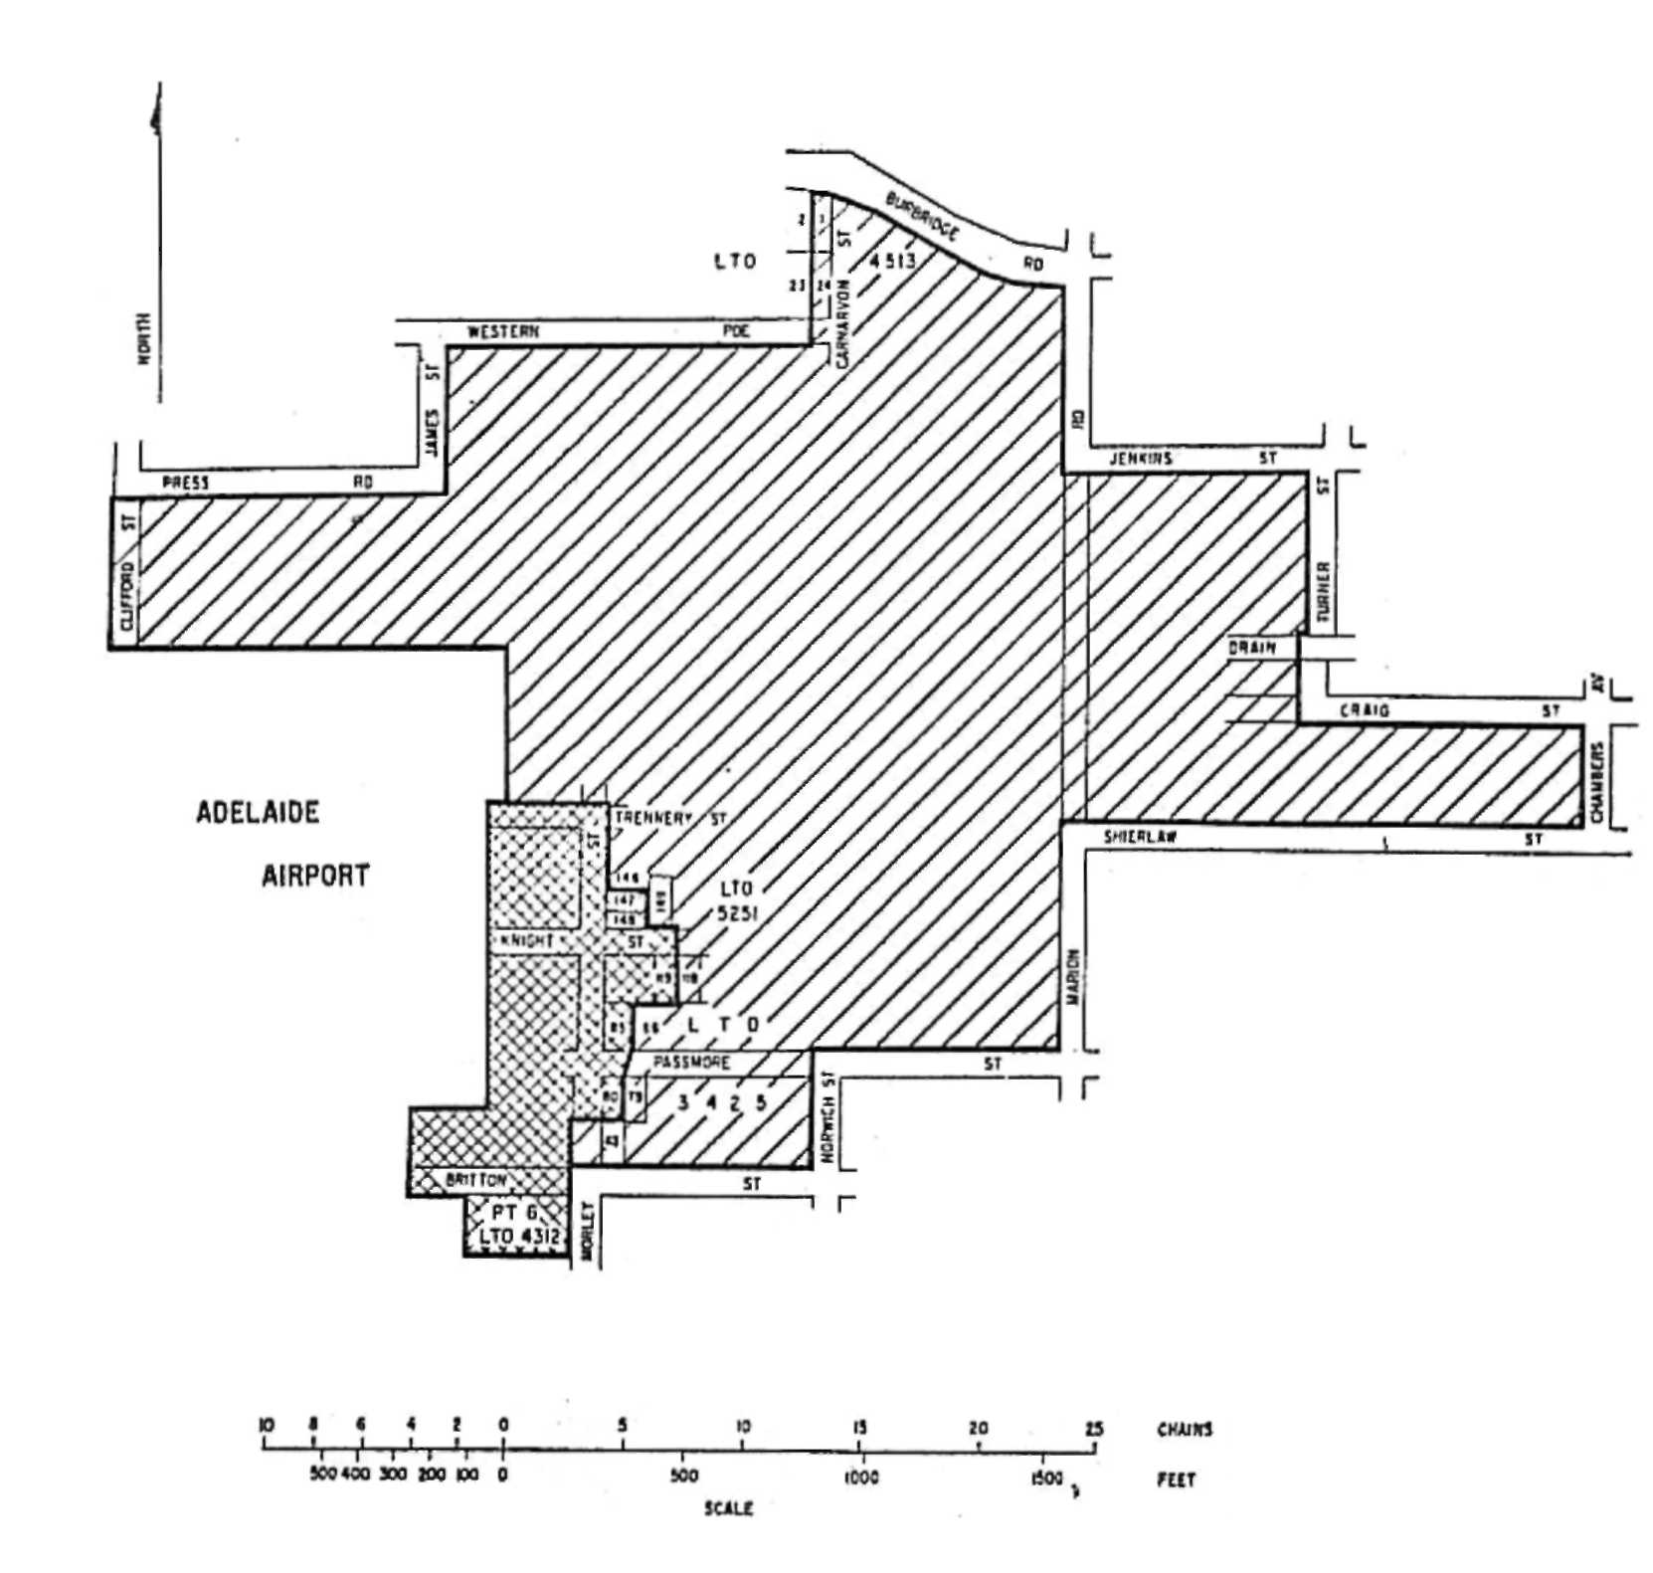
Fifth Schedule—continued
Plan No. 21—Adelaide Airport
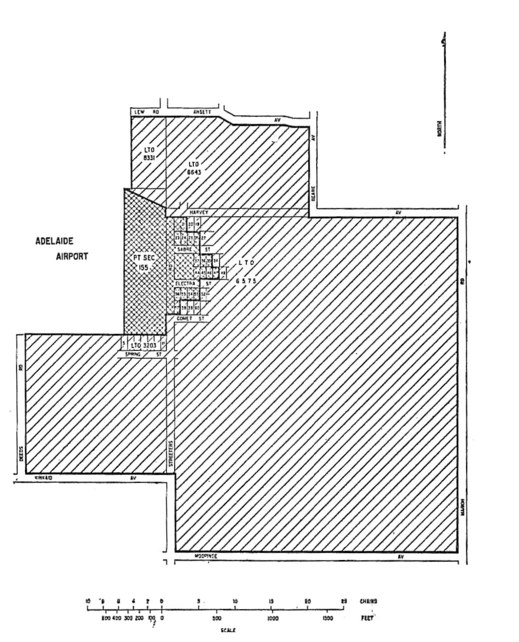
Fifth Schedule—continued
Plan No. 22—Adelaide Airport
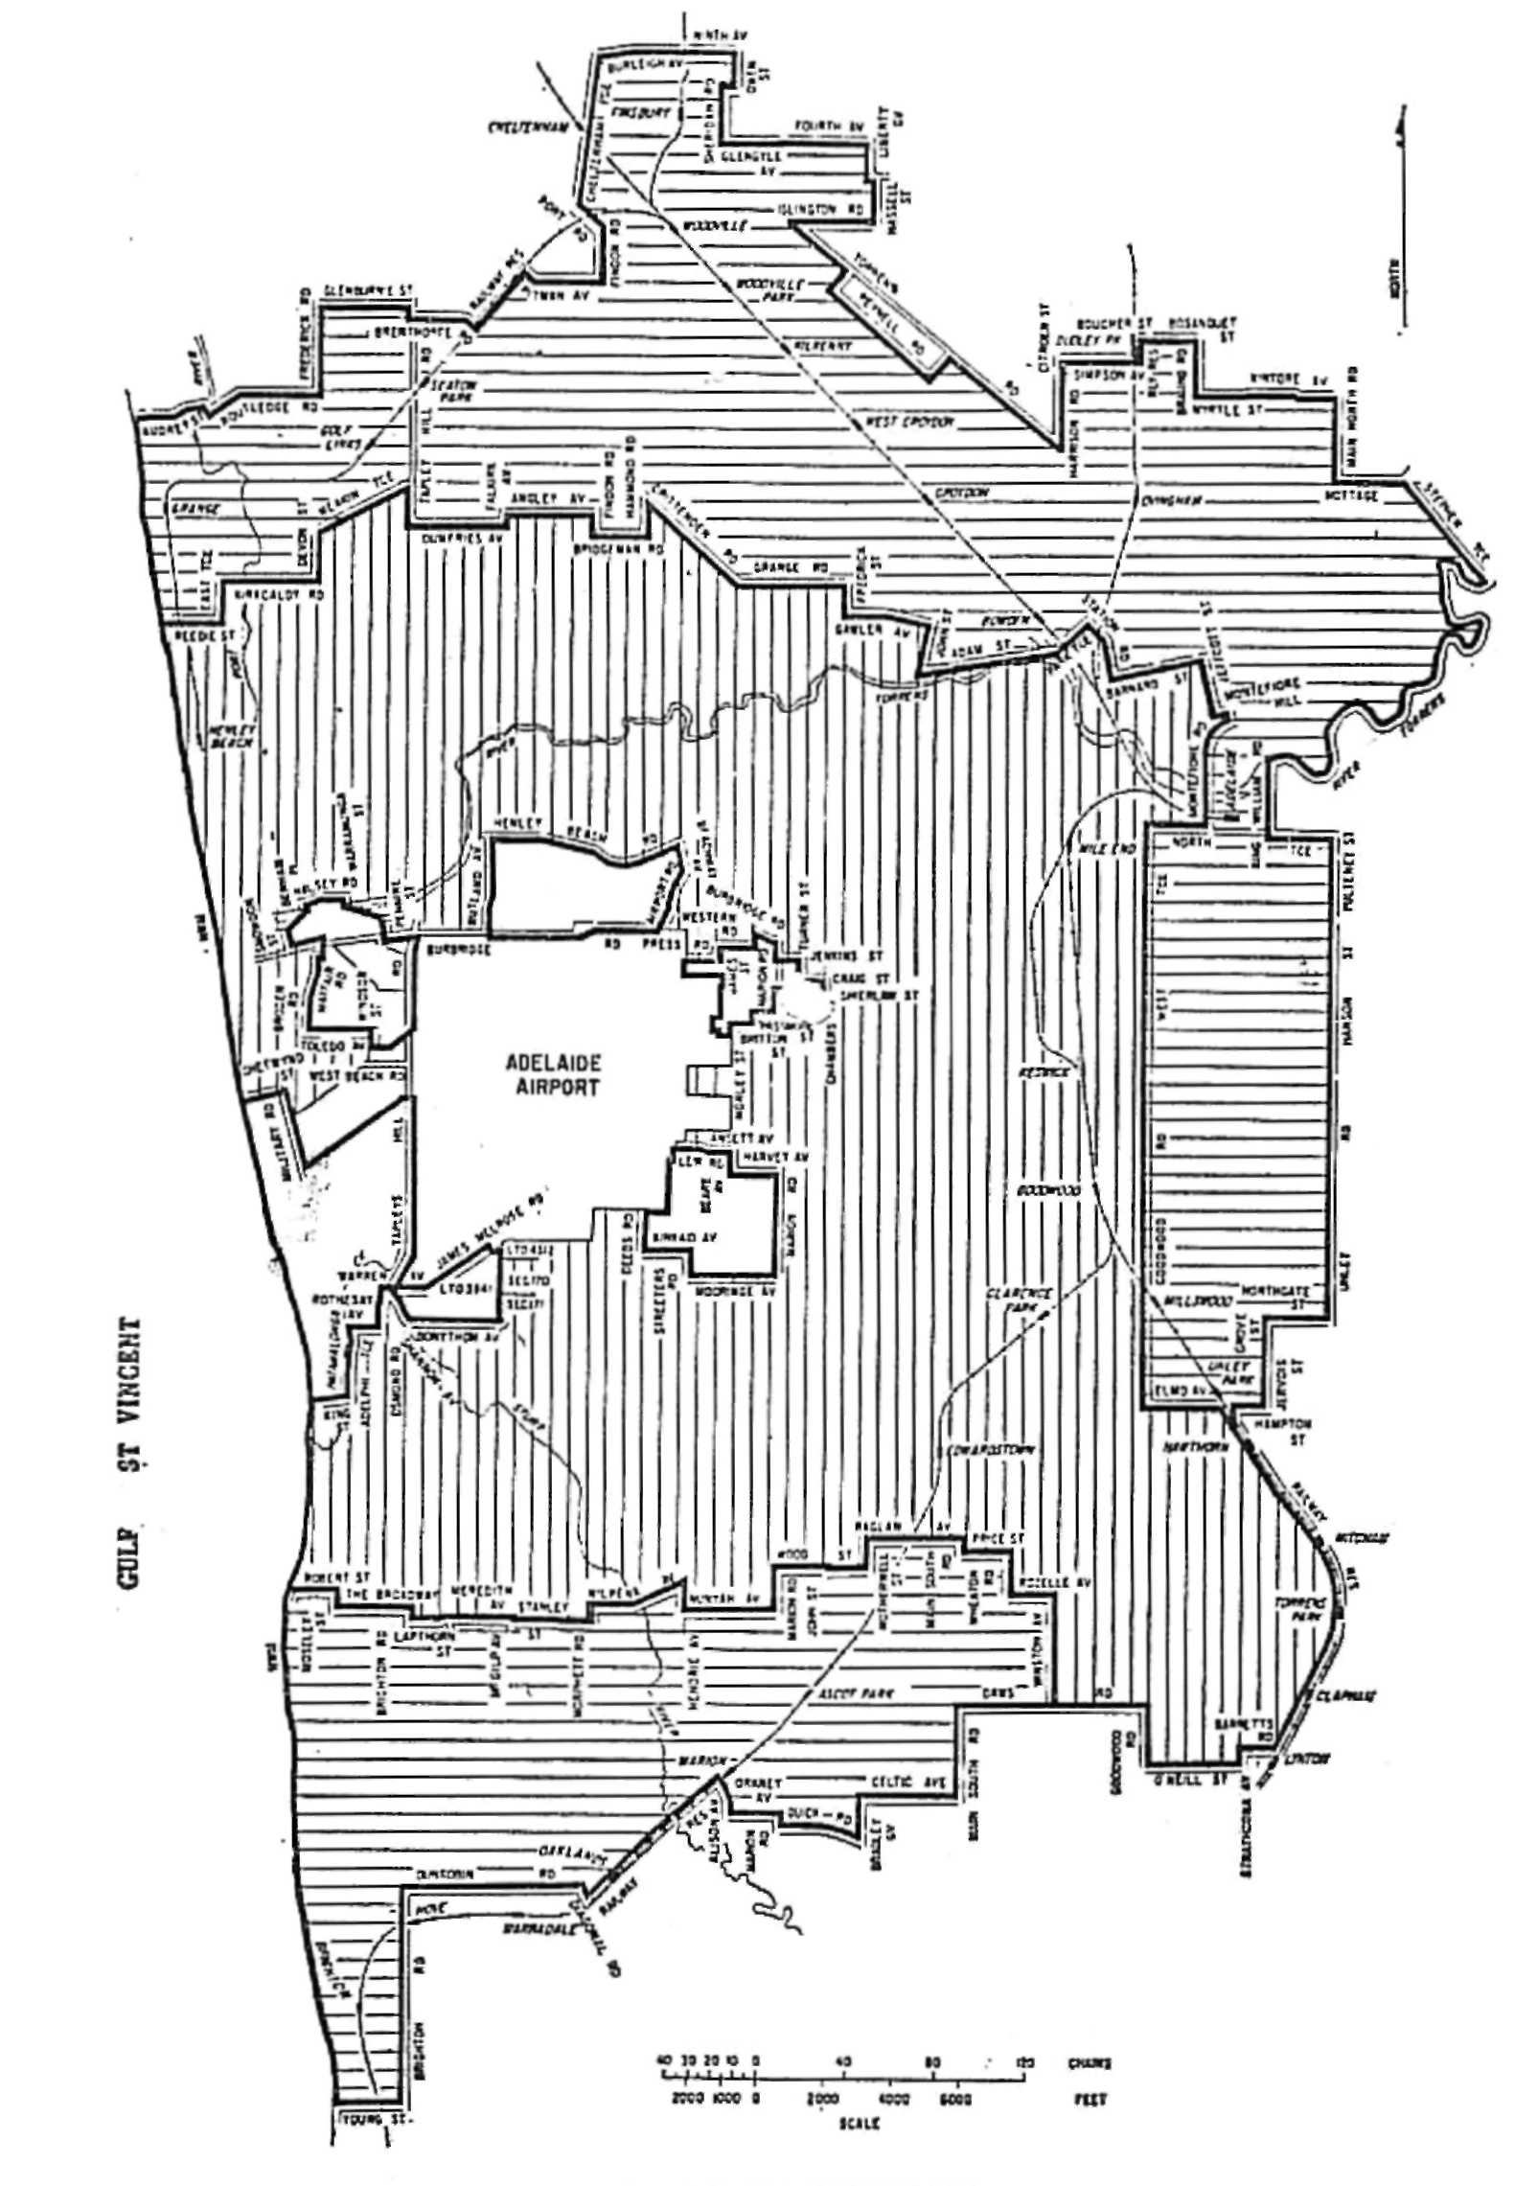

____________________
A. J. Arthur, Commonwealth Government Printer, Canberra.

