STATUTORY RULES.
1956. No. .
REGULATION UNDER THE SEAT OF GOVERNMENT (ADMINISTRATION) ACT 1910-1955.*
I, THE GOVERNOR-GENERAL in and over the Commonwealth of Australia, acting with the advice of the Federal Executive Council, hereby make the following Regulation under the Seat of Government (Administration) Act 1910-1955.
Dated this fourteenth
day of December , 1956
W. J. Slim
Governor-General.
By His Excellency’s Command,
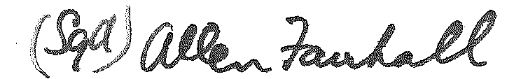
Minister of State for the Interior.
Repeal of the Accommodation By-laws.
The Accommodation By-laws (being Statutory Rules 1929, No. 22) are repealed.
* Notified in the Commonwealth Gazette on , 1956.
By Authority : A. J. Arthur, Commonwealth Government Printer, Canberra.
6852/56.—Price 3d. 9/22.11.1956.

