STATUTORY RULES.
1954. No. 92.
––––––––––
REGULATION UNDER THE NAVAL DEFENCE ACT 1910-1952.*
I, THE GOVERNOR-GENERAL in and over the Commonwealth of Australia, acting with the advice of the Federal Executive Council, hereby make the following Regulation under the Naval Defence Act 1910-1952.
Dated this eighteenth day of August, 1954.
Governor-General.
By His Excellency’s Command,
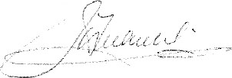
Minister of State for the Navy.
––––––
Repeal of Statutory Rules 1913, No. 202.

Repeal.
Statutory Rules 1913, No. 202 are repealed.

* Notified in the Commonwealth Gazette on , 1954.
––––––––––––––––
By Authority: L. F. Johnston, Commonwealth Government Printer, Canberra.
3183.—Price 3d. 9/12.7.1954.

