STATUTORY RULES.
1953. No. 50.
___________
REGULATIONS UNDER THE MEAT EXPORT CONTROL ACT 1935-1950.*
I, THE GOVERNOR-GENERAL in and over the Commonwealth of Australia, acting with the advice of the Federal Executive Council, hereby make the following Regulations under the Meat Export Control Act 1935-1950.
Dated this nineteenth day of May, 1953.
W. J. SLIM
Governor-General.

By His Excellency’s Command,

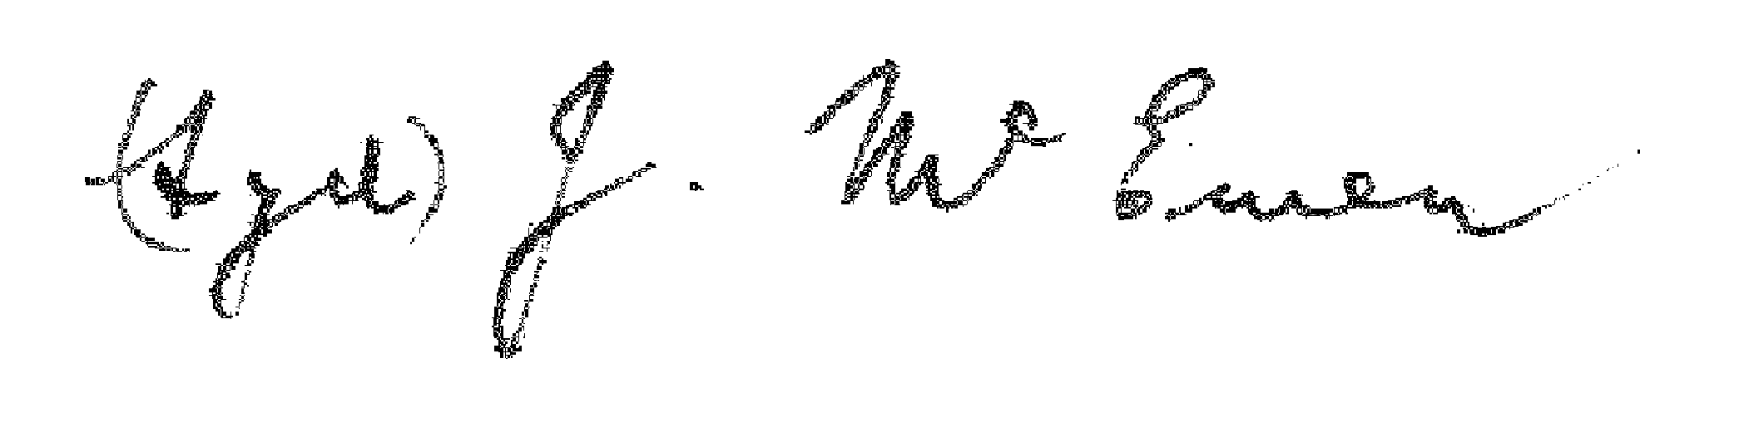
Minister of State for Commerce and Agriculture.
_________

AMENDMENTS OF THE MEAT EXPORT CONTROL (STAFF) REGULATIONS.†
Commencement.
1. Regulation 2 of the Meat Export Control (Staff) Regulations is amended by omitting sub-regulation (2.).
Salaries of officers.
2. Regulation 5 of the Meat Export Control (Staff) Regulations is amended by omitting sub-regulations (1.) and (3.) and inserting in their stead the following sub-regulations:—
“(1.) An officer who occupies an office specified in column 1 of Table A is entitled to the annual salary, or salary within the limits of salary, specified in column 2 of that Table opposite to that office and to the increments of salary within those limits specified in column 3 of that Table.
“(2.) An officer who occupies the office of Publicity Officer or the office of Research Officer shall be entitled to be paid annual salary within the limits of £1,154-£1,244 and increments of £30 within those limits in respect of his service between the twenty-ninth day of June, 1951, and the second day of September, 1952.
“(3.) An officer who occupies the office of Publicity and Research Officer shall, in respect of his service on and after the second day of September, 1952, be entitled to be paid annual salary within the limits of £1,214-£1,304 and increments of £30 within those limits.”.
____________________________________________________________________________________
* Notified in the Commonwealth Gazette on , 1953.
† Statutory Rules 1948, No. 123, as amended by Statutory Rules 1949, Nos. 117 and 118; 1950, Nos. 71 and 76; and 1951, Nos. 29, 35 and 114.
1413.—Price 3D. 9/29.4.1953.
Schedule.
3. The Schedule to the Meat Export Control (Staff) Regulations is amended by omitting Table A and inserting in its stead the following Table:—
TABLE A.
(Column 1.) | (Column 2.) | (Column 3.)
Office. | Annual Salary or Limits of Annual Salary. | Increments.
 | £ | £
Manager | 1,738–1,924 | 62
Technical Officer and State Representative—New South Wales | 1,590 | ..
Chief Accountant | 1,366–1,552 | 62
State Representative—Victoria | 1,401 | ..
State Representative—Queensland | 1,401 | ..
State Representative—Western Australia | 1,004–1,124 | 30
Executive Officer—Meat Canning | 908–1,004 | 24
Branch Accountant | 812–908 | 24
Inspector | 572–812 | 4 of 24
 |  | 4 of 36
Clerk (Male)—
Under 18 years of age | 276 | ..
At 18 years of age | 318 | ..
At 19 years of age | 372 | ..
At 20 years of age | 432 | ..
At 21 years of age and over—
Clerk (Male) (£524–£620) | 524–620 | 24
Clerk (Male) (£572–£692) | 572–692 | 2 of 24
 |  | 2 of 36
Clerk (Male) (£620–£764) | 620–764 | 36
Clerk (Male) (£692–£812) | 692–812 | 2 of 36
 |  | 2 of 24
Clerk (Male) (£764–£860) | 764–860 | 24
Clerk (Male) (£812–£908) | 812–908 | 24
Assistant (Female), Grade 1—
Under 18 years of age | 238 | ..
At 18 years of age | 266 | ..
At 19 years of age | 308 | ..
At 20 years of age | 335 | ..
At 21 years of age and over | 365–401 | l of 24
 |  | l of 12
Assistant (Female), Grade 2 | 401–425 | 12
Assistant (Female), Grade 3 | 449–497 | 1 of 12
 |  | 2 of 18
Telephonist (Female)—
Under 18 years of age | 246 | ..
At 18 years of age | 274 | ..
At 19 years of age | 316 | ..
At 20 years of age | 343 | ..
At 21 years of age and over | 383–431 | 1 of 24
 |  | 2 of 12
Accounting Machinist (Female), Grade 1—
Under 18 years of age | 246 | ..
At 18 years of age | 274 | ..
At 19 years of age | 316 | ..
At 20 years of age | 343 | ..
At 21 years of age and over | 383–467 | l of 24
 |  | 5 of 12
Accounting Machinist (Female), Grade 2 | 491 | ..
Accounting Machinist (Female), Grade 3 | 515 | ..
Typist (Female), Grade 2 | 491 | ..
Typist (Female), Grade 3 | 515 | ..
TABLE A—continued.
(Column 1.) | (Column 2.) | (Column 3.)
Office. | Annual Salary or Limits of Annual Salary. | Increments.
 | £ | £
Typist (Female), Grade 1— |  | ..
Under 18 years of age | 246 | ..
At 18 years of age | 274 | ..
At 19 years of age | 316 | ..
At 20 years of age | 343 | ..
At 21 years of age and over | 383–467 | 1 of 24
 |  | 5 of 12
Junior Assistant (Male)—
Under 18 years of age | 252 | ..
At 18 years of age | 288 | ..
At 19 years of age | 336 | ..
At 20 years of age | 390 | ..
London Office—
Assistant Executive Officer and Surveyor | 850–1,200 | 50
Assistant Surveyor | 675–850 | 25
Commencement.
4. These Regulations shall be deemed to have come into operation on the thirtieth day of June, 1951.

_____________________
By Authority: L. F. JOHNSTON, Commonwealth Government Printer, Canberra.

