STATUTORY RULES.
1950. No. 81.
———————
REGULATIONS UNDER THE EGG EXPORT CONTROL ACT 1947-1948.*
I, THE GOVERNOR-GENERAL in and over the Commonwealth of Australia, acting with the advice of the Federal Executive Council, hereby make the following Regulations under the Egg Export Control Act 1947-1948.
Dated this sixteenth day of November, 1950.
W.J. McKell
Governor-General.
By His Excellency’s Command,
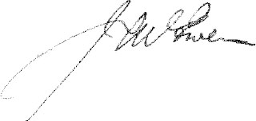
Minister of State for Commerce and Agriculture.
—————
Amendment of the Egg Export Control (Fees, Salaries and Expenses) Regulations.†
Salary of Chairman of Board.
1. Regulation 3 of the Egg Export Control (Fees, Salaries and Expenses) Regulations is amended by omitting the words “ One thousand three hundred and fifty ” and inserting in their stead the words “ One thousand five hundred ”.
Commencement.
2. Regulation 1 of these Regulations shall be deemed to have come into operation on the first day of May, 1950.

* Notified in the Commonwealth Gazette on , 1950.
† Statutory Rules 1948, No. 93.
—————————
By Authority: L. F. Johnston, Commonwealth Government Printer, Canberra.
5289.—Price 3d. 9/6.10.1950.

