STATUTORY RULES.
1949. No. .

REGULATION UNDER THE DEFENCE (TRANSITIONAL PROVISIONS) ACT 1946-1948.*
I, THE GOVERNOR-GENERAL in and over the Commonwealth of Australia, acting with the advice of the Federal Executive Council, hereby make the following Regulation under the Defence (Transitional Provisions) Act 1946-1948.
Dated this ninth day of November, 1949.
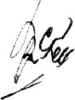
Governor-General.
By His Excellency’s Command,
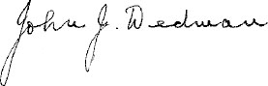
Minister of State for Post-war Reconstruction.

Amendment of the National Security (General) Regulations.†
Unauthorized possession or sale of uniforms and badges.
Regulation 31a of the National Security (General) Regulations is amended by adding at the end of sub-regulation (5a.) the following paragraph:—
“ (e) General Service Badge.”.

* Notified in the Commonwealth Gazette on , 1949.
† Being the Regulations having that title as in force under the Defence (Transitional Provisions) Act 1946-1948. The Regulations under the National Security Act 1939-1946 having the corresponding title comprise Statutory Rules 1939, No. 87, as amended. For amending Statutory Rules, see footnote † to Statutory Rules 1946, No. 156. These Regulations were further amended by Statutory Rules 1947, No. 113; and 1948, No. 4.

By Authority: L. F. Johnston, Commonwealth Government Printer, Canberra.
4102.—Price 3d. 8/2.9.1949.

