STATUTORY RULES
1947. No. 23.

REGULATION UNDER THE FORESTRY AND TIMBER BUREAU ACT 1930-46.*
I, THE ADMINISTRATOR of the Government of the Commonwealth of Australia, acting with the advice of the Federal Executive Council, hereby make the following Regulation under the Forestry and Timber Bureau Act 1930-1946.
Dated this twenty sixth day of February, 1947.
W. DUGAN
Administrator.
By His Excellency’s Command,
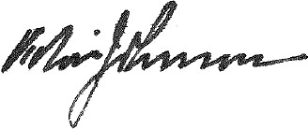
Minister of State for the Interior.

Amendment of the Board of Higher Forestry Education Regulations.†
Power and functions of Board.
Regulation 3 of the Board of Higher Forestry Education Regulations is amended by omitting the words “Inspector-General of Forests” (wherever occurring) and inserting in their stead the word “Director-General”.

* Notified in the Commonwealth Gazette on , 1947.
† Statutory Rules 1945, No. 27.

By Authority: L. F. Johnston, Commonwealth Government Printer, Canberra.
557—Price 3d. 8/29.1.1947.

