STATUTORY RULES.
1943. No. 274.

REGULATIONS UNDER THE BLACK MARKETING ACT 1942.*
I, THE GOVERNOR-GENERAL in and over the Commonwealth of Australia, acting with the advice of the Federal Executive Council, hereby make the following Regulations under the Black Marketing Act 1942.
Dated this third of November, 1943.
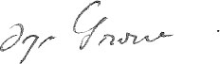
Governor-General.
By His Excellency’s Command,
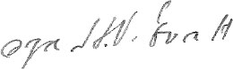
Attorney-General

Black Marketing Regulations.
Citation.
1. These Regulations may be cited as the Black Marketing Regulations.
Declaration of unlawful retention of licences, &c., to be black marketing.
2. It is hereby declared to be black marketing for any person to retain in his possession, without lawful authority, any licence, ration ticket, ration document or ration coupon issued, or any licence form, ration ticket, ration document or ration coupon authorized by an authority of the Commonwealth to be issued, under the Regulations.

* Notified in the Commonwealth Gazette on ,1943.

By Authority: L. F. Johnston, Commonwealth Government Printer, Canberra.
4626.—Price 3d. 25/9.9.1943.

