STATUTORY RULES.
1943. No. .

REGULATION UNDER THE NATIONAL SECURITY ACT 1939-1940.*
I, THE DEPUTY OF THE GOVERNOR-GENERAL in and over the Commonwealth of Australia, acting with the advice of the Federal Executive Council, hereby make the following Regulation under the National Security Act 1939-1940.
Dated this sixteenth day of August, 1943.
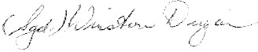
Deputy of the Governor-General.
By His Excellency’s Command,
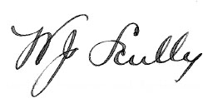
for and on behalf of the Minister of State for Defence.

Amendment of the National Security (Wheat Acquisition) Regulations.†
After regulation 26 of the National Security (Wheat Acquisition) Regulations the following regulation is inserted:—
Sale of wheat for particular purpose.
26a.—(1.) The Board may sell any wheat subject to the condition that it shall be used for a purpose specified by the Board.
“(2.) A person to whom any wheat is so sold shall not, except with the consent of the Board, dispose of the wheat, or use it otherwise than for the purpose specified by the Board”.

* Notified in the Commonwealth Gazette on , 1943.
† Statutory Rules 1939, No. 96, as amended by Statutory Rules 1939, Nos. 120, 155 and 180; 1940, Nos. 10, 132, 174, 208 and 271; 1941, Nos. 80, 110 and 256; 1942, Nos. 66 and 426; and 1943, No. 52.

By Authority: L. F. Johnston, Commonwealth Government Printer, Canberra.
3526.—Price 3d. 27/8.6.1943.

