STATUTORY RULES.
1942. No. 177.

REGULATIONS UNDER THE NATIONAL SECURITY ACT 1939–1940.*
I, THE GOVERNOR-GENERAL in and over the Commonwealth of Australia, acting with the advice of the Federal Executive Council, hereby make the following Regulations under the National Security Act 1939–1940.
Dated this fifteenth
day of April , 1942.
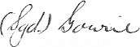
Governor-General.
By His Excellency’s Command,
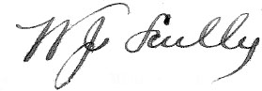
for and on behalf the Minister of State
for Defence

Amendment of National Security (Dairy Produce Acquisition) Regulations.†
Dairy Produce Control Committee.
Regulation 3 of the National Security (Dairy Produce Acquisition) Regulations is amended by omitting from sub-regulation (2.) the word “twelve” and inserting in its stead the word “thirteen”.

* Notified in the Commonwealth Gazette on , 1942.
† Statutory Rules 1939, No. 145, as amended by Statutory Rules 1940, No. 64; and 1941, No. 276.

By Authority: L. F. Johnston, Commonwealth Government Printer, Canberra.
2614.—Price 3d. 25/9.4.1942.

