STATUTORY RULES.
1939. No. 57.

REGULATION UNDER THE POST AND TELEGRAPH ACT 1901-1934.*
I, THE GOVERNOR-GENERAL in and over the Commonwealth of Australia, acting with the advice of the Federal Executive Council, hereby make the following Regulation under the Post and Telegraph Act 1901-1934.
Dated this twelfth day of July, 1939.
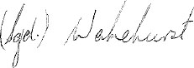
Deputy of the Governor-General.
By His Excellency’s Command,
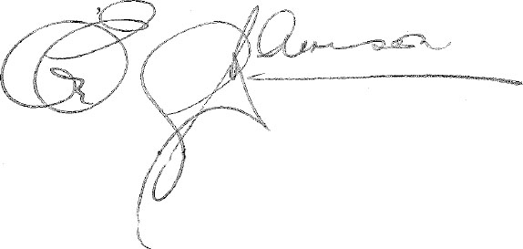
Postmaster-General.

Amendment of the Postal Regulations.†
The Postal Regulations are amended by inserting the following regulation after regulation 61:—
National Registration Papers.
61a. Postal articles containing papers provided for by the National Registration Act 1939 or the Regulations thereunder may be transmitted through the post free of charge if they are sent by or addressed to the Commonwealth Statistician, and the envelope or other covering in which the papers are posted bears on the outside the words “On His Majesty’s Service—National Registration Papers Only (National Registration Act 1939)”, or “National Registration Act 1939”, or “National Register (National Registration Papers Only)”.

* Notified in the Commonwealth Gazette on , 1939.
† Statutory Rules 1935, No. 8, as amended by Statutory Rules 1935, Nos. 53, 70, 80 and 95; 1936, Nos. 50 and 113; 1937, Nos. 13, 35, 37 and 48; 1938, Nos. 2, 55, 94 and 100; and 1939, No. 44.

By Authority: L. F. Johnston, Commonwealth Government Printer, Canberra.
3539.—8/30.6.1939.—Price 3d.

