STATUTORY RULES.
1939. No. 45.

REGULATION UNDER THE SCIENCE AND INDUSTRY RESEARCH ACT 1920-1937.*
I, THE GOVERNOR-GENERAL in and over the Commonwealth of Australia, acting with the advice of the Federal Executive Council, hereby make the following Regulation under the Science and Industry Research Act 1920-1937.
Dated this thirty first day of May, 1939.
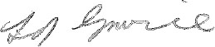
Governor-General.
By His Excellency’s Command,
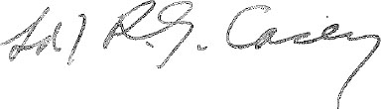
for Prime Minister.

Amendment of the Science and Industry Reseaech Regulations.†
Constitution of State Committees and terms of appointment.
Regulation 3 of the Science and Industry Research Regulations is amended by omitting from sub-regulation (9.) the words “two guineas” and inserting in their stead the words “thirty shillings”.

* Notified in the Commonwealth Gazette on , 1939.
† Statutory Rules 1926, No. 125, as amended by Statutory Rules 1927, Nos. 38 and 57; 1934, No. 41; 1936, No. 13; 1937, No. 3; 1938, No. 14; and 1939, No. 15.

By Authority: L. F. Johnston, Commonwealth Government Printer, Canberra.
2187.—6/27.4.1939.—Price 3d.

