STATUTORY RULES.
1938. No. 83.
––––––––
REGULATION UNDER THE MEAT EXPORT CHARGES ACT 1935.*
WHEREAS it is provided by section five of the Meat Export Charges Act 1935 that the Governor-General may, after report to the Minister by the Australian Meat Board constituted under the Meat Export Control Act 1935-1938, make regulations for prescribing lower rates of the charges imposed by the Meat Export Charges Act 1935 on any meat exported from the Commonwealth:
And whereas the Australian Meat Board has made a report to the Minister that the rates of the charges imposed on lamb exported from the Commonwealth should be as prescribed by the Meat Export Charges Regulations as amended by the regulation hereunder:
And whereas it is provided by section 17 of the Acts Interpretation Act 1901-1937 that the expression “the Governor-General” in any Act includes the person for the time being administering the Government of the Commonwealth, acting with the advice of the Federal Executive Council:
Now therefore I, the Administrator of the Government of the Commonwealth, acting with the advice of the Federal Executive Council, hereby make the following regulation under the Meat Export Charges Act 1935.
Dated this Tenth day of August , 1938.
HUNTINGFIELD
ADMINISTRATOR
By His Excellency’s Command,
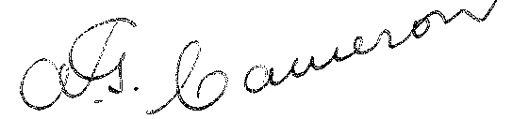
Acting Minister of State for Commerce.
––––––––
Amendment of the Meat Export Charges Regulations. †
Rates of charge.
Regulation 3 of the Meat Export Charges Regulations is amended by omitting from the table contained therein the figures “¾” (wherever occurring) and inserting in their stead the figures “½”.

* Notified in the Commonwealth Gazette on 1938.
† Statutory Rules 1936, No. 23, as amended by Statutory Rules 1937, No. 97.
–––––––––––––––
By Authority: L. F. Johnston, Commonwealth Government Printer, Canberra.
4319.—8/1.8.1938.—Price 3d.

