STATUTORY RULES.
1922. No. 2.

REGULATION UNDER THE QUARANTINE ACT 1908-1920.
I, THE GOVEENOR-GENERAL in and over the Commonwealth of Australia, acting with the advice of the Federal Executive Council, hereby make the following Regulation under the Quarantine Act 1908-1920, to come into operation forthwith.
Dated this fifth day of January, 1922.
FORSTER,
Governor-General.
By His Excellency’s Command,
W. MASSY GREENE,
Minister for Health.

Amendment of Quarantine Regulations 1917.
Regulation 61 of the Quarantine Regulations 1917 is hereby amended by omitting paragraph (2) (Statutory Rules No. 227 of 1918), and inserting in its stead the following paragraph:—
61. (2) No rat guard, disc, or screen shall be regarded as effective for the purpose of these Regulations unless it complies in all respects with the following requirements, and is in accordance with the plan and specification shown hereunder:—
(a) It shall be circular in outline, formed in the shape of a cone, and shall measure not less than 6 inches from base to apex, and not less than 24 inches directly across any diameter of its base rim to rim;
(b) It shall be made of sheet-metal of at least 26 gauge, without any opening or perforation except as hereunder specified;
(c) It shall be so constructed that when fitted the apex of the cone shall point away from the vessel, and the rope or hawser shall pass through the apex of the cone and the centre of the base and all openings in the disc screen or guard shall be effectively closed.
C.18862.—Price 3d.

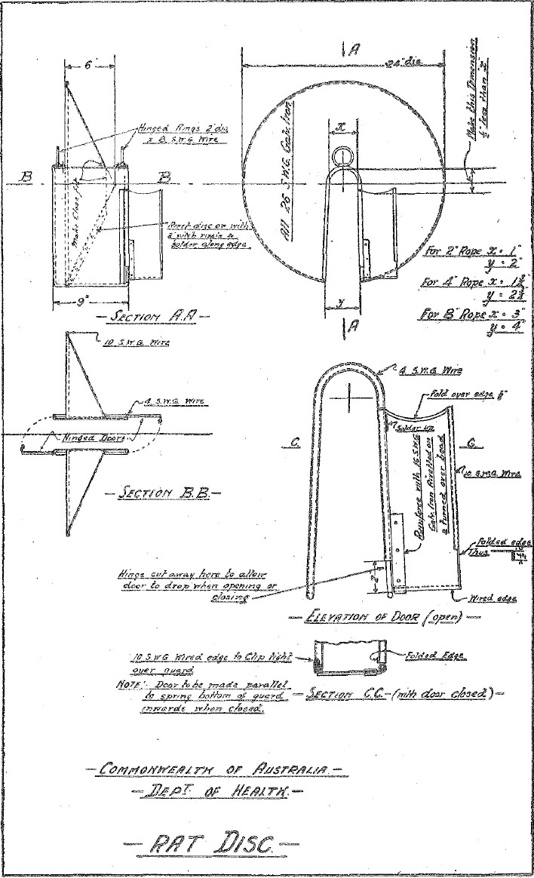

Printed and Published for the Government of the Commonwealth of Australia by Albert J. Mullett, Government Printer for the State of Victoria.

